These are instructions specifically for the DOA 2023 DOA December Training sessions. Make sure you activate the io application before the sessions begins.
- Click on this link to begin https://tncot.cnf.io/ and select the applicable session (State Specific Ethics, GASB Update, or Grants and Federal Funding). You will need to restart this for each of the 3 sessions.
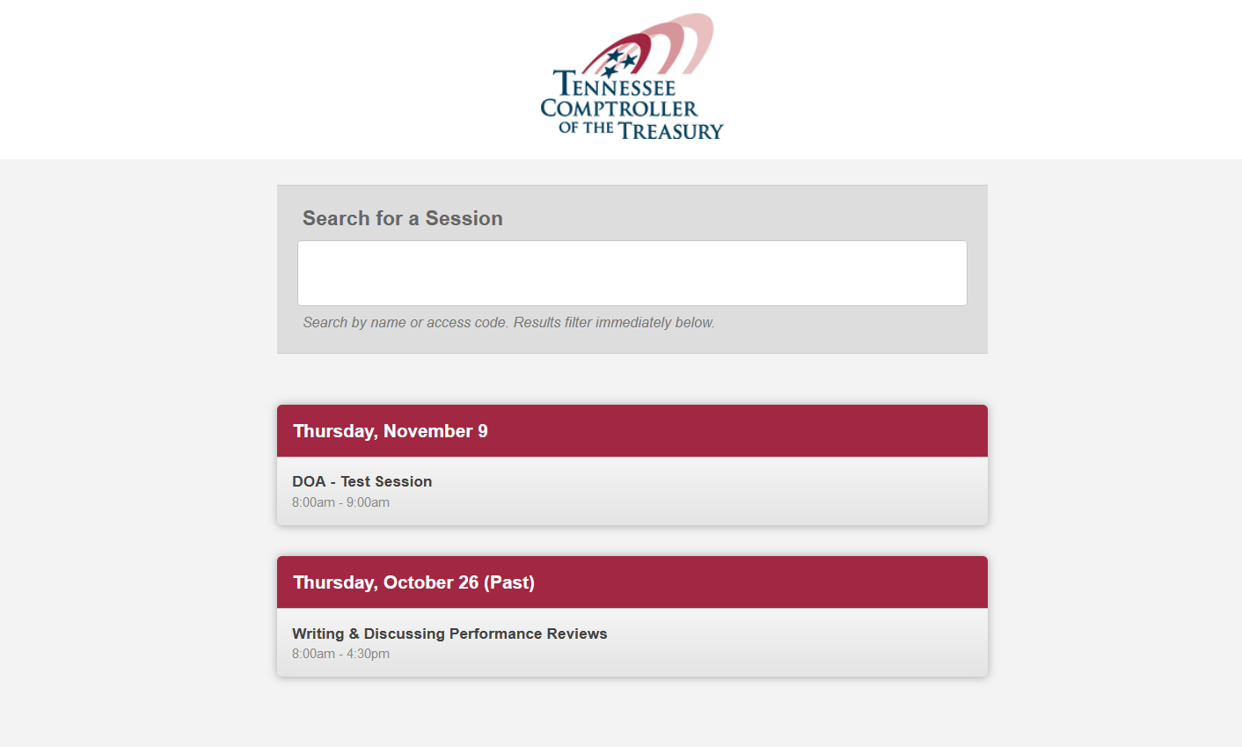
- Or, scan any of the 3 applicable QR codes:
State Specific Ethics
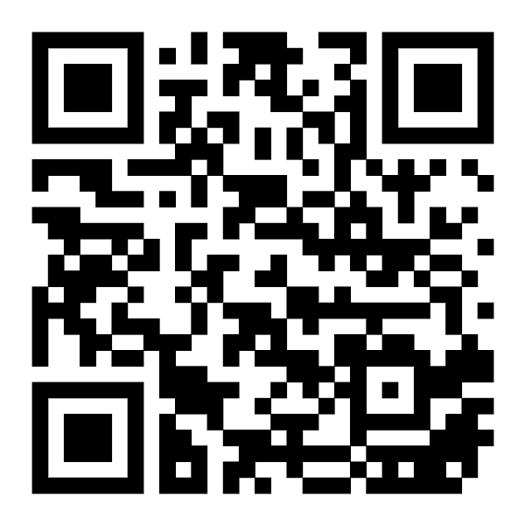

GASB Update
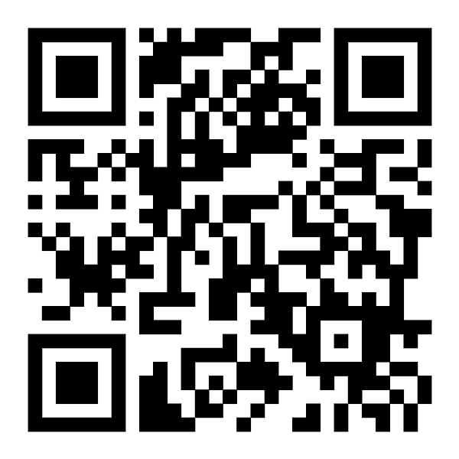
Grants and Federal Funding
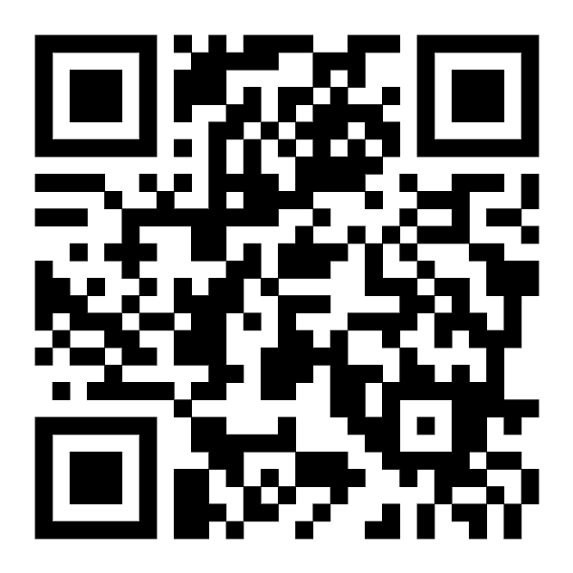

- Complete the information in each field and click on Check in Now.
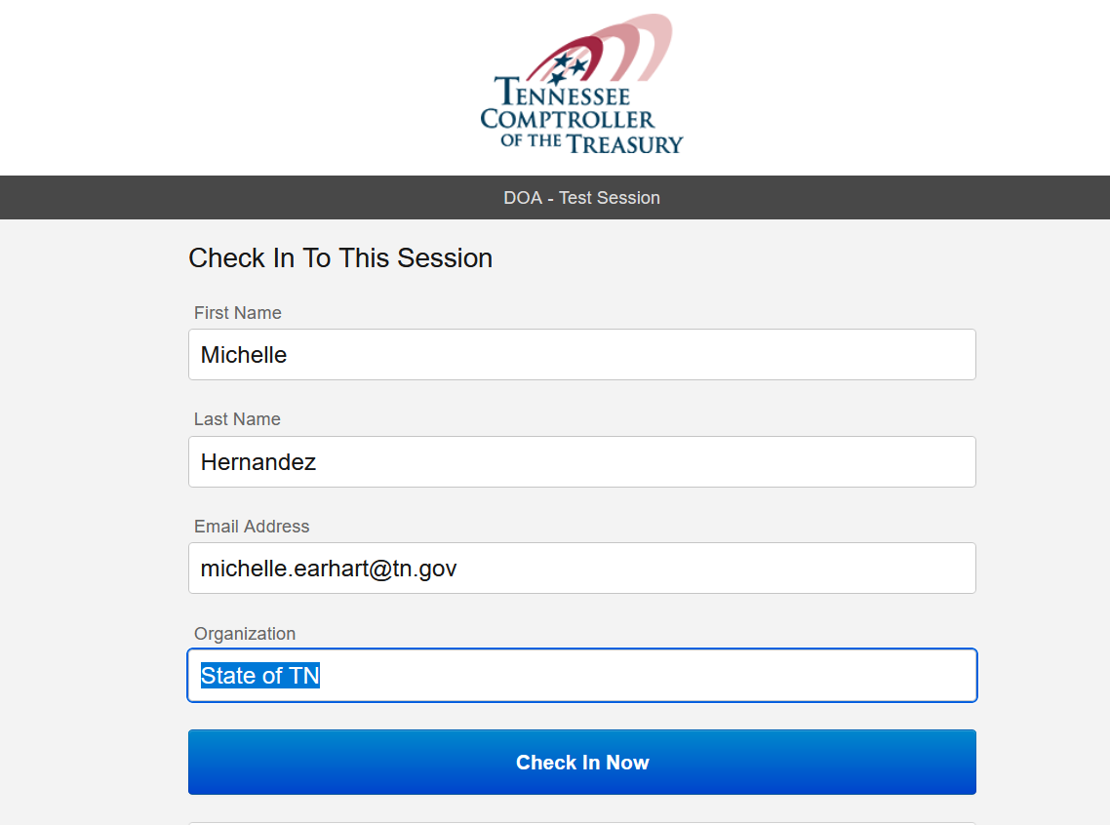

- Keep this screen active and you will see the poll questions pop up. Do not check out until the session is complete.
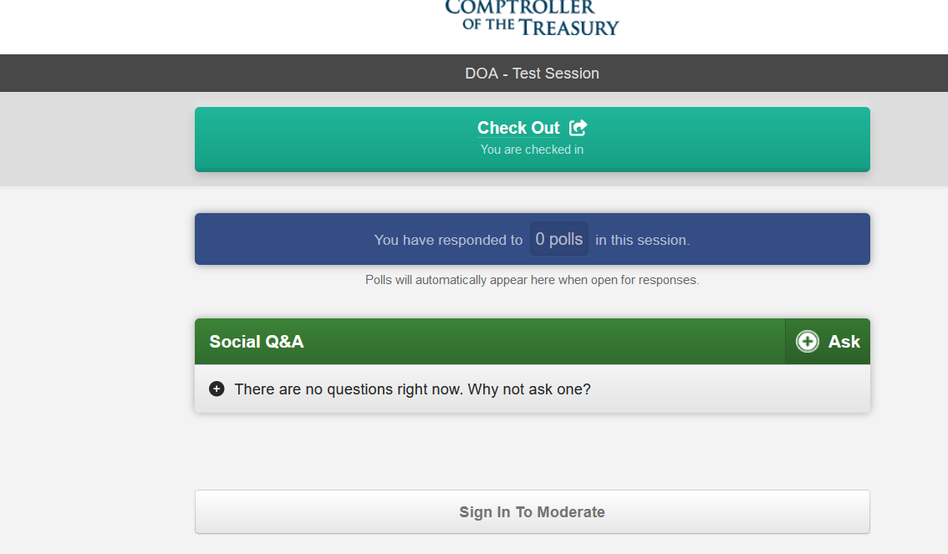

- When a poll question is launched, click on the answer and then Submit.
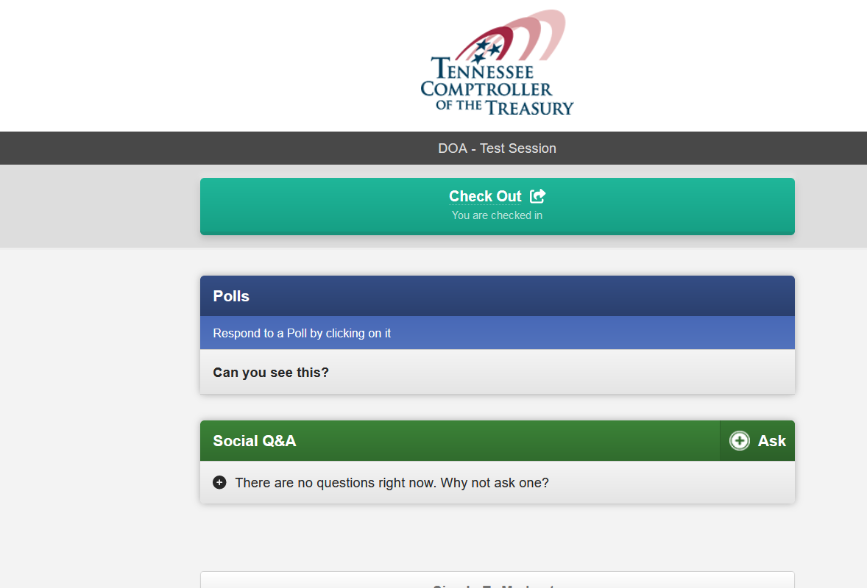
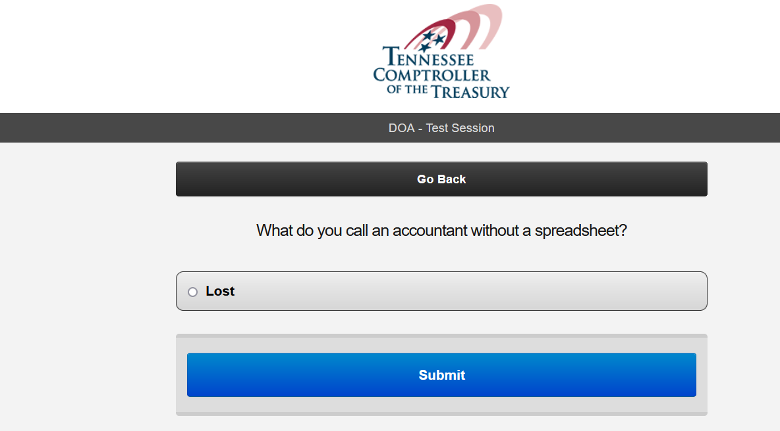

- If you have successfully answered the polling question and clicked on Submit, you should see the appropriate number of responses.
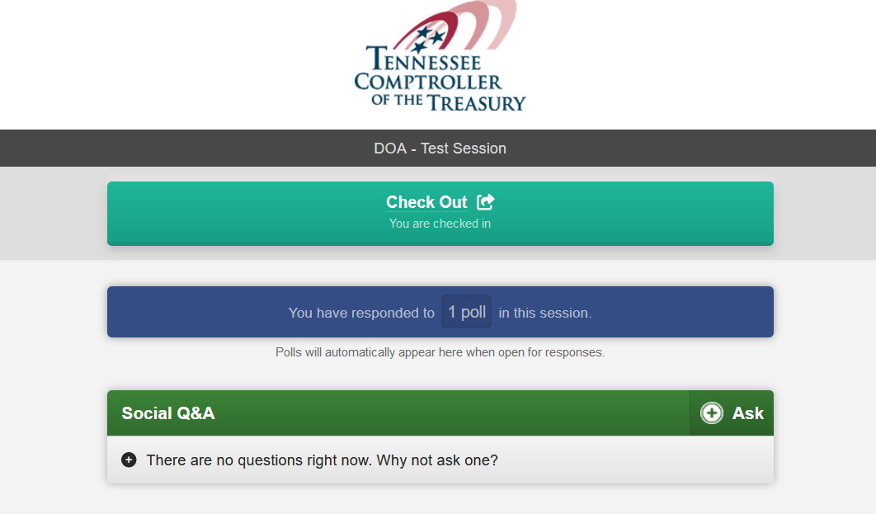

- When polling questions are complete for the whole session, you can go back and Checkout of the session.
