External customers will log in here: https://tnkord.labs.tracefirst.com
At this screen, they will click on “Forgot your password?”
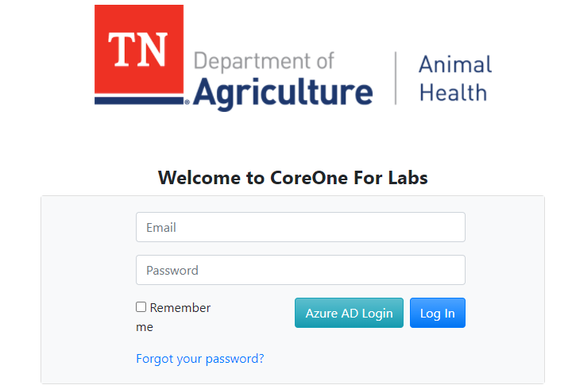
User will be taken here:
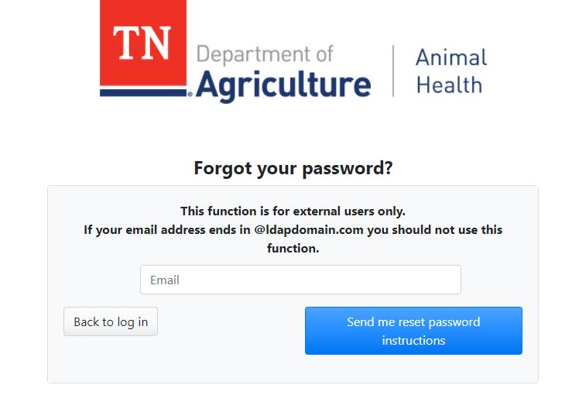
They will enter their email and click on “Send me reset password instructions”.
Once they receive the automated email, they can reset, and they should then see the portal page:
