Level One
Level Two
Level Three
DIGITAL ARTS & DESIGN
__________

Arts, A/V Technology, & Communications
__________

Level Four

ABOUT THE PROGRAM OF STUDY
Dual credit/ dual enrollment options include:
Course A
Course B

The Digital Arts & Design program of study is for students interested in pursuing careers as multimedia artists, animators, graphic designers, and communications specialists. Course content is designed to develop strong knowledge in communications technologies, animation and software applications, digital graphics, motion graphics, and more for a broad range of business and industry applications. Students will leverage digital tools to gather, evaluate, and use information, and apply design skills in the communication of materials as they would for an organization or company. Upon completion of the program of study, students will be prepared to pursue advanced study in graphic design or communications, or seek entry level employment with such organizations.

This is not an exhaustive list of all of the opportunities available in Tennessee.
CAREER OPPORTUNITIES
In Tennessee, employment of graphic designers is projected to grow by 1.6 percent between 2014 and 2022. Annual average openings are projected at 115. Job opportunities for graphic designers, photographers, multi-media artists, and animators are strongest in urban and surrounding areas in Tennessee.¹ Nationally, employment of graphic designers in newspaper, periodical, book, and directory publishers is projected to decline, but employment in computer systems design and related services is projected to grow 21 percent between 2014 and 2024.²
Occupation | Total Percent Change | Annual Avg. Openings
Graphic Designers | 1.6% | 115
Photographers | 14.3% | 65
Art Directors | -0.6% | 15
Multimedia Artists and Animators | 8.1% | 15
Commercial and Industrial Designers | 2.7% | 15
Set and Exhibit Designers | 9.1% | 15

Digital Arts & Design Related Occupations with the Most Annual Average Openings in Tennessee (2014-2022)

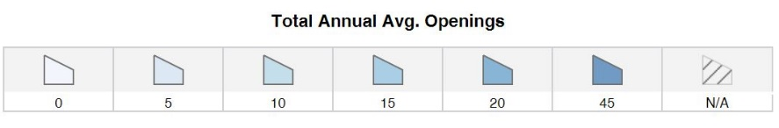
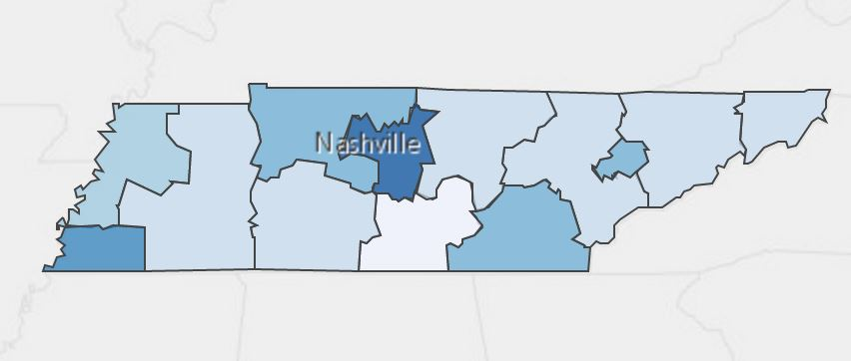
Annual Average Openings for Graphic Designers in Tennessee (2014-2022)

Students in this program of study will be eligible to join SkillsUSA. In addition to school events, students will be able to compete at the regional, state, and national level. Through SkillsUSA, students not only learn about digital arts and design, but also professionalism, leadership, and workplace skills. Walk away from your high school career with experience in competing, networking, applying course content, and more!

¹TN Department of Labor and Workforce Development. (2015). Employment Security Division, Labor Market Information Section, on the internet at https://www.jobs4tn.gov/
²Bureau of Labor Statistics, U.S. Department of Labor, Occupational Outlook Handbook, 2016-17 Edition, Graphic Designers, on the Internet at http://www.bls.gov/ooh/arts-and-design/graphic-designers.htm

See your teacher to learn more about SkillsUSA or visit http://tnskillsusa.com/.
Have you registered for the Tennessee Promise? Seniors enrolled in this program have the chance to attend a two-year program at a Tennessee College of Applied Technology (TCAT), community college, or
POSTSECONDARY OPTIONS

For more information, contact:
School High School
County Name Schools
CTE Director: Name
Email
Instructor: Name
Email

some 2-year university programs for free! To learn more, please see your school counselor or visit http://www.tennesseepromise.gov.

School | Degree Program
Chattanooga State | Digital Media Design and Production
Nashville State | 3D Design and Graphics
Nashville State | Photography
TCAT Crump | Computer Based Graphic Design
For more college and career planning resources, visit http://collegefortn.org.

