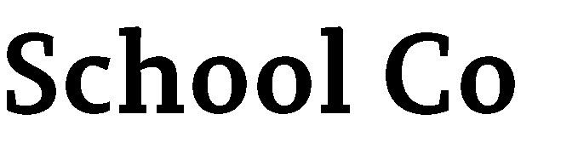
Foundations | Completed/ Implemented | In  Process | Not Started | Evidence
Beliefs
Vision statement
Mission statement
T.C.A., State Board of
Education policies, and
Ethical Standards
Program goals
Program Expectations
Student standards
Professional school counselor competencies

Management | Completed/ Implemented | In  Process | Not Started | Evidence
School data review
School counseling program audit
School counselor competencies assessment
Use of time assessment
Needs Assessments
Program Management agreements
Advisory councils
Program Action Plans
Lesson plans
Calendars

Accountability | Completed/ Implemented | In  Process | Not Started | Evidence
School data analysis
Use of time analysis
Program assessment analysis
Curriculum program results report
Small group results report
Closing the gap results report
Program evaluation
School counselor competencies analysis
School counselor professional evaluation

Delivery of Services | Completed/ Implemented | In  Process | Not Started | Evidence
School counseling core curriculum
Individual student planning
Responsive services
Consultations
Collaborations
Referrals

