CHILDHOOD DEVELOPMENT SERVICES
__________

Human Services
__________

Level Four
Level Three
Level Two
Level One
ABOUT THE PROGRAM OF STUDY
Hospitality Childhood Development Services is designed for students interested in becoming a preschool teacher, nanny, or childcare provider. While in this program of study, students will cover components of child development, planning age-appropriate activities, learning environments, and many other skills related to teaching younger children. Upon completion of this program of study, students will get to work alongside educators with younger children, a complete professional portfolio, and will feel prepared for further training at the postsecondary level.
Dual credit/ dual enrollment options include:
- TCAT Hohenwald, TCAT Crossville, and TCAT Nashville
- Roane State Community College

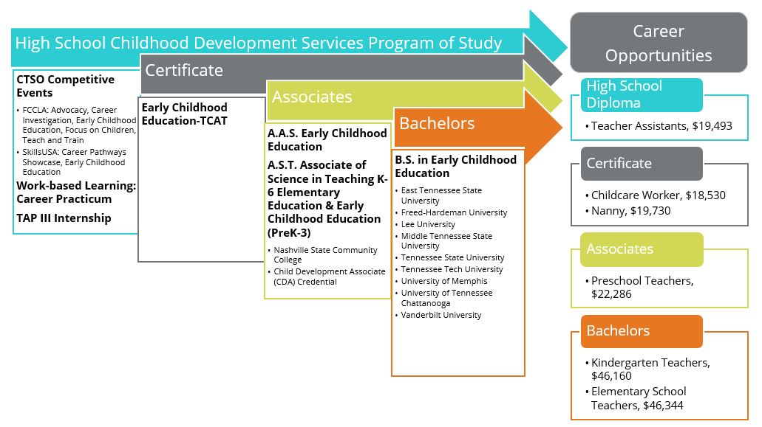

Occupation | Total Percent Change | Annual Avg. Openings Due to Growth
Childcare Workers | 26.50% | 815
Preschool Teachers, Except Special Education | 40.50% | 460
Preschool & Childcare Center Education Administrators | 35.00% | 50
Source: TN Dept of Labor & Workforce Dev, Div Emp Sec, R&S
Downloaded: 02/08/2016 1:52 PM
CAREER OPPORTUNITIES

The Childhood Development Services occupation group in Tennessee is projected to grow at a rate much greater than the national averages between 2014 and 2022. For example, preschool teacher occupations are growing at a rate of 40 percent in Tennessee and the job outlook at the national level is at a 7 percent increase. Job opportunities are strongest in urban and surrounding areas in Tennessee but statewide are increasing.

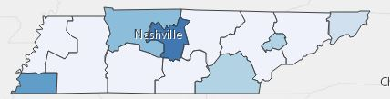
Annual Average Openings for Childcare Workers in Tennessee (2014-2022)

POSTSECONDARY OPTIONS
Postsecondary Offerings Aligned to this Program of Study
School | Degree Program
Nashville State Community College | Early Childhood Education
Jackson State Community College | Teaching
Motlow Community College | Early Childhood Education
Have you registered for the Tennessee Promise? Seniors enrolled in this program have the chance to attend a two-year program at a Tennessee College of Applied Technology (TCAT), community college, or some 2-year university programs for free! To learn more, please see your school counselor or visit http://www.tennesseepromise.gov .
For more information, contact:
School High School
County Name Schools
CTE Director: Name
Email
Instructor: Name
Email
For more college and career planning resources, visit http://collegefortn.org.

Students in this program of study will be eligible to join FCCLA, Family, Career and Community Leaders of America or SkillsUSA. In addition to school events, students will be able to compete at the district or regional, state, and national level. Involvement in FCCLA or SkillsUSA offers students the opportunity to expand their leadership potential and develop skills for life—planning, goal setting, problem solving, decision making, and interpersonal communication—necessary in the home and workplace. Walk away from your high school career with experience in competing, networking, applying course content, and more! See your teacher to learn more about FCCLA & SkillsUSA or visit http://www.tennesseefccla.org or http://tnskillsusa.com.

