AUTOMOTIVE COLLISION REPAIR
__________

Level One
Level Two
Level Three
Transportation
__________

Level Four

ABOUT THE PROGRAM OF STUDY
Available industry certifications:
- ASE Student Certification
  - Non-Structural Analysis/ Repair
  - Painting & Refinishing
- I-CAR ProLevel 1
  - Refinish Technician
  - Non-Structural Technician
Dual credit/ dual enrollment options:
- Course A
- Course B

The Automotive Collision Repair program of study prepares students for entry into careers as professional service technicians. Content emphasizes customer service skills, proper use of tools and equipment, safety, shop operations, engine fundamentals, damage analysis, cost estimation, painting and refinishing, and structural and non-structural repair in a hands-on environment. Upon completion of this program of study, students will be eligible to take the examination for Automotive Student Excellence (ASE) student certifications or I-CAR ProLevel 1 in Refinish Technician or Non-Structural Technician and be prepared to pursue further study in collision repair at postsecondary institutions.

Career Opportunities

Occupation | Total Percent Change | Annual Avg. Openings
First-Line Supervisors of Mechanics, Installers, and Repairers | 6.3% | 335
Mechanical Engineers | 5.3% | 170
Tire Repairers and Changers | 10.5% | 125
Mobile Heavy Equipment Mechanics, Except Engines | 7.6% | 100
Automotive Body and Related Repairers | 3.8% | 75
Mechanical Engineering Technicians | 7.5% | 35

Automotive Collision Repair Related Occupations with the Most Annual Average Openings in Tennessee (2014-2022)
CAREER OPPORTUNITIES
The automotive body and related repairers occupation is projected to grow by 3.8 percent in Tennessee between 2014 and 2022 with a total annual average of 75 openings and 3,320 employed in the group in 2022. Nationally, the growth rate for automotive body and related repairers is higher with a 9 percent change predicted.¹ Mechanical engineers is a related occupation requiring a bachelor’s degree.

¹ Bureau of Labor Statistics, U.S. Department of Labor, Occupational Outlook Handbook, 2016-17 Edition, Automotive Body and Glass Repairers, on the Internet at http://www.bls.gov/ooh/installation-maintenance-and-repair/automotive-body-and-glass-repairers.htm (visited February 25, 2016).

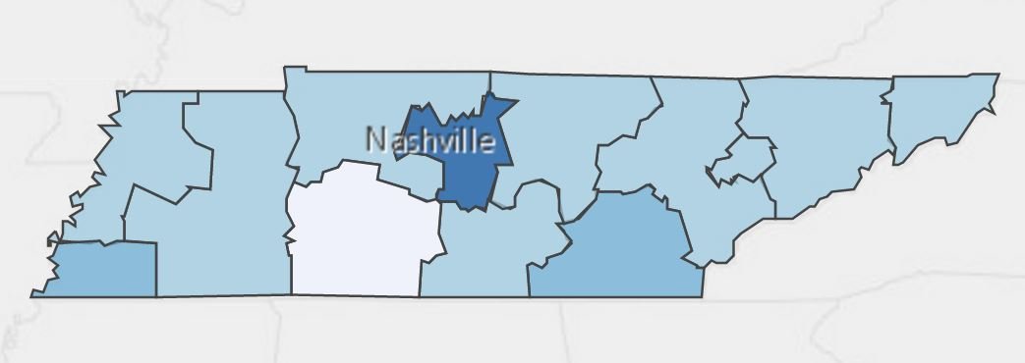
Annual Average Openings for Automotive Body and Related Repairers in Tennessee (2014-2022)

Students in this program of study will be eligible to join SkillsUSA. In addition to school events, students will be able to compete at the regional, state, and national level. Through SkillsUSA, students not only learn about automotive repair, but also professionalism, leadership, and workplace skills. Walk away from your high school career with experience in competing, networking, applying course content, and more!

School | Degree Program
TCAT Knoxville | Collision Repair
TCAT Crossville | Collision Repair
Chattanooga State | Mechanical Systems
Tennessee Tech | Mechanical Engineering
For more college and career planning resources, visit http://collegefortn.org.

POSTSECONDARY OPTIONS

community college, or some 2-year university programs for free! To learn more, please see your school counselor or visit http://www.tennesseepromise.gov.

Have you registered for the Tennessee Promise? Seniors enrolled in this program have the chance to attend a two-year program at a Tennessee College of Applied Technology (TCAT), community college, or some 2-year university programs for free! To learn more, please see your school counselor or visit http://www.tennesseepromise.gov.

Source: TN Department of Labor and Workforce Development. (2015). Employment Security Division, Labor Market Information Section, on the internet at https://www.jobs4tn.gov/ (visited Feb. 25, 2016)
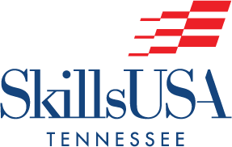
For more information, contact:
Central High School
County Name Schools
CTE Director: Susan Smith Susan.Smith@school.edu
Instructor: Bob Johnson Bob.Johnson@school.edu

See your teacher to learn more about SkillsUSA or visit http://tnskillsusa.com/.

