EDUCATIONAL SUPPORT CAREERS
__________

Education & Training
__________

Level Four
Level Three
Level Two
Level One
ABOUT THE PROGRAM OF STUDY
Dual credit/ dual enrollment options include:
- Course A
- Course B
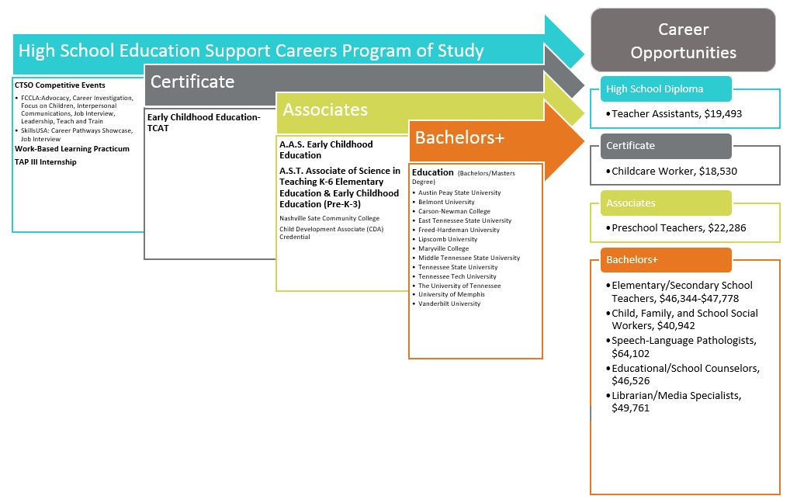
Educational Support Careers is designed for students that want to focus on occupations that support the everyday functioning of school environments, such as school counselors, librarians, speech-language pathologists, media specialists, and instructional coordinators. While in this program of study, students are exposed to all the critical components of effective teaching and learning at the K-12 level, as well as professional ethics, communications skills, school counseling models, and counseling approaches for a range of ages. Upon completion of this program of study, students will have had a the opportunity to work alongside educators in an internship, build a professional portfolio, and graduate prepared for further study in a variety of educational support fields.

CAREER OPPORTUNITIES

The Educational Support Careers occupation group has a bright outlook statewide between 2014 and 2022. Job opportunities are strongest in urban, and suburban areas of Tennessee. The job outlook for this program of study in Tennessee is as follows: 12.3 percent increase for educational counselors, 12.2 percent increase for instructional coordinators and librarians, and 14.2 percent increase for speech-language pathologists by 2022.

Employment Projections for Educational Support Careers in Tennessee (2014-2022)
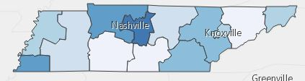

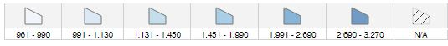

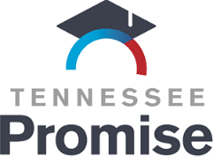
POSTSECONDARY OPTIONS
School | Degree Program
Columbia State Community College | Teaching or Early Childhood Education
Volunteer State Community College | Teaching or Early Childhood Education
Dyersburg State Community College | Child Development
Have you registered for the Tennessee Promise? Seniors enrolled in this program have the chance to attend a two-year program at a Tennessee College of Applied Technology (TCAT), community college, or some 2-year university programs for free! To learn more, please see your school counselor or visit http://www.tennesseepromise.gov .
For more college and career planning resources, visit http://collegefortn.org.
Educational Support Careers Related Occupations with the Most Annual Average Openings in Tennessee (2014-2022)
Occupations | Total Percent Change | Total Annual Avg. Openings
Education, Training, and Library Workers | 7.80% | 25
Educational, Guidance, School, and Vocational Counselors | 12.30% | 160
Instructional Coordinators | 12.20% | 55
Librarians | 12.20% | 110
Library Technicians | 9.60% | 90
Speech-Language Pathologists | 14.20% | 75
Teacher Assistants | 15.30% | 855
Source: TN Dept of Labor & Workforce Dev, Div Emp Sec, R&S
Downloaded: 03/03/2016 11:11 AM

Students in this program of study will be eligible to join FCCLA, Family, Career and Community Leaders of America. In addition to school events, students will be able to compete at the district, state, and national level. Involvement in FCCLA offers students the opportunity to expand their leadership potential and develop skills for life—planning, goal setting, problem solving, decision making, and interpersonal communication—necessary in the home and workplace. Walk away from your high school career with experience in competing, networking, applying course content, and more! See your Family and Consumer Science teacher to learn more about FCCLA or visit http://www.tennesseefccla.org.

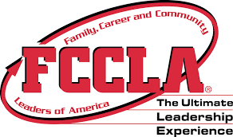
For more information, contact:
School High School
County Name Schools
CTE Director: Name
Email
Instructor: Name
Email

