PUBLIC HEALTH
Health Science
Level Four
Level Three
Level Two
Level One
ne

Dual Enrollment options include:
- Dual enrollment Public Health
ABOUT THE PROGRAM OF STUDY
Public Health is designed to place students at the intersection of health science and health policy. This program investigates the patterns, causes, and effects of diseases in a variety of populations and how the provision of healthcare has changed in response to global needs. Successful international strategies and programs will be examined. Upon completion of this program of study, proficient students will be able to interpret and communicate statistical information relating to the distribution of disease and mortality/morbidity in the United States and globally, determine national and international health disparities, analyze national and international health policies, and evaluate outcomes from a range of health interventions.

This is not an exhaustive list of all of the opportunities available in Tennessee.

2024 Projected Employment for Public Health Related Occupations In Tennessee
Occupations | Total Percent Change | Total Annual Av. Openings
Community Health Workers | 24.8% | 30
Environmental Science & Protection Technicians | 21% | 50
Health Educators | 34.6% | 50

Career Opportunities
The Public Health occupation group will have positive growth statewide between 2014 and 2024. Job opportunities are strongest in urban and suburban areas of Tennessee. The job outlook for this program of study in Tennessee is as follows: 25 percent increase for health educators, 7 percent increase for Occupational Health and Safety Specialists, and 5 per cent increase for epidemiologists by 2024.

2024 Projected Employment for Environmental Scientists and Specialists
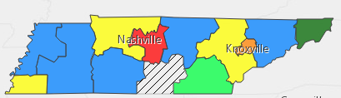

Students in this program of study will be eligible to join HOSA: Future Health Professionals. In addition to school events, students will be able to compete at the regional, state, and national level.
HOSA's two-fold mission is to promote career opportunities in the health care industry and to enhance the delivery of quality health care to all people. HOSA's goal is to encourage all health occupations instructors and students to join and be actively involved in the HSE-HOSA Partnership. HOSA provides a unique program of leadership development, motivation, and recognition exclusively for secondary, postsecondary, adult, and collegiate students enrolled in HSE programs. HOSA is 100% health care! For more information, please visit http://www.hosa.org .

Postsecondary Offerings Aligned for this Program of Study
School | Degree Program
Roane, Cleveland, Columbia, Dyersburg, Nashville, Volunteer, and South West Tennessee State Community Colleges | A.A.S. Environmental Health Technology
East & Middle Tennessee State Universities | B.S., Community and Public Health or Environmental Health
For more college and career planning resources, visit http://collegefortn.org.

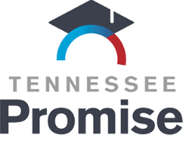
POSTSECONDARY OPTIONS
Have you registered for the Tennessee Promise? Seniors enrolled in this program have the chance to attend a two year program at a Tennessee College of Applied Technology (TCAT), community college, or some two year university programs for free! To learn more, please see your school counselor or visit http://www.tennesseepromise.gov.

For more information, contact:
School High School
County Name Schools
CTE Director: Name
Email
Instructor: Name
Email

