therapeutic services

Health Science

*Level One*

*Level Two*

*Level Three*

*Level Four*

**ABOUT THE PROGRAM OF STUDY**

*Therapeutic Services*is designed to prepare students to pursue careers in fields of dentistry, pharmacology, nutrition, or rehabilitation. Upon completion of this program, a proficient student will be able to identify careers in therapeutic clinical services; assess, monitor, evaluate, and report patient/client health status; and identify the purpose and components of treatments. Students have the option to take part in a clinical internship at the end of this program of study.

**Industry Certifications options include:**

* Certified Clinical Medical Assistant
* Certified Pharmacy Technician

This is not an exhaustive list of all of the opportunities available in Tennessee.

**Career Opportunities**

Therapeutic careers are projected to have a total annual average number of openings of over 2,200 and estimated employment of over 63,150 by 2024. The therapeutic careers can be further broken down into groups of related occupations such as physical and respiratory therapies, dental, pharmacological, and nutritional services. Each of these areas have projected positive growth from 2014-2024 with medical assistants, dental assistants, and pharmacy technicians projected to have the largest number of openings.

**2024 Projected Employment forTherapeutic Services Related Occupations**

|  |  |  |
| --- | --- | --- |
| Occupations | Total Percent Change | Total Annual Av. Openings |
| Dental Assistant | 16.20% | 210 |
| Pharmacy Technician | 25% | 420 |
| Medical Assistant | 33% | 730 |

**2024 Projected Employment for Pharmacy Technicians**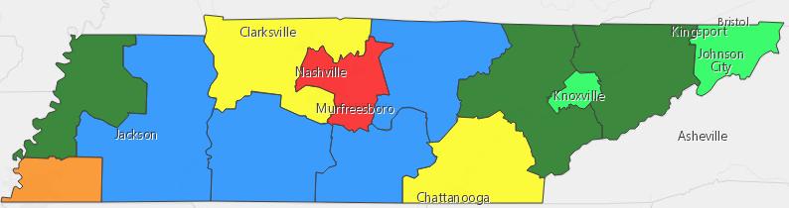





**For more information, contact:**

**School High School**

**County Name Schools**

**CTE Director: Name**

**Email**

**Instructor: Name**

**Email**



Students in this program of study will be eligible to join HOSA: Future Health Professionals. In addition to school events, students will be able to compete at the regional, state, and national level.

HOSA's two-fold mission is to promote career opportunities in the health care industry and to enhance the delivery of quality health care to all people. HOSA's goal is to encourage all health occupations instructors and students to join and be actively involved in the HSE-HOSA Partnership. HOSA provides a unique program of leadership development, motivation, and recognition exclusively for secondary, postsecondary, adult, and collegiate students enrolled in HSE programs. HOSA is 100% health care! For more information, please visit <http://www.hosa.org> .

|  |  |
| --- | --- |
| Postsecondary Offerings Aligned to this Program of Study | |
| School | **Degree Program** |
| Northeast, Chattanooga, Roane State Community Colleges | A.A.S. Dental Hygiene |
| UT Martin and Austin Peay State University | B.S. Health and Human Performance |
| For more college and career planning resources, visit http://collegefortn.org. | |



**POSTSECONDARY OPTIONS**

Have you registered for the Tennessee Promise? Seniors enrolled in this program have the chance to attend a two year program at a Tennessee College of Applied Technology (TCAT), community college, or some two year university programs for free! To learn more, please see your school counselor or visit <http://www.tennesseepromise.gov>.