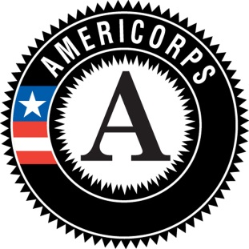
Weekly Check-In with AmeriCorps Supervisor

Projects I am currently working on:

Accomplishments from the last week:

Greatest challenge from the last week:

I would describe my satisfaction with the placement this week as:

I would describe my frustration level as:

I would describe my stress level as:

Suggestions I have for improving a situation(s) at the site:

I need/would like the following from you:

