Agribusiness
Agriculture, Food, and Natural Resources
__________

Level Four
Level Three
Level Two
Level One

¹ Satisfies one lab science credit required for graduation, ²Satisfies half credit requirement for personal finance.³Statewide dual credit available

ABOUT THE PROGRAM OF STUDY
As the population continues to grow, successful production of food and other agricultural products will remain a global issue. The Agribusiness program of study will prepare students for agricultural businesses careers in industries related to the food, fiber, and natural resources industry. Students in this program of study will develop decision-making skills, understanding the dynamics and the leadership/management qualities to enhance their contributions to agribusiness enterprises or their own entrepreneurial venture. Proficient students have the opportunity to earn both general education and postsecondary credit while being prepared for advanced business courses at the postsecondary level or for a variety of agricultural careers.
Dual credit/dual enrollment options include:
- Course A
- Course B

Agribusiness Related Occupations with the Largest Percentage of Openings in Tennessee (2014-20124)
Occupation | 2014 Estimated Employment | 2024 Projected Employment | Employment Change | Annual Avg. Percent Change
13-1021 Buyers and Purchasing Agents, Farm Products | 260 | 300 | 40 | 16%
13-2072 Loan Officers | 5,800 | 6,380 | 580 | 8%
15-1151 Computer User Support Specialists | 7,430 | 9,360 | 310 | 26%
27-1024 Graphic Designers | 3,880 | 4,090 | 120 | 6%
Source: TN Dept of Labor & Workforce Dev, Div Emp Sec, R&S
Downloaded: May 17, 2018
Job growth projections for buyers and purchasing agents of farm products through 2024.
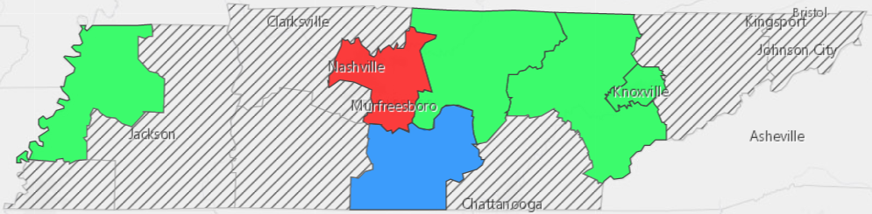
Source: JOBS4TN.GOV, Accessed Aug.15, 2017

POSTSECONDARY OPTIONS
Have you registered for the Tennessee Promise? Seniors enrolled in this program have the chance to attend a two-year program at a Tennessee College of Applied Technology (TCAT), community college, or some two-year university programs for free! To learn more, please see your school counselor or visit http://www.tennesseepromise.gov.
Postsecondary Offerings
Program of Study | School | Degree Program
Food and Agricultural Business  Natural Resources & Environment | University of Tennessee, Knoxville | Bachelor’s, Master’s , and/or Doctoral
Agricultural Business | University of Tennessee, Martin | Bachelor’s
Agribusiness Management | Tennessee Tech University | Bachelor’s
Agribusiness | Middle Tennessee State University | Bachelor’s
Agricultural Business | Waters State Community College | Applied Associate’s, Associate’s
For more college and career planning resources, visit http://collegefortn.org

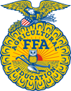
Students in this program of study will be eligible to join FFA. Students will learn about agriculture, but also professionalism, leadership, and soft skills. Walk away from your high school career with experience in competing, networking, applying course content, and more! See your agriculture teacher to learn more about FFA or visit http://www.tnffa.org.
For more information, contact:
Name of High School
Name of School System
CTE Director: [enter name]
Email
Teacher: [enter name]
Email

