**Therap Guidance for Providers – Ancillary Services**

**List of required Therap Placeholders for Ancillary Services**



**List of Ancillary services**

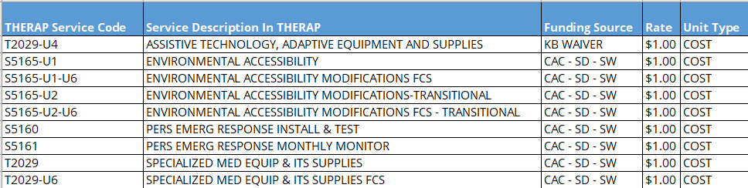

* ISC/Case Manager will submit a service request to the Regional Plans Review (PR)
  + Body of PCSP updated.
  + Supporting Documents (Bid(s), treatment plans, MD orders, etc.) uploaded to Therap Document Checklist
  + In Therap enter Ancillary Placeholder (Non-billable) in the service supports section of PCSP.
* Plan Reviewer Actions
  + DIDD will confirm receipt of the service request and assign the service request to a Plans Reviewer.
  + The PR sends out disposition to ISC/CM.
* Provider Actions
  + Provider completes work and/or orders equipment.
  + Provider emails invoices to the Regional Billing Department.
  + Upon notification from the regional office, the Provider acknowledges the authorization in Therap.

**Regional Billing Department Email Addresses**

* East: **DDETRO.CPC@tn.gov**
* Middle: [**MTRO.Billing@tn.gov**](mailto:MTRO.Billing@tn.gov)
* West: west.service-request.followups@tn.gov
* Regional Billing Actions
  + Review billing invoice.
  + Sends to the Therapy Department if applicable for follow-up and/or work completion confirmation.
  + Create a ‘Change Form’ in Therap.
  + In Therap …
    1. Upload Invoice(s) in Therap to ‘Document Checklist.’
    2. Delete Ancillary Placeholder from Therap
    3. Create a new SLI and enter the invoiced amount for Ancillary Service.
    4. Authorize the SLI.
  + Email the Provider that the billable authorization has been created in Therap and is ready for acknowledgment and billing of the authorization.
* Provider Actions
  + Acknowledge Ancillary Service.
  + Upon notification from the Regional Office, the Provider acknowledges the billable Ancillary Service authorization and enters the ‘Billing Data Input’ for the service in Therap.
  + Provider can then submit the claim to MCO.