ISC Agency Therap Billing Guidance
This guidance document is to assist ISC agencies with documenting billing data and submitting claims in Therap for the monthly Independent Support Coordination (ISC) services.
General Billing Guidance for ISCs in Therap
It is up to the ISC agency to determine which day of the month to submit billing data for the ISC service. It may be easiest to enter the same billing date for all individuals within a given month (i.e. the last day of the month).
Note: From a TennCare and DDA risk management/audit perspective, billing dates should be on or after the date of the billable contact in a given month. Audit is looking for a billable contact to occur during the month, not the exact billing date entered in Therap, so they do not need to match.
The ISC service is a monthly-rate service, so billing data only needs to be reported for one day per month, per individual in Therap’s Attendance module. Therap will prevent more than one ISC service claim from being generated per month, per individual.
For months that have new annual PCSP’s for individual’s mid-month, ISCs should follow their same billing schedule as for any other month (i.e. enter billing data last of month). Below is an example.
Example – For ISCs entering their monthly service billing data on the last day of the month:
An individual’s current PCSP ends on August 13th, and new PCSP starts August 14th. The ISC will have already received a Service Authorization that ends August 13, via the current PCSP, and will receive a second Service Auth starting August 14 for the new PCSP. The ISC will only report their billing data on August 31 in the Attendance module, similar to any other month, and will not report any other billing for August.

Available ISC Services in Therap:

Funding Source | Therap Service Code | Service Description | Unit Type
CAC - SW | T2022 | INDEPENDENT SUPPORT COORDINATION | MONTHLY
STATE FUNDS | ST-T2022 | INDEPENDENT SUPPORT COORDINATION | MONTHLY
STATE FUNDS | ST-T2022-01 | INDEPENDENT SUPPORT COORDINATION – KBB | MONTHLY
STATE FUNDS | ST-T2022-02 | INDEPENDENT SUPPORT COORDINATION – KBB - HALF RATE | MONTHLY

Note: While some of the below guidance is speciﬁc to ISC agencies, the general Therap processes follow the same workﬂow as for all providers. For support, the Therap Support Site can be used for additional guidance documentation: Therap for Tennessee Department of Intellectual and Developmental Disabilities (therapservices.net), or you can contact Therap Support directly at tnsupport@therapservices.net.

Step 1: Acknowledging Service Authorizations
When an ISC service line item (SLI) has been approved in an individual’s PCSP, the ISC will receive a Service Authorization for each approved SLI in their provider account.
The ﬁrst step is to review and acknowledge Pending Service Authorizations. These can be accessed via the
‘To Do’ tab, or via the ‘Individual’ tab, under the Pre Auth Service Authorization section.
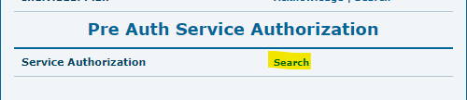

The Service Auth Search allows ﬁltering by entering an individual, date range, or a status, or you can simply click Search, in the bottom right corner, to search all.
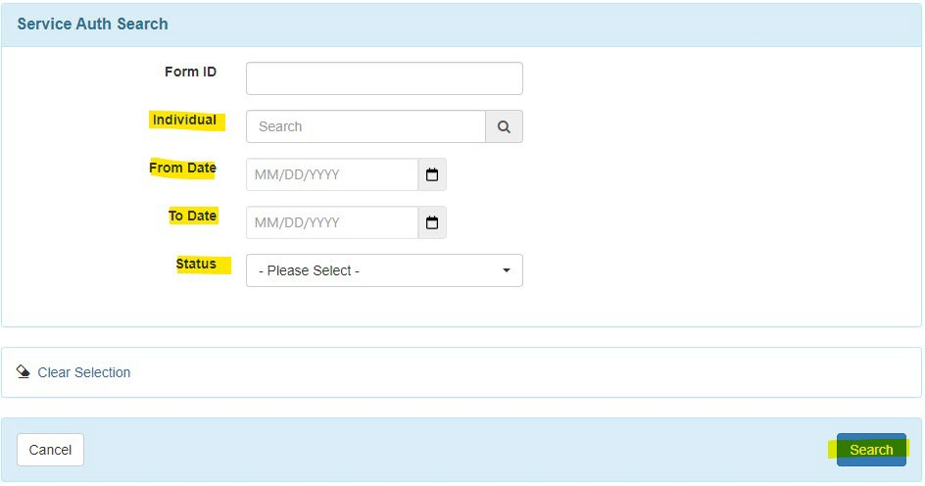
Next, you can open a Service Authorization by selecting a speciﬁc row.
Note: You can ﬁlter this list by typing in the ‘Filter’ box, and can sort by clicking a column heading
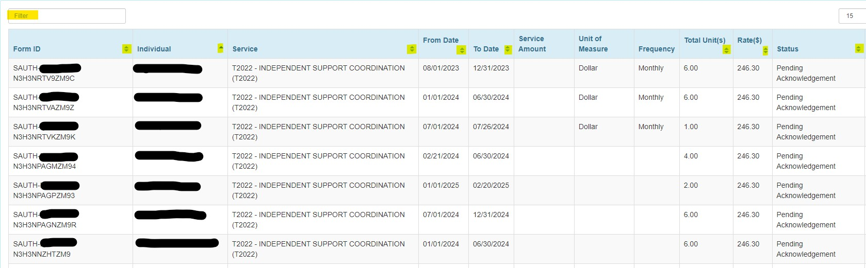

It is the provider’s responsibility to verify all service information prior to acknowledgement. If any information is incorrect, it must be corrected in the PCSP, and re-approved by DDA Plans Review before acknowledging and moving forward.
Most ﬁelds will be auto populated, the one exception being the Program (Site) in certain scenarios (see note below). For this example, the individual was only enrolled in one Program, so Program (Site) ﬁeld auto populated, and no action was needed.
If the information is correct, you can proceed to Acknowledge at the bottom of the page. Every Service Auth must be Acknowledged in order to bill for the approved timespan.
Note on Program (Site): If an individual is enrolled in more than one billing Program, the correct Program (Site) under Billing Service Authorization will need to be selected prior to acknowledgement. If there is nothing to select, then the individual needs to be enrolled in a Program ﬁrst.
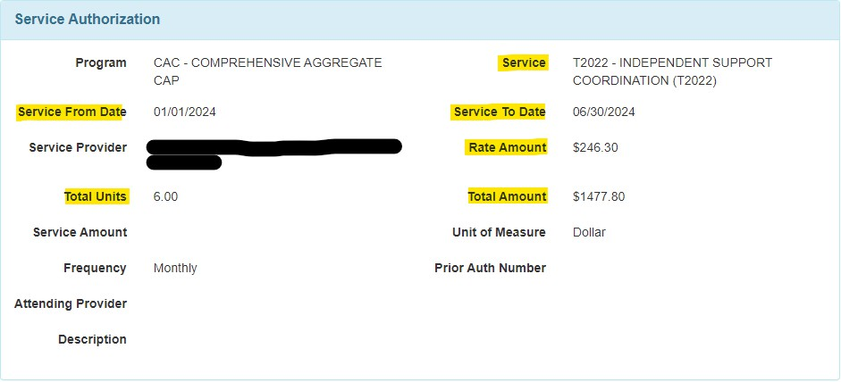
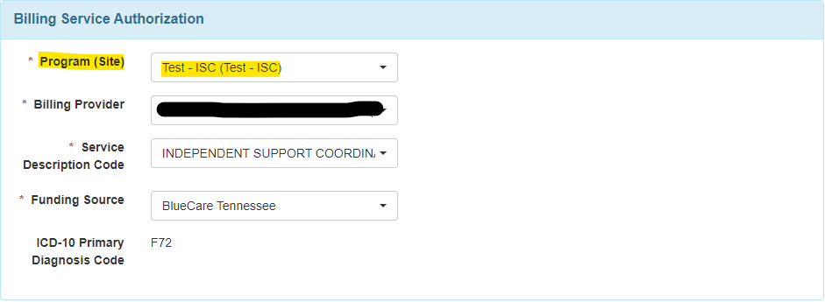

Step 2: Entering Billing Data
All ISC services are documented in the Therap Attendance module, via Daily Attendance.
From the ‘Billing’ tab, navigate to the Attendance module, and select either New or Search.
Note: ‘New’ allows one speciﬁc day to be entered, where ‘Search’ allows a range of up to one month,
within the same month.
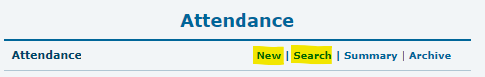

After selecting an option, enter the following on the Attendance Data New/Search Screen:
- The date (or date range) to submit your billing data.
- The Attendance Type: Daily Attendance.
- Service Description (Code): The ISC service you are entering billing for.
- Program (Site): The program you tied to the Service Auths in the previous step.
- *Optional* Individual: To enter one individual’s data.
If the ‘Individual’ ﬁeld is left blank, all individuals within the above parameters will be displayed, if they have an Acknowledged Service Auth.

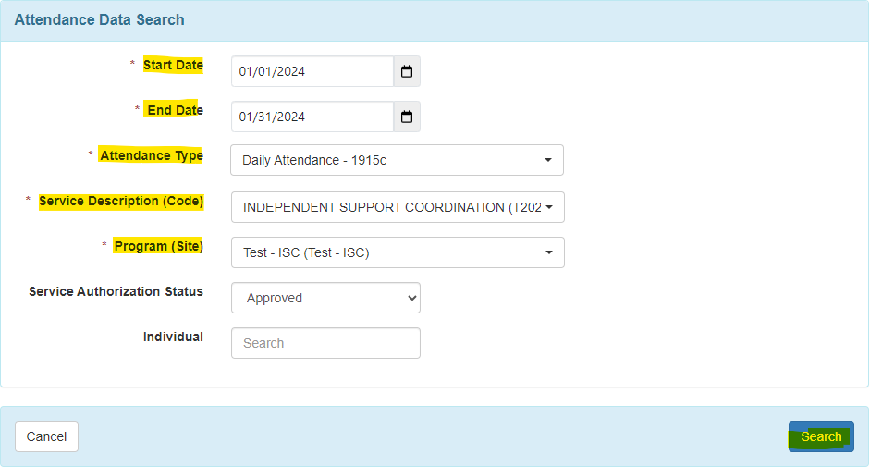

After searching, an Attendance grid will display for the day(s) selected, and individuals displayed.
To enter new billing data, select the Input tab, and change the Attendance Options to Present (P) – Billable.
You can the select a billable day for one or multiple individuals by clicking the checkboxes under the desired day. Or you can select one day for ALL individuals by checking the box at the top of the desired date. After picking the individuals/dates, click Submit New in the bottom right corner.
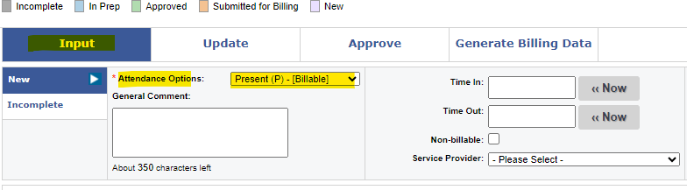
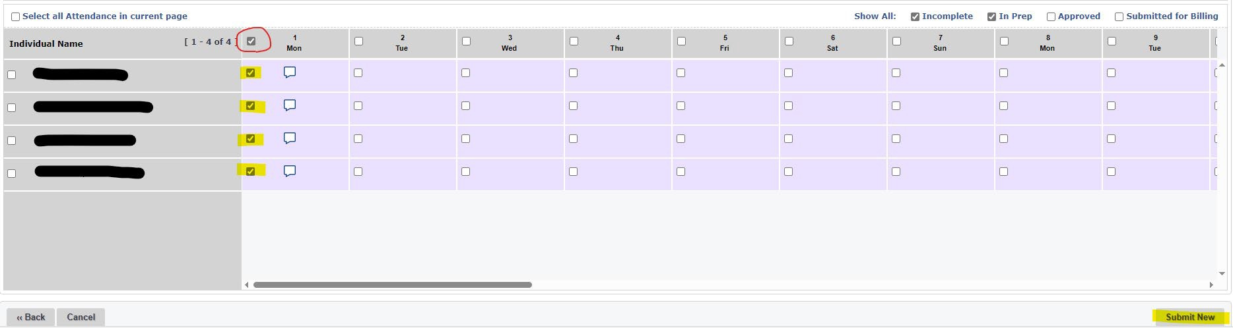

Once Submitted, the Attendance grid will update to reﬂect the status of Present.
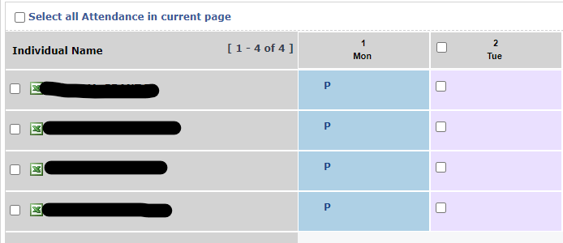

The next step is to approve the Attendance submitted. If all is correct, select the Approve tab from within the same page, select all items, and click Approve in the bottom right corner.
Note: If something needs to be changed or deleted, prior to approving, the status can be modiﬁed or deleted from the Update tab.
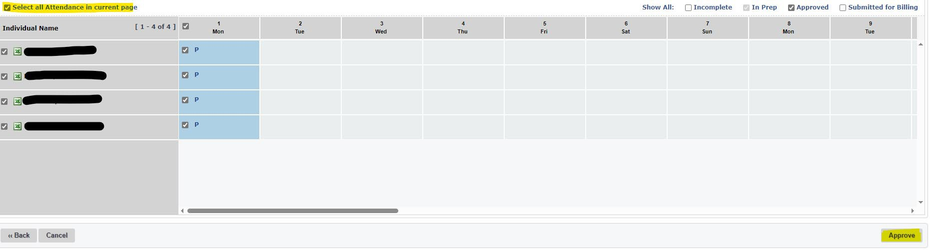

Once Approved, the Attendance grid will update to reﬂect the status of Approved.
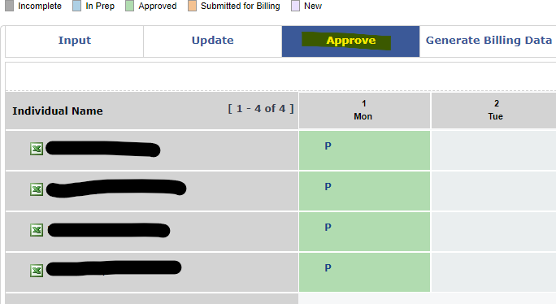

The ﬁnal step is to Generate Billing Data, to turn the Attendance info into billable units. If all is ready, select the Generate Billing Data tab from within the same page, select all items, and click Generate Billing Data in the bottom right corner.
Note: If something needs to be changed or deleted, prior to Generating Billing Data, the status can still be modiﬁed or deleted from the Update tab.

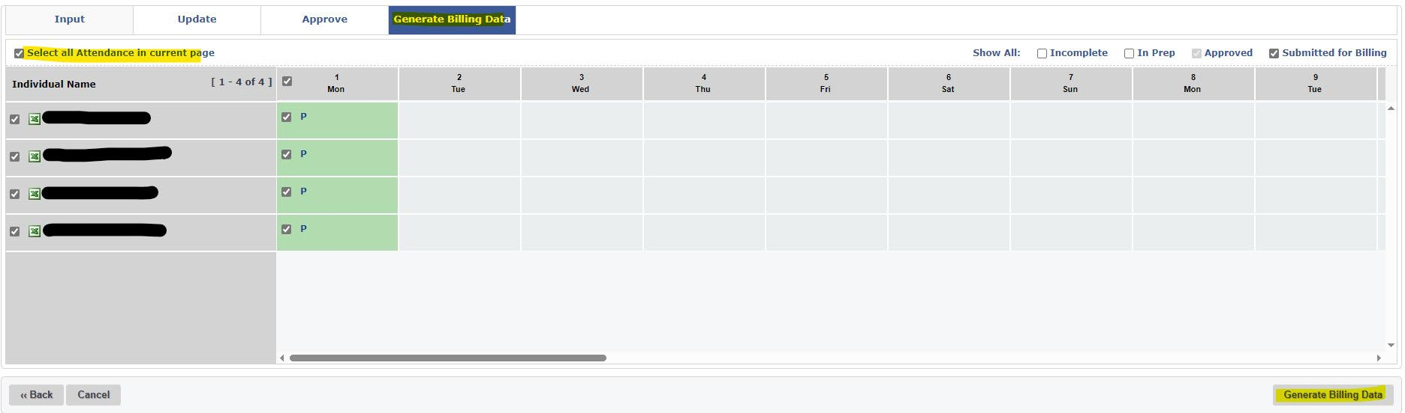

After Generating Billing Data, a popup window will display with what was generated for each person and each day. A green check mark means it was successful. A red x indicates something was unsuccessful, and there will be a description of the issue to be resolved.
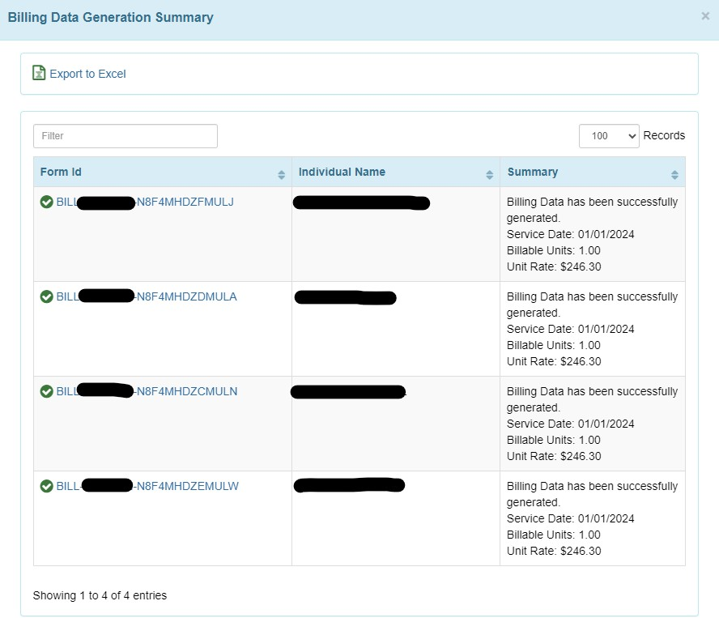

Days that have billing generated will be highlighted in orange. Attendance entry is now complete for these days.
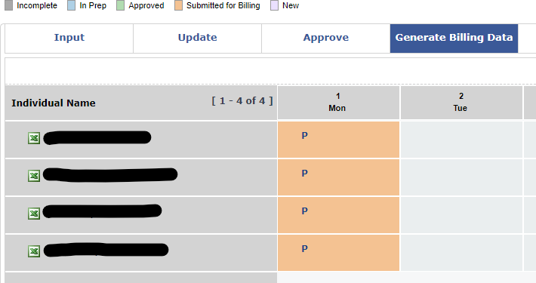

Step 3: Generating (Institutional) Claims
Once Billing Data has been generated, the next step is to generate Institutional claim(s).
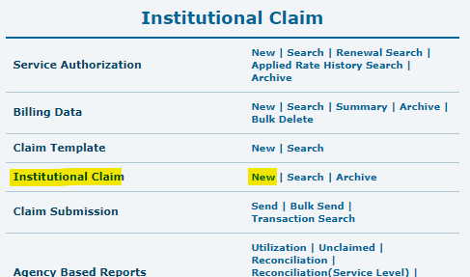
From the ‘Billing’ tab, navigate to the Institutional Claim section and select New next to Institutional Claim

From the New Institutional Claim Generator screen, select the appropriate ISC service to create a claim (one service at a time), and the date range (must be within the same month), then click Next.
Note: It is recommended to leave the Adjust Billing Data Unit box checked when generating claims.
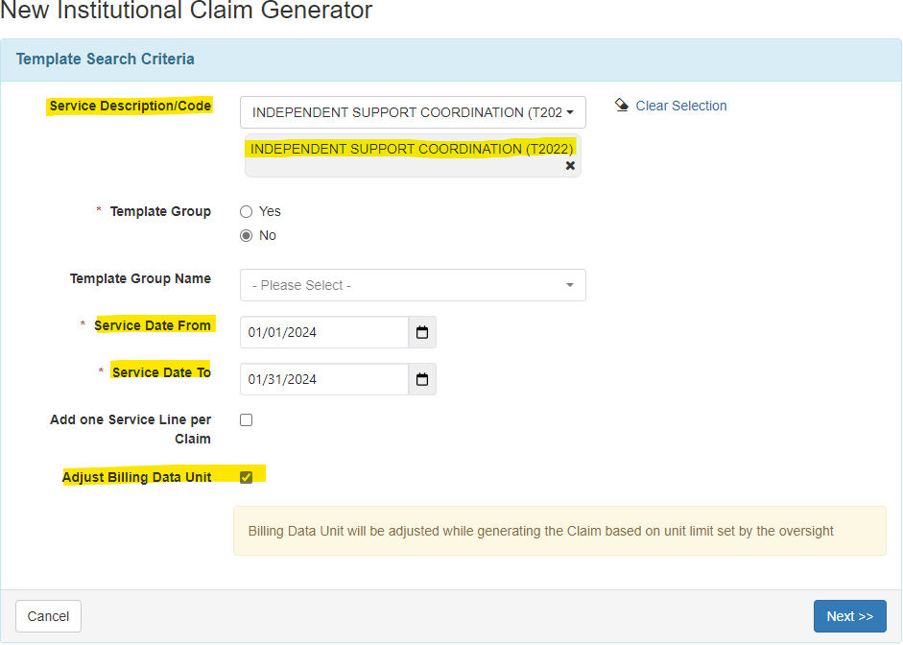

After selecting Next, all eligible billing data will display below. Select the individuals to create claims for, or select all, and click Generate Claims.
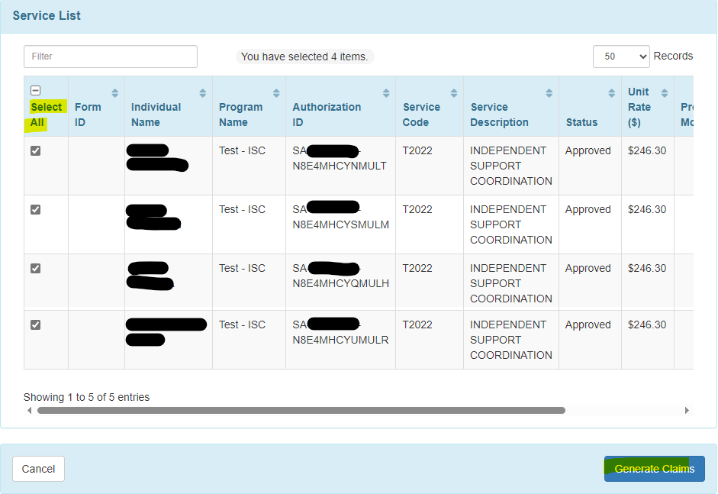

After Generating Claims, a summary report will be provided for each claim. A green check mark means it was successful. A red x indicates something was unsuccessful, and there will be a description of the issue to be resolved.
Generating Claims sets the status to ‘Billable’ in Therap.
If you need to generate claims for additional ISC services, click Back to Claim Generator at the bottom of the screen and repeat the same steps. Otherwise proceed to step 4.
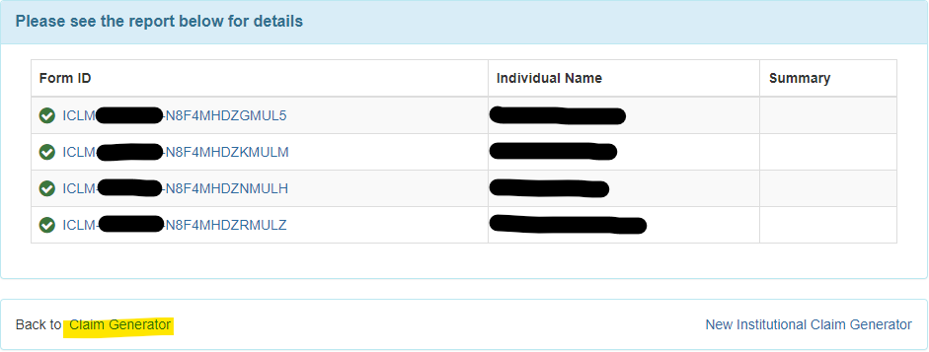

Step 4: Claim Submission
Once claims have been generated, the ﬁnal step is to Send the claims to the MCOs or the State for adjudication and payment.
From the ‘Billing’ tab, navigate to the Institutional Claim section and select Send or Bulk Send next to Claim Submission. For this example, we are using the Send option.
Note: The Send option allows providers to select individual claims, per payor, and send up to 100 per transaction. The Bulk Send option will send every created claim, per payor, no selection necessary.

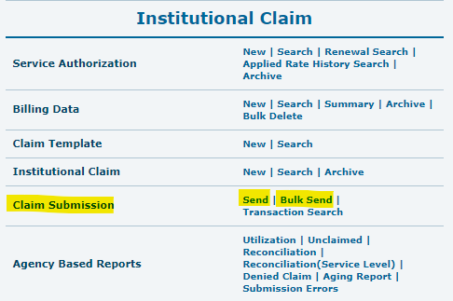

From the Search Claims to Send screen, there are multiple parameters that can be set, but the only required ﬁeld is the Payer. Each payer’s claims must be sent separately.
1915c waiver ISC services will be sent to: BCBST, United HealthCare, and Wellpoint
State Funded and KBB ISC services will be sent to: TN DIDD State Funded
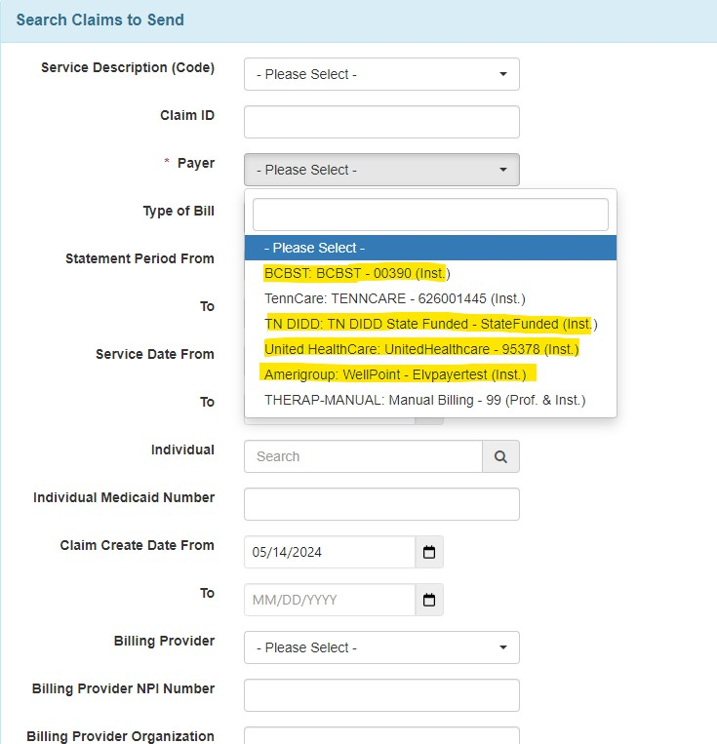

After selecting a payer and picking a date range to search (Therap defaults to a Claim Create Date From of 31 days prior), any available claims to send will be displayed. Select the claims to send and click Send Claim in the bottom right corner. A ‘Successful’ message will display if sent to the MCO/State successfully.
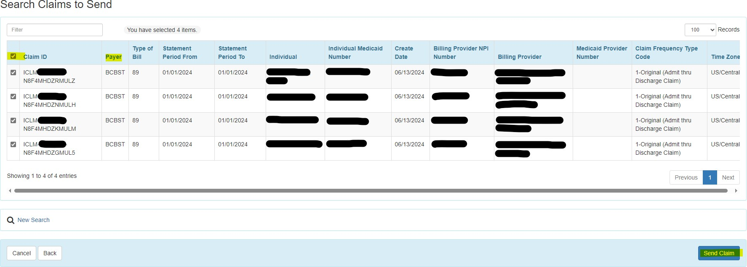

Repeat the above steps to send claims to the other MCOs or State. This completes the claim submission
process.
Once a claim is Sent, the status will update to “Queued” in Therap.
Therap will automatically pick up “Queued” claims on certain days/times and send to the appropriate payer. The claim status will be updated to “Sent” when this occurs.
Once a claim has been adjudicated by the payer, it will return a status of Paid, Partially Paid, or Denied in
Therap.

