Budget Narrative Template

All applicants must submit a budget narrative proposing how funds will be expended. The budget worksheet will be completed in SmartSimple. In SmartSimple click on the "Budget Sheet" button.

The first table in the worksheet, Budget Details, will auto-populate based on input from the tables below: Salaries and Wages, Professional Fees, Supplies, Telephone, Postage and Shipping, Equipment Rental and Maintenance, Printing and Publications (less than $5,000}, Capital Purchases, Other Non - Personnel, Employee Benefits & Payroll Taxes, Administrative Expenses, and Specific Assistance to Individuals.

If there are expenses relating to a table specific to each budget category, you may add as many rows as needed by clicking the"+" button below the table. If you need to remove a row, you may click the "X" button at the end of the row.

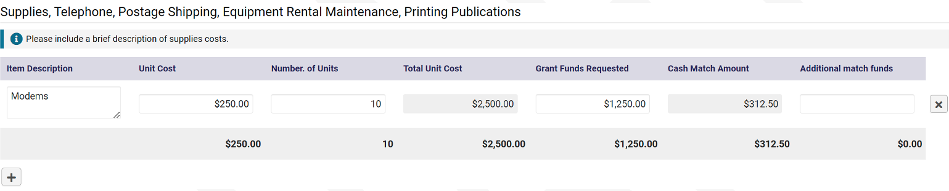

Note that the Total Unit Cost column and the Cash Match Amount columns will automatically populate based on input from the other columns.

Once you have completed filling out the budget worksheet, press the save button at the bottom of the worksheet. If you need to restart the worksheet for any reason, you may also quickly clear the worksheet by pressing the "Clear" button as shown here.

The following examples are references for each budget category of the budget worksheet. Please note that costs are to be broken down by line item and the description should include methods used to calculate the costs and any additional information to describe the costs. Below is an example of what the detailed budget will look like in SmartSimple.

Line-Item Description |  | No. of Units | Total Unit Cost | Grant Funds Requested | Cash Match Amount | Additional Match Funds
Ex. Program Director |  | 120 hours | $6,000 | X | X | X

Example of a sufficient budget narrative detailed description for the line item above:
- Program Director ($6,000): 120 hours of a program director's time at $50 each. A program director is necessary for project coordination, oversight, and strategic planning. The purchase price is based on the average market cost for this position.
- Note: "X" indicates fields that will need to be filled in by the applicant-the fields filled in above are for example purposes only.

Line-Item Unit Cost No. of Units Total Unit Grant Funds Cash Match Additional
Description |  |  | Cost | Requested | Amount | Match Funds
Ex. Equity Assessment Planning | $1,000 | 1 | $1,000 | X | X | X
Final Total

Example of a sufficient budget narrative detailed description for the line item above:

- Equity assessment planning ($1,000): An equity assessment needs to be conducted for the project. To accurately complete the assessment, there needs to be a plan on how necessary data will be gathered and submitted. The $1,000 will cover the costs of data-gathering and the submission of the assessment. Costs are based on average costs for assessment planning.
- Note: "X" indicates fields that will need to be filled in by the applicant-the fields filled in above are for example purposes only.

Line-Item Unit Cost No. of Units Total Unit Grant Funds Cash Match Additional
Description |  |  | Cost | Requested | Amount | Match Funds
Ex. Modems | $250 | 10 | $2,500 | X | X | X
Final Total

Example of a sufficient budget narrative detailed description for the line item above:

- Modems ($2,500): 10 consumer-grade modems at $250 each. Modems are necessary for communication between ISP and devices. Purchase price is based on standard cost for this equipment type.
- Note: "X" indicates fields that will need to be filled in by the applicant-the fields filled in above are for example purposes only.

Line-Item Unit Cost No. of Units Total Unit Grant Funds Cash Match Additional
Description |  |  | Cost | Requested | Amount | Match Funds
Ex. Computer Desktop | $500 | 10 | $5,000 | X | X | X
Final Total

Example of a sufficient budget narrative detailed description for the line item above:
- Computer Desk Tops ($5,000): 10 desktops at $500 each. Desktops for our library are necessary digital skills training course. Purchase price is based on standard cost for this equipment type.
- Note: "X" indicates fields that will need to be filled in by the applicant-the fields filled in above are for example purposes only.

Line-Item Unit Cost No. of Units Total Unit Grant Funds Cash Match Additional
Description |  |  | Cost | Requested | Amount | Match Funds
Ex. Building Permit | $5,000 | 1 | $5,000 | X | X | X
Final Total

Example of a sufficient budget narrative detailed description for the line item above:

- Building Permit ($5,000): Permit is necessary for the construction of infrastructure. Cost is based on industry standards for building permits for the area.
- Note: "X" indicates fields that will need to be filled in by the applicant-the fields filled in above are for example purposes only.

Line-Item Unit Cost No. of Units Total Unit Grant Funds Cash Match Additional
Description |  |  | Cost | Requested | Amount | Match Funds
Ex. Health Insurance | $3,400 | 5 | X | X | X | X
Final Total

Example of a sufficient budget narrative detailed description for the line item above:

- Health Insurance: Employees will require health insurance for the project's life. On average, health insurance costs $3,400 per employee. The total cost for five employees would be $3,400 x 5, totaling $17,000.
- Note: "X" indicates fields that will need to be filled in by the applicant-the fields filled in above are for example purposes only.

Line-Item Unit Cost No. of Units Total Unit Grant Funds Cash Match Additional
Description |  |  | Cost | Requested | Amount | Match Funds
Ex. Legal fees associated with sub- recipient contracts/ Accounting fees associated.  with Audit | $3,000 | 4 | $12,000 | X | X | X
Final Total

Example of a sufficient budget narrative detailed description for the line item above:

- Legal Fees/Accounting Fees: Recipients will be audited annually for the life of the project. An audit costs $3,000; the anticipated life of the project is four years. The total cost of accounting fees associated with auditing would be $3,000 x 4, which totals to $12,000.
- Note: "X" indicates fields that will need to be filled in by the applicant-the fields filled in above are for example purposes only

Line-Item Unit Cost No. of Units Total Unit Grant Funds Cash Match Additional
Description |  |  | Cost | Requested | Amount | Match Funds
Ex.  Transportation | $200 | 50 | $10,000 | X | X | X
Final Total

Example of a sufficient budget narrative detailed description for the line item above:
- Transportation ($10,000): This will fund 50 We Go cards (1 for each of our planned 50 program participants) at $200 each. $200 for each card to enable round trips for our twice-a-week programming for our 6 month-long training program (estimated 24 weeks). (24 weeks) * (2 days/ week)* ($4 daily fare cap/ 1 day)=
$192 for each card. Rounded up to $200 for each card.
- Note: "X" indicates fields that will need to be filled in by the applicant-the fields filled in above are for example purposes only.

