Public management & administration
Government and Public Administration
Level Four
Level One
Level Two
Level Three
About the Program of Study
The Public Management & Administration program of study is designed for students who are planning careers in service to the public and/or political science. Course content covers such topics as philosophies of constitutional government, government provision and administration of services, ethical and legal issues faced by public officials, government funding sources, laws and regulations, budgeting practices, and community planning. Upon completion of this program of study, students will be prepared for a wide range of careers in the public and non-profit sectors, or for advanced study in business, public affairs, or public administration at the postsecondary level. City and county government officials, commissioners, and city planners are viable career options in this program of study.

This is not an exhaustive list of all of the opportunities available in Tennessee.
2024 Projected Employment for Public Management & Administration Related Occupations in Tennessee
Occupations | Total Percent Change | Total Annual Av. Openings
Court Clerk | 11.6% | 70
Social & Community Service Managers | 13.9% | 90

CAREER OPPORTUNITIES
Of the jobs in the Bureau of Labor Statistics’ Standard Occupational Classification System, one million are assigned to the Government and Public Administration cluster. Median annual wages for these occupations ranged from $20,620 for legislators to $57,060 for urban planners. Occupations in this cluster typically require a bachelor’s degree for entry, but employment opportunities range from a high school diploma or equivalent and short-term on-the-job training for transportation security screeners to a master’s degree for urban and regional planners.
For more information, contact:
High School
District/County Name
CTE Director: Name
Email
Instructor: Name
Email
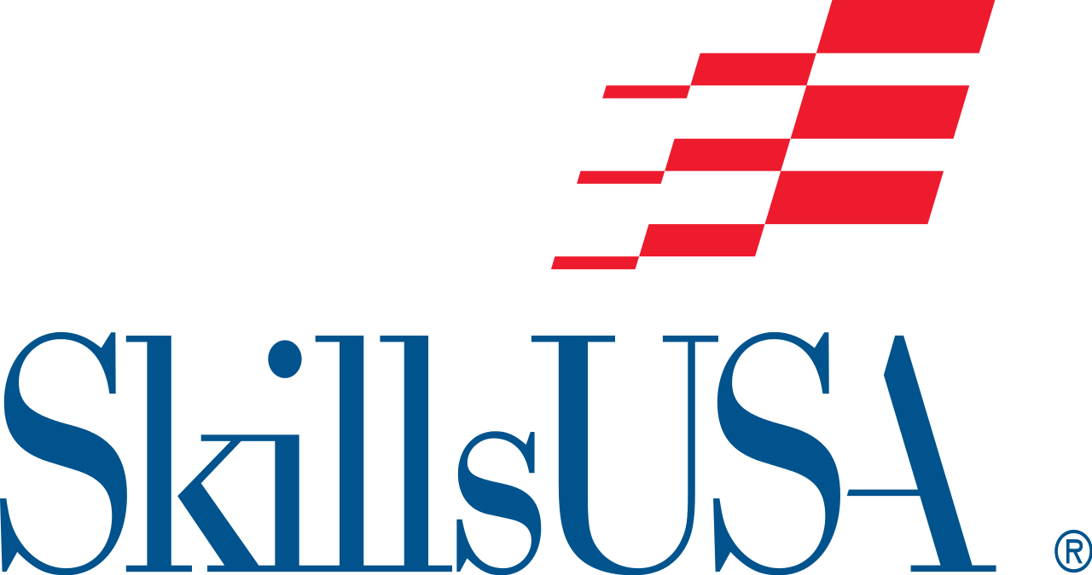 Students in this program of study will be eligible to join SkillsUSA. In addition to school events, students will be able to compete at the regional, state, and national level. SkillsUSA improves the quality of America’s skilled workforce through a structured program of citizenship, leadership, employability, technical, and professional skills training. SkillsUSA enhances the lives and careers of students, instructors, and industry representatives as they strive to be champions at work. See your manufacturing teacher to learn more about SkillsUSA or visit http://www.skillsusa.org.

Opening and Closing Ceremonies
A teamwork and oral presentation contest evaluates teams’ understanding of the symbolic representation of the colors and assembled parts of the SkillsUSA emblem. Each team includes seven registered members in the roles of president, vice president, parliamentarian, reporter, treasurer, secretary, and historian. The contest is a demonstration of the SkillsUSA Opening and Closing Ceremonies conducted according to the script and description as printed in the SkillsUSA Championships Technical Standards.

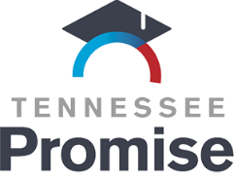
POSTSECONDARY OPTIONS
Have you registered for the Tennessee Promise? Seniors enrolled in this program have the chance to attend a two-year program at a Tennessee College of Applied Technology (TCAT), community college, or some two-year university programs for free! To learn more, please see your school counselor or visit http://www.tennesseepromise.gov.

Annual Average Openings for Social & Community Service Managers in Tennessee (2014-2024)
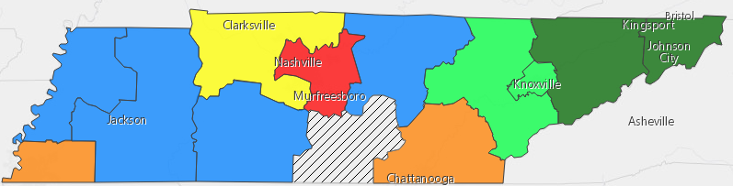
Postsecondary Offerings Aligned to this Program of Study
School | Degree Program
Chattanooga, Motlow, Pellissippi, and Roane State Community Colleges | A.S. Political Science
ETSU, UTK, MTSU, APSU | A.S. Public & Government Services
For more college and career planning resources, visit http://collegefortn.org.

