FIRE management Services

Law, Public Safety, Corrections, and Security

*Level Four*

*Level Three*

*Level One*

*Level Two*

**Dual Credit/Dual Enrollment/Industry Certification options include:**

* Fire Science 1 & 2 @Vol State
* Firefighter Certification

**Fire Management Services**

In this program of study, students acquire the skills and knowledge needed to pursue the Firefighter 1 certification. Those students who complete this program of study will be prepared, after graduation, to further their instruction at a training facility. Upon completion of this course, proficient students will be able to correctly demonstrate skills associated with ventilation, water supply, fire hose, and fire streams in a non-live situation, and safety with hazardous materials. Standards in this course are aligned with the National Fire and Emergency Services Higher Education (FESHE) model.

This is not an exhaustive list of all of the opportunities available in Tennessee.

**Fire Fighting Related Occupations with Positive Growth In Tennessee (2014-2024)**

|  |  |  |
| --- | --- | --- |
| Occupations | Total Percent Change | Total Annual Av. Openings |
| Fire Fighter | 11.5% | 190 |
| Forest Fire Inspector | 11.9% | 10 |

**Career Opportunities**

With 5,840 firefighters projected to be employed in Tennessee by 2024, and a total employment change of 450, *jobs4tn.gov* lists firefighting as having a bright future. Jobs were distributed across the state in 2014 with the highest concentrations in the metropolitan areas. With current supply and demand being such that the total supply of fire science workers is 35 and demand is 274, the employment outlook is very good.

**2024 Projected Employment for Firefighters**

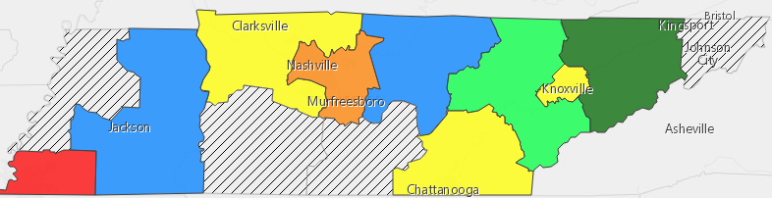





Students in this program of study will be eligible to join SkillsUSA. In addition to school events, students will be able to compete at the regional, state, and national level. SkillsUSA improves the quality of America’s skilled workforce through a structured program of citizenship, leadership, employability, technical, and professional skills training. SkillsUSA enhances the lives and careers of students, instructors, and industry representatives as they strive to be champions at work. See your manufacturing teacher to learn more about SkillsUSA or visit [http://www.skillsusa.org](http://www.skillsusa.org/)

The Firefighting contest evaluates the contestant’s preparation for firefighting careers through hands-on skill demonstrations and both written and oral presentations. Areas tested include safety; breathing apparatus; fire streams; ladders, ropes, knots and hoses; fire control; ventilations; emergency medical care and rescue; and protecting fire cause evidence. Contestants are evaluated using standards established by the National Fire Protection Association (NFPA).

.



**POSTSECONDARY OPTIONS**

Have you registered for the Tennessee Promise? Seniors enrolled in this program have the chance to attend a two-year program at a Tennessee College of Applied Technology (TCAT), community college, or some 2-year university programs for free! To learn more, please see your school counselor or visit <http://www.tennesseepromise.gov>.

|  |  |
| --- | --- |
| Postsecondary Offerings Aligned to this Program of Study | |
| School | **Degree Program** |
| Chattanooga and Volunteer State Community Colleges | Fire Science Technology |
| Bethel University | B.S. Emergency Services Management |
| For more college and career planning resources, visit http://collegefortn.org. | |

**For more information, contact:**

**School: High School**

**District/County Name**

**CTE Director: Name**

**Email**

**Instructor: Name**

**Email**