Pre-Law

Law, Public Safety, Corrections, & Security

*Level Four*

*Level Three*

*Level Two*

*Level One*

**ABOUT THE PROGRAM OF STUDY**

The *Pre-Law* program of study is designed for students interested in legal services careers. In this program of study, course content covers a wide range of knowledge and skills related to the American legal system including basic principles common to business, personal, criminal and civil law. Other topics include legal careers, the justice system, juvenile justice, immigration law, ethics, and professionalism. Upon completion of this POS, students will be prepared to pursue advanced study in law and criminal justice.

|  |
| --- |
|  |

|  |
| --- |
|  |
|  |

|  |
| --- |
|  |

**Dual Credit/ Dual Enrollment options include:**

Course A

Course B

This is not an exhaustive list of all of the opportunities available in Tennessee.

**2024 Projections for Legal and Correction Related Occupations**

|  |  |  |
| --- | --- | --- |
| Occupations | Total Percent Change | Total Annual Av. Openings |
| Court Clerk | 11.6% | 70 |
| Paralegal | 20% | 170 |
| Lawyer | 8.8% | 200 |

**CAREER OPPORTUNITIES**

The outlook for lawyers is average in most of the Southern states. This is not the case for Paralegals and Legal Assistants. They will see an increase by 49 percent with a job market of approximately 7,170 jobs in 2024 in TN with a median salary of $47,900. Currently there are 83 openings for paralegals in Tennessee. Other careers in Legal Services can include court reporters, municipal clerks, license clerks, and legal secretaries. These careers are lower skill level, but students can enter these careers while preparing for higher-level occupations.

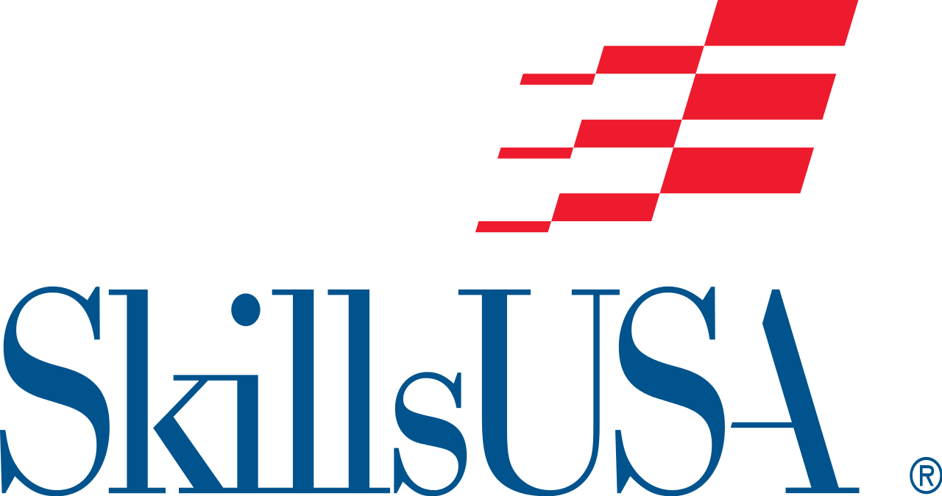 Students in this program of study will be eligible to join SkillsUSA. In addition to school events, students will be able to compete at the regional, state, and national level. SkillsUSA improves the quality of America’s skilled workforce through a structured program of citizenship, leadership, employability, technical, and professional skills training. SkillsUSA enhances the lives and careers of students, instructors, and industry representatives as they strive to be champions at work. See your manufacturing teacher to learn more about SkillsUSA or visit [http://www.skillsusa.org](http://www.skillsusa.org/).

**American Spirit**

A notebook contest documents SkillsUSA chapters’ community service, patriotism and citizenship, and promotion of career and technical education projects that demonstrate a belief in the American way of life and the purposes of SkillsUSA.

**Opening and Closing Ceremonies**

A teamwork and oral presentation contest evaluates teams’ understanding of the symbolic representation of the colors and assembled parts of the SkillsUSA emblem. Each team includes seven registered members in the roles of president, vice president, parliamentarian, reporter, treasurer, secretary, and historian. The contest is a demonstration of the SkillsUSA Opening and Closing Ceremonies conducted according to the script and description as printed in the SkillsUSA Championships Technical Standards.

**2024 Projected Employment for Paralegal and Legal Assistants**

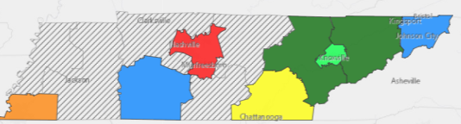



**For more information, contact:**

**High School**

**District/County Name**

**CTE Director: Name**

**Email**

**Instructor: Name**

**Email**

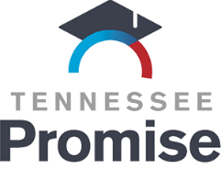

**POSTSECONDARY OPTIONS**

Have you registered for the Tennessee Promise? Seniors enrolled in this program have the chance to attend a two year program at a Tennessee College of Applied Technology (TCAT), community college, or some two year university programs for free! To learn more, please see your school counselor or visit <http://www.tennesseepromise.gov>.

|  |  |
| --- | --- |
| Postsecondary Offerings Aligned to this Program of Study | |
| School | **Degree Program** |
| Nashville, Chattanooga, Southwest, Volunteer,& Roane State Community Colleges | A.A.S. Paralegal Studies |
| Tennessee State, Tennessee Technological, & Middle Tennessee State Universities | B.S. Pre-law |
| For more college and career planning resources, visit http://collegefortn.org. | |