Claim Entry in TMAC

Completing a Claim – Community Eligibility Provision (CEP)
The following information describes the process of entering monthly data to claim reimbursable meals for lunch, breakfast, and afterschool snacks for a CEP school.
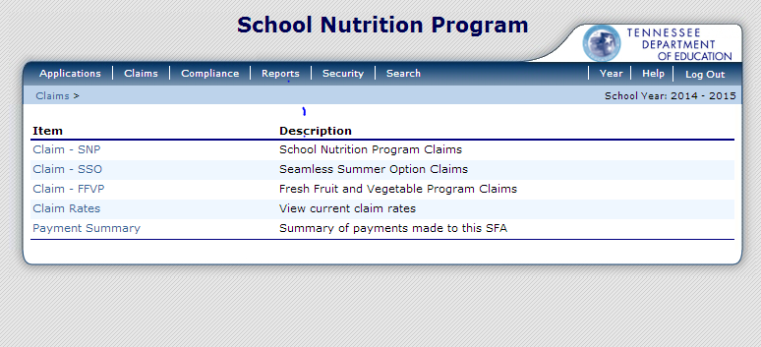
The above screenshot appears when a user logs into “Tennessee: Meals, Accounting, and Claiming (TMAC)”. From the toolbar, select Claims. Then, from the list provided, select Claim-SNP in order to complete the breakfast, lunch, and afterschool snack claims for a month.

Select the month to start the claim. Only the month(s) available for the claim submission will be highlighted.
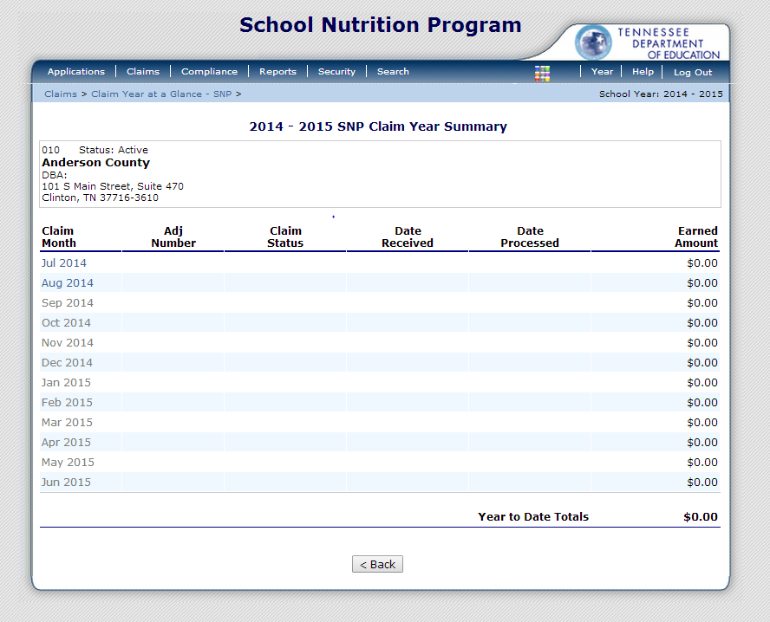

Once the month is selected, the following screen will appear. Click Add Original Claim to start filing the claim.
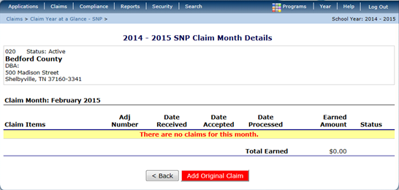

If returning to a claim, the following screen will appear.
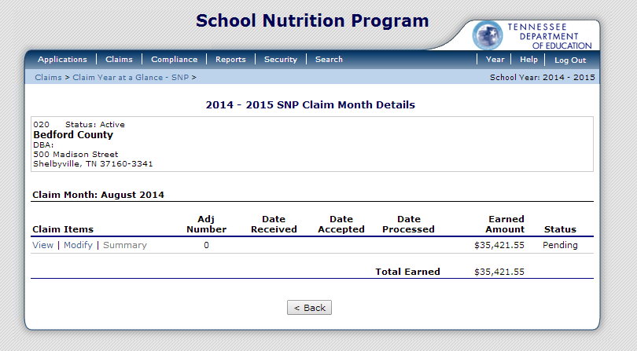
To make adjustments to the initial claim prior to submitting, select Modify.

Once Modify has been selected, the following screen will appear.

The fields below highlighted with gray are pre-populated (G1, G2, and G6), and the values in these fields may not be changed.
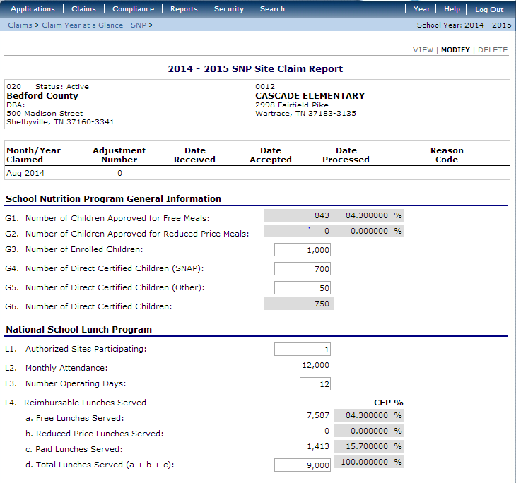
- (G3) Number of Enrolled Children: Enter the highest attendance day for the month.
- (G4) Number of Direct Certified Children (SNAP): Enter an accurate count of the number of children that are directly certified from the Direct Certified (DC) list for SNAP only.
- (G5) Number of Direct Certified Children (Other): Enter the number of children directly certified by other sources such as TANF, Homeless, Runaway, and Migrant.
- (L1) Authorized Sites Participating: Enter one for CEP schools.
- (L2) Monthly Attendance: For CEP schools, this value will be entered automatically based on the number of operating days and the number of enrolled children.
- (L3) Number of Operating Days: Enter the number of operating days for lunch and breakfast separately. It is possible that the number of operating days for lunch and the number of operating days for breakfast could be different due to weather or half-day attendance.
- (L4) Reimbursable Lunches Served: In a CEP school, a, b, and c will be entered automatically. Enter the total meal counts for lunch in L4, d. The number of free and paid lunches will be determined by the CEP percentages automatically.

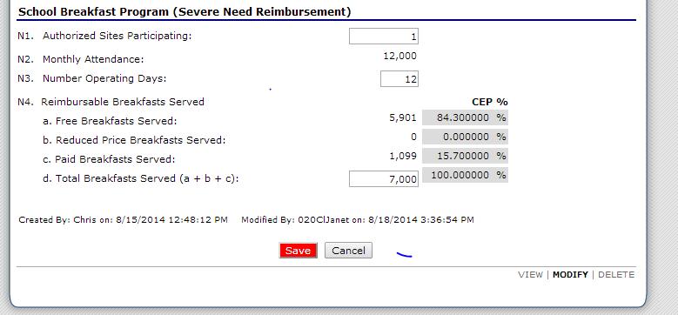

- (N1) Authorized Sites Participating: Enter one for CEP schools.
- (N2) Monthly Attendance: For CEP schools, this value will be entered automatically based on the number of operating days and the number of enrolled children.
- (N3) Number of Operating Days: Enter the number of operating days for lunch and breakfast separately. It is possible that the number of operating days for lunch and the number of operating days for breakfast could be different due to weather or half-day attendance.
- (N4) Reimbursable Breakfasts Served: In a CEP school, a, b, and c will be entered automatically. Enter the total meal counts for breakfast in N4, d. The number of free and paid lunches will be determined by the CEP percentages automatically.

Once all of the information has been entered, click the Save button at the bottom.

Completing a Claim – Non Community Eligibility Provision (CEP)
The following information describes the process of entering monthly data to claim reimbursable meals for lunch, breakfast, and afterschool snacks for a non-CEP school/district.

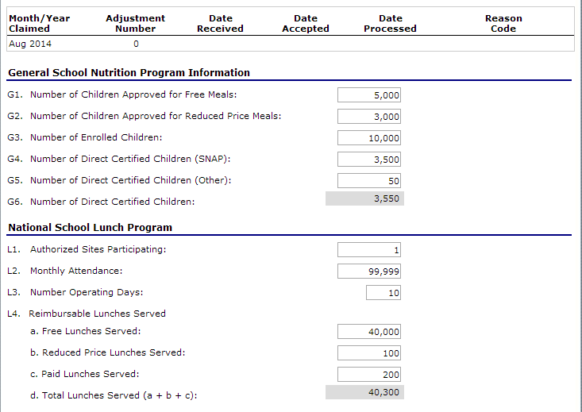
- (G1) Number of Children Approved for Free Meals: Enter the number of children approved for free meals during the claim month.
- (G2) Number of Children Approved for Reduced Price Meals: Enter the number of children approved for reduced meals during the claim month.
- (G3) Number of Enrolled Children: Enter the highest attendance day for the month.
- (G4) Number of Direct Certified Children (SNAP): Enter an accurate count of the number of children that are directly certified from the Direct Certified (DC) list for SNAP only.
- (G5) Number of Direct Certified Children (Other): Enter the number of children directly certified by other sources such as TANF, Homeless, Runaway, and Migrant.
- (L1) Authorized Sites Participating: Enter one if filing the claim by school. Enter the number of sites if filing district-wide.
- (L2) Monthly Attendance: If entering the claim by school site, this value will be entered automatically based on the number of operating days and the number of enrolled children. If entering the claim district-wide, this value will be sum of each site’s total attendance for that month.
- (L3) Number of Operating Days: Enter the number of operating days for lunch and breakfast separately. It is the possible that the number of operating days for lunch and the number of operating days for breakfast could be different due to weather or half-day attendance.
- (L4) Reimbursable Lunches Served:
  - Free Lunches Served: Enter the total free lunch meal counts in L4, a.
  - Reduced Price Lunches Served: Enter the total reduced lunch meal counts in
L4, b.
- Paid Lunches Served: Enter the total paid lunch meal counts in L4, c.
  - Total Lunches Served: The lunch meal counts will total automatically in L4, d.

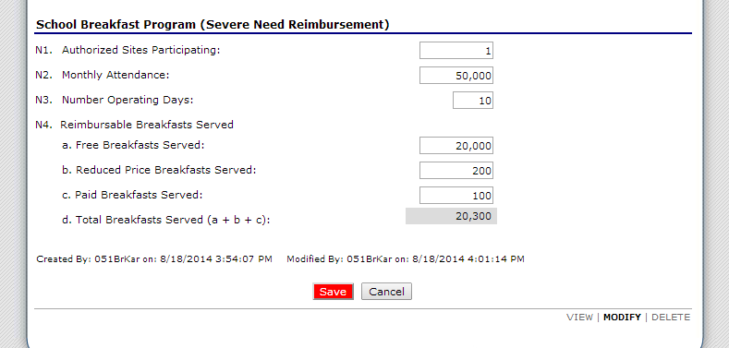
- (N1) Authorized Sites Participating: Enter one if filing the claim by school. Enter the number of sites if filing district-wide.
- (N2) Monthly Attendance: If entering the claim by school site, this value will be entered automatically based on the number of operating days and the number of enrolled children. If entering the claim district-wide, this value will be sum of each site’s total attendance for that month.
- (N3) Number of Operating Days: Enter the number of operating days for breakfast and lunch separately. It is the possible that the number of operating days for lunch and the number of operating days for breakfast could be different due to weather or half-day attendance.
- (N4) Reimbursable Breakfasts Served:
  - Free Breakfasts Served: Enter the total free breakfast meal counts in N4, a.
  - Reduced Price Breakfast Served: Enter the total reduced breakfast meal counts in N4, b.
  - Paid Breakfast Served: Enter the total paid breakfast meal counts in N4, c.
  - Total Breakfasts Served: The breakfast meal counts will total automatically in N4, d.
Once all of the information has been entered, click the Save button at the bottom.

Afterschool Snacks
The following information describes the process of entering monthly data to claim reimbursement for the area eligible afterschool snacks.
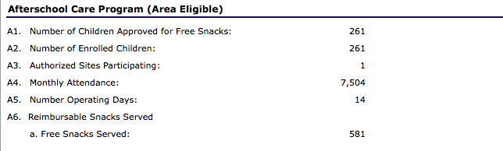
- (A1) Number of Children Approved for Free Snacks: Enter the total number of children approved for free snacks. This number will be equal to the number of enrolled children (A2).
- (A2) Number of Enrolled Children: Enter the total number of enrolled students in the school.
- (A3) Authorized Sites: Enter the total number of sites participating in Afterschool Snacks. This value may differ from the total authorized sites for breakfast or lunch.
- (A4) Monthly Attendance: If entering the claim district-wide, this value will be sum of each site’s total attendance for that month.
- (A5) Number of Operating Days: Enter the total number of operating days eligible for Afterschool Snacks. This value could differ from the total operating days for breakfast or lunch.
- (A6) Reimbursable Snacks Served: Enter the total number of snacks served to students.

The following information describes the process of entering monthly data to claim reimbursment for
non-area eligible afterschool snacks.
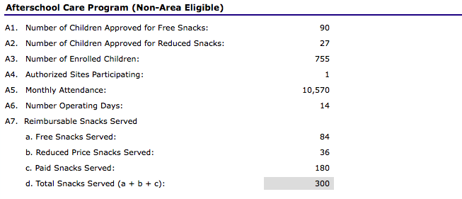

- (A1) Number of Children Approved for Free Snacks: Enter the total number of children approved for free snacks.
- (A2) Number of Children Approved for Reduced Snacks: Enter the total number of children approved for reduced price snacks.
- (A3) Number of Enrolled Children: Enter the total number of enrolled students in the school.
- (A4) Authorized Sites: Enter the total number of sites participating in Afterschool Snacks. This value may differ from the total authorized sites for breakfast or lunch.
- (A5) Monthly Attendance. If entering the claim district-wide, this value will be sum of each site’s total attendance for that month.
- (A6) Number of Operating Days: Enter the total number of operating days eligible for Afterschool Snacks. This value could differ from the total operating days for breakfast or lunch.
- (A7) Reimbursable Snacks Served.
  - Free Snacks Served: Enter the total free snack counts in A7, a.
  - Reduced Price Snacks Served: Enter the total reduced snack counts in A7, b.
  - Paid Snacks Served: Enter the total paid snack counts in A7, c.
  - Total Snacks Served: The snack counts will total automatically in A7, d.

Once all of the information has been entered, click the Save button at the bottom.

If filing a district-wide claim the entry may look like this:
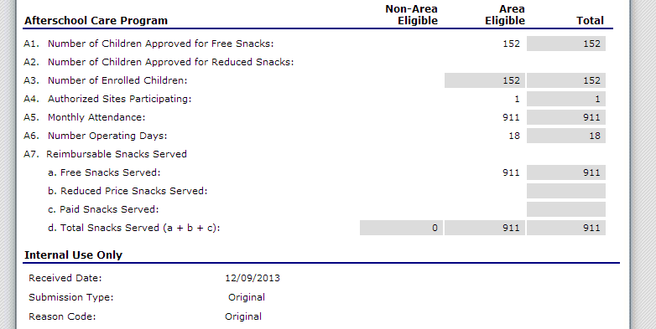

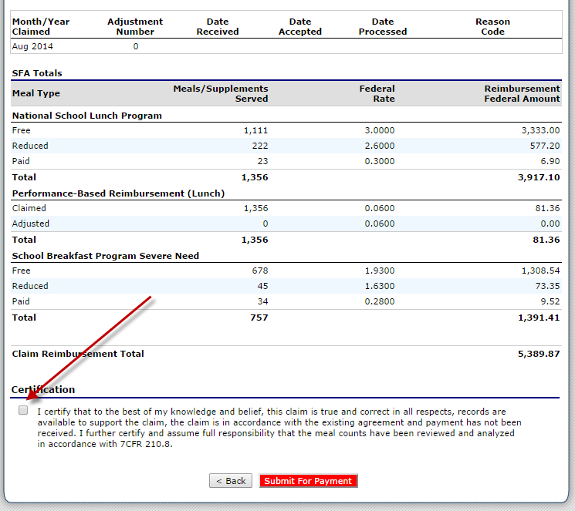
This is the summary screen for the claim. It shows the total dollar amount of reimbursement that will be received based on the values entered for meals served. Check the Certification box, and Submit For Payment.

If the claim is correctly submitted the Claim Status will indicate Accepted.
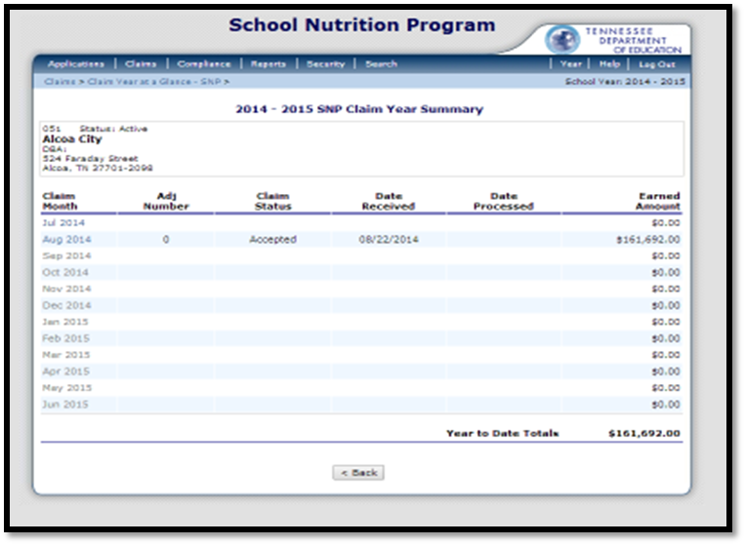

If the Claim Status column indicates as error, the claim cannot be accepted and processed until the error is corrected and resubmitted.

Once the claim has been processed for payment, the Claim Status column will indicate processed.
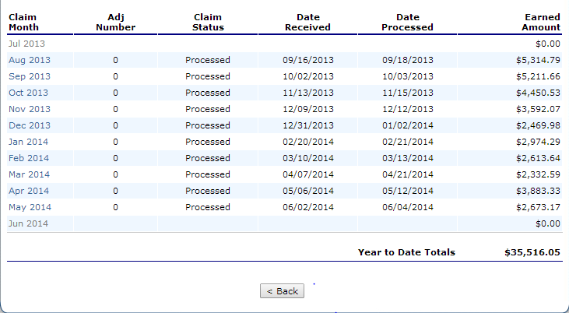

The above screenshot appears when a user logs into “Tennessee: Meals, Accounting, and Claiming (TMAC)”. From the toolbar, select Claims. Then, from the list provided, select Claim-SNP in order to complete the breakfast, lunch, and snack claims for a month.

