FSCM>GENERAL LEDGER>GENERAL REPORTS>TRIAL BALANCE

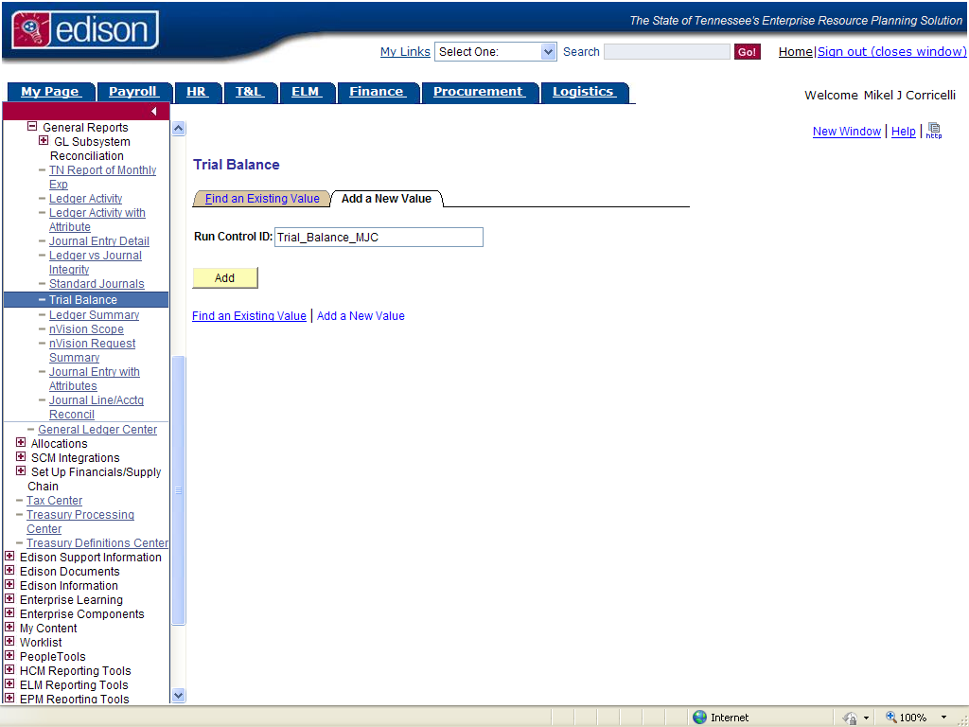
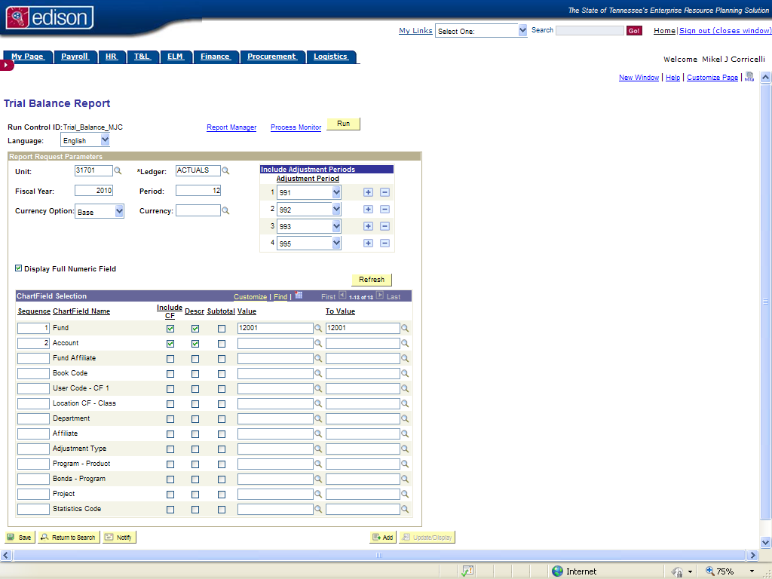
2. Make Chartfield Selections
1. Select Parameters

Unit: Defaults to your BU
Ledger: Defaults to ACTUALS
Fiscal Year: Fiscal year you wish to report on
Period: Enter the period to which you would like to see data
Currency Option: Defaults to Base
Currency: Leave blank
Display Full Numeric Field box should be checked
Adjustment Period: Enter adjustment period(s) to include in report

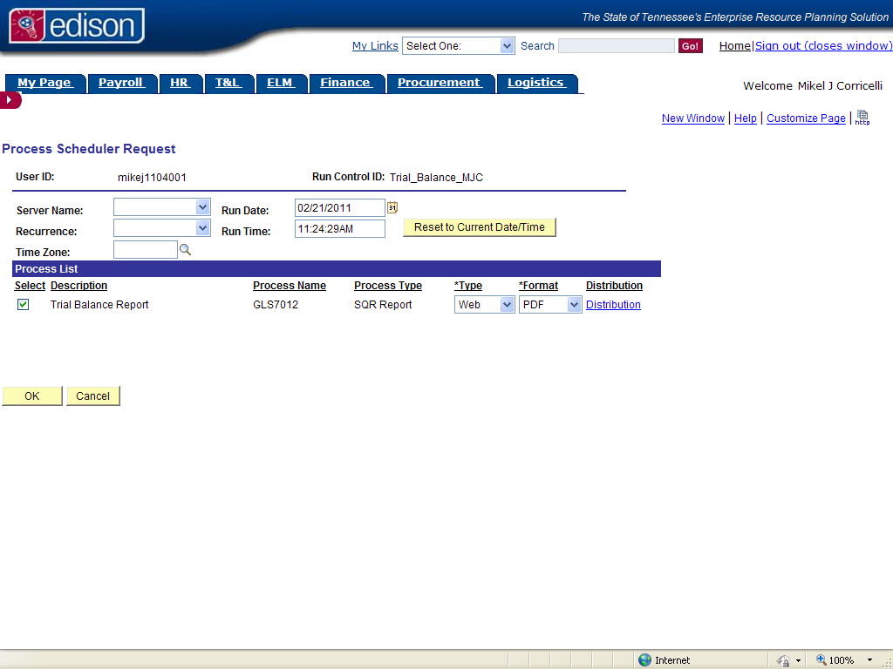
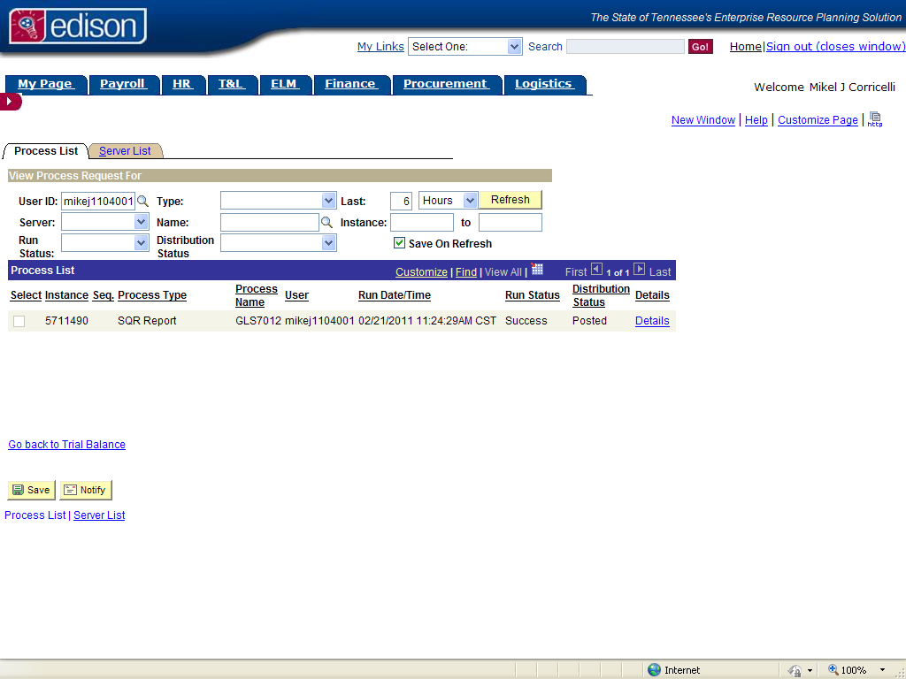
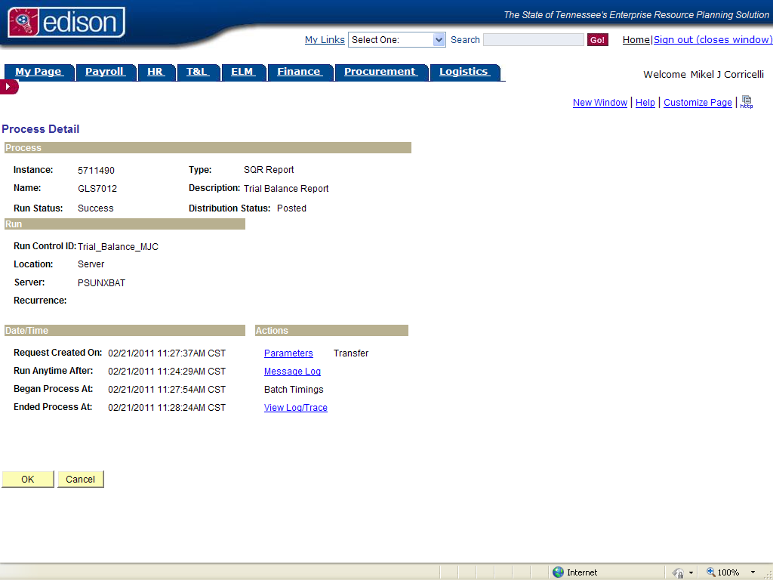
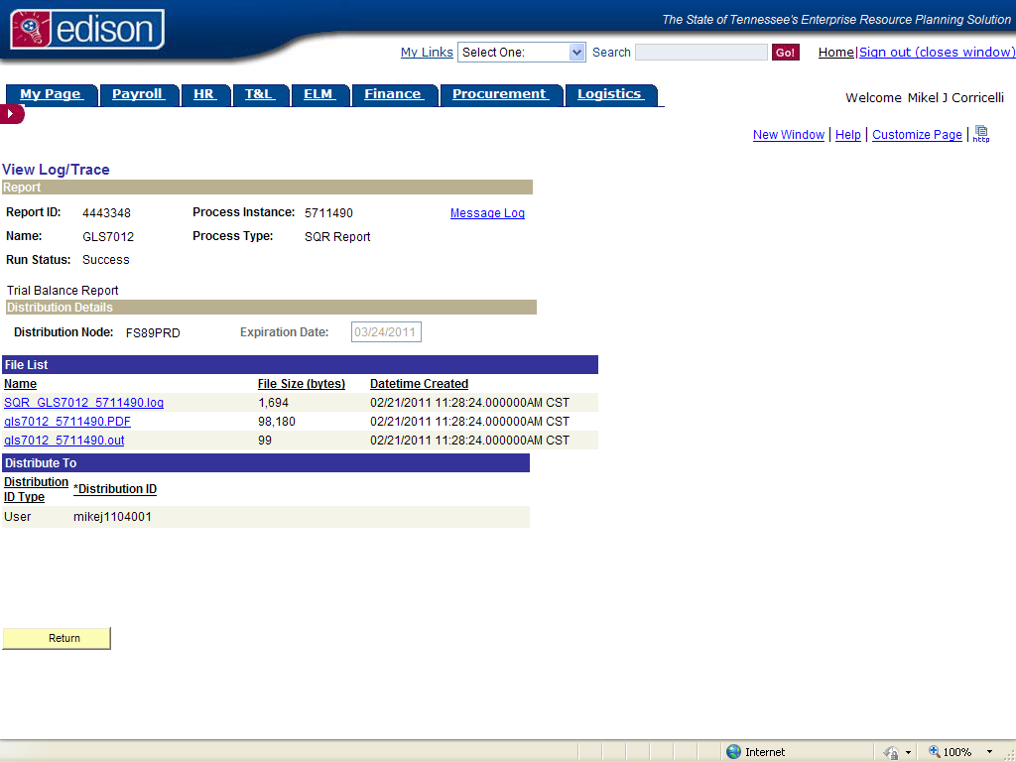
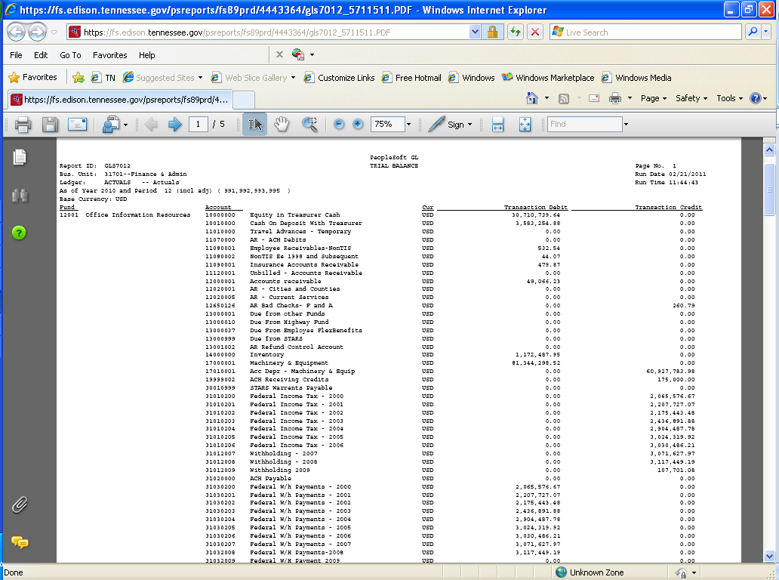

FSCM Reporting Tools>FSCM Schedule Query

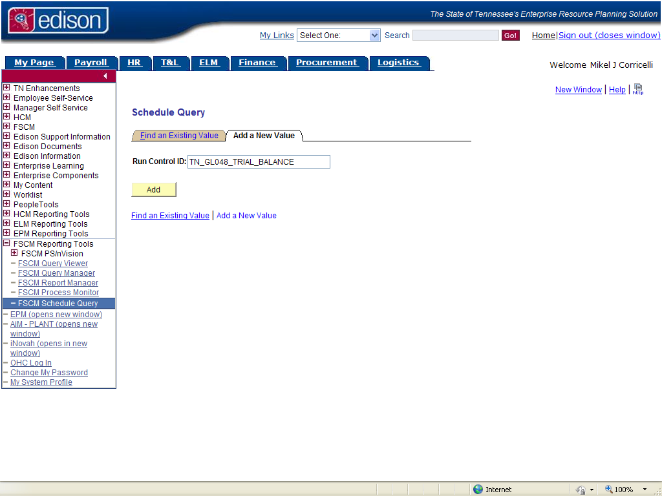
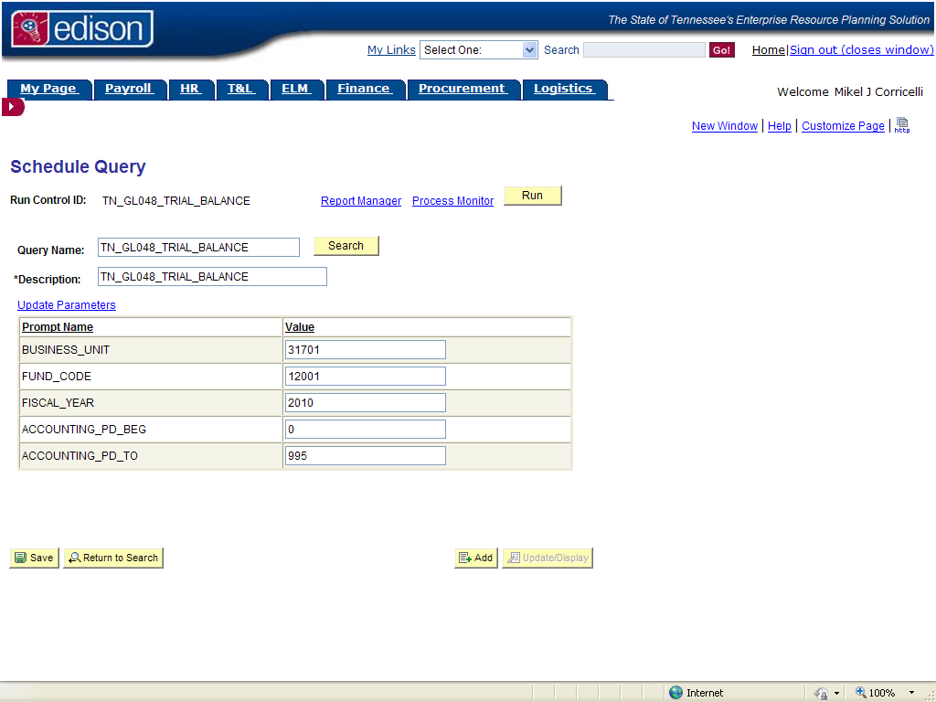
Specify Parameters

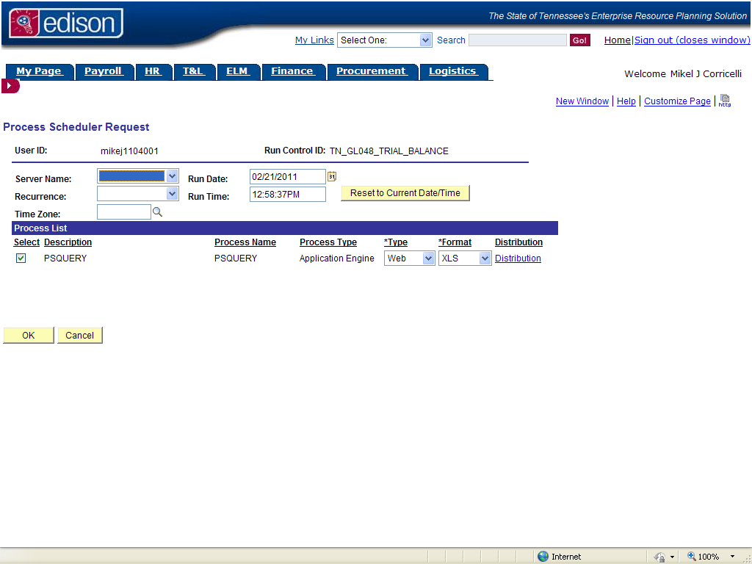
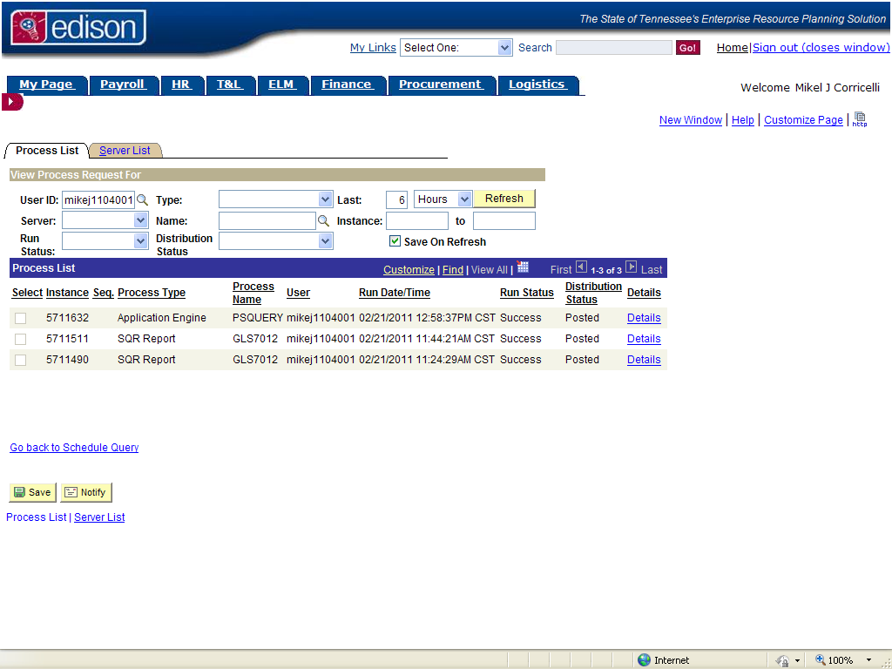
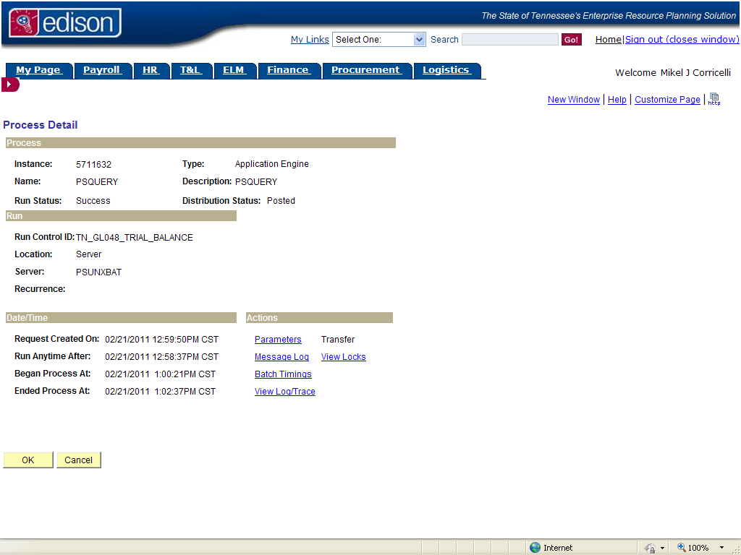
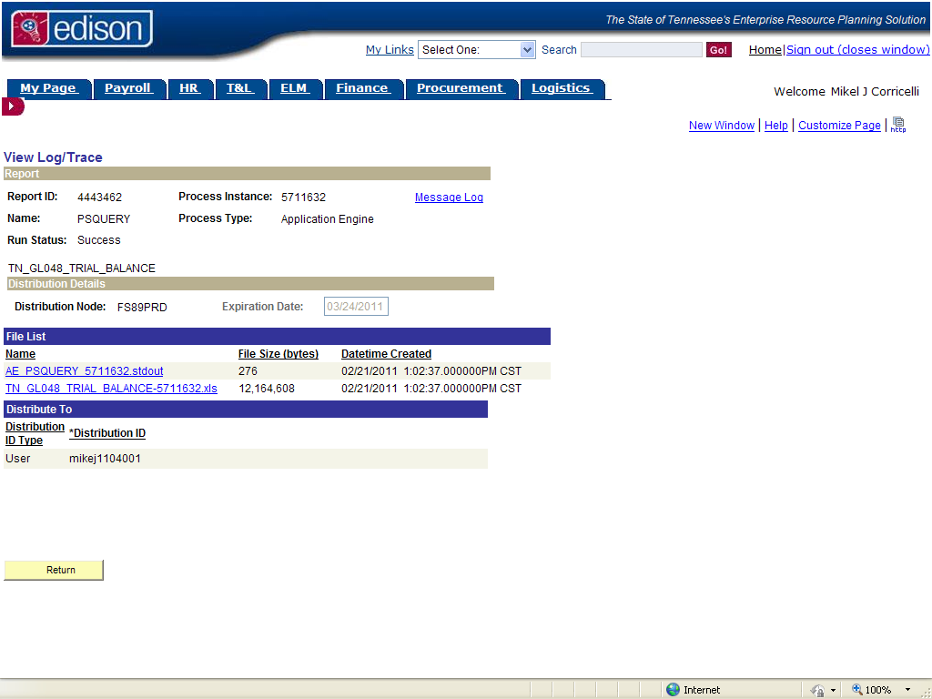

TO RESEARCH UNUSUAL BALANCES:

FSCM>General Ledger>General Reports>Ledger Activity
Can typically be run to csv format and opened in Excel without much “clean up”

Public queries:
TN_GL65_ASSET_ENTRIES_PD
TN_GL66_LIABILITY_ENTRIES_PD
(For those of you who were around in the legacy days, these generally mimic the STARS 816 and 818 reports)

