Agency Only Journal Approval

In an effort to maximize the efficiency and timeliness of GL processing of journals, a new journal source type has been created and is being made available to agency personnel. Source AG, or Agency Only Approval, can be used for journals in which all lines net to zero by BU, Fund, Account, and the first five digits of the Department ID. If a journal being created meets the above criteria, source AG can be used, and the journal can be approved by the agency and will post without flowing to Division of Accounts for final approval.
Follow the steps below to create an Agency Only Approval, source AG, journal:
- Populate Source field with AG when creating/uploading a journal entry.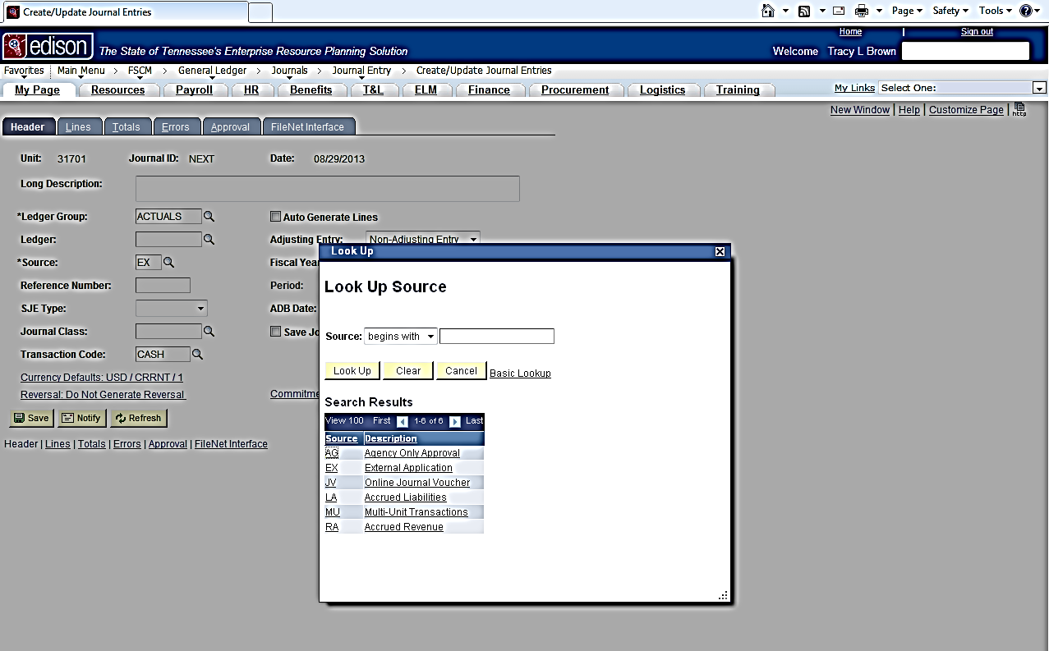
- Complete the journal Header tab as usual except for the AG source.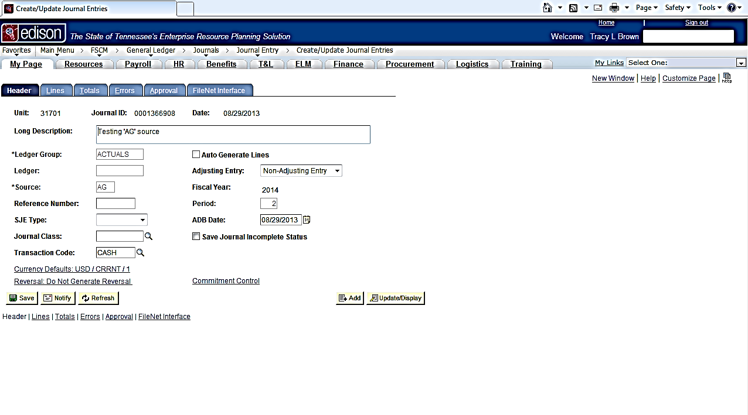
- Ensure that the lines are populated so that the BU, Fund, Account, and the first five digits of the Department ID do not change. 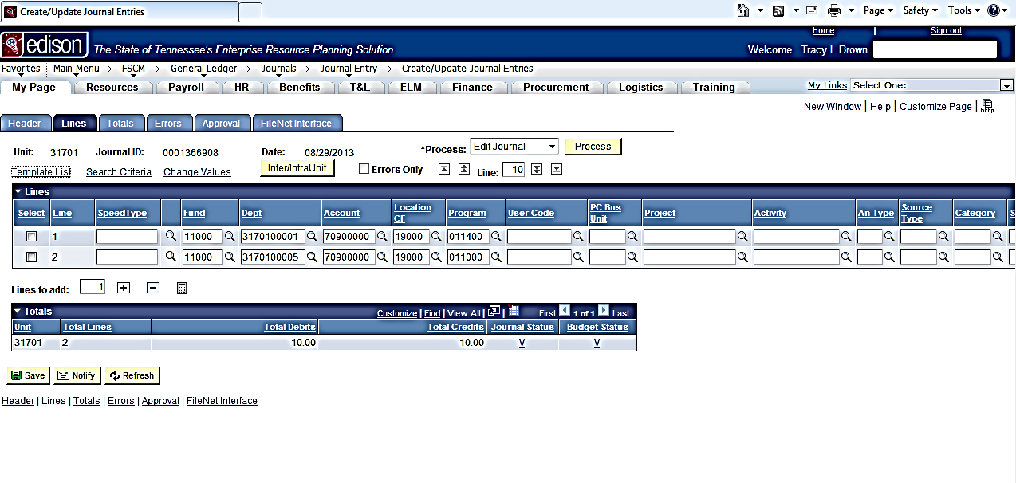
- Submit the journal as usual after obtaining a valid journal status and valid budget status.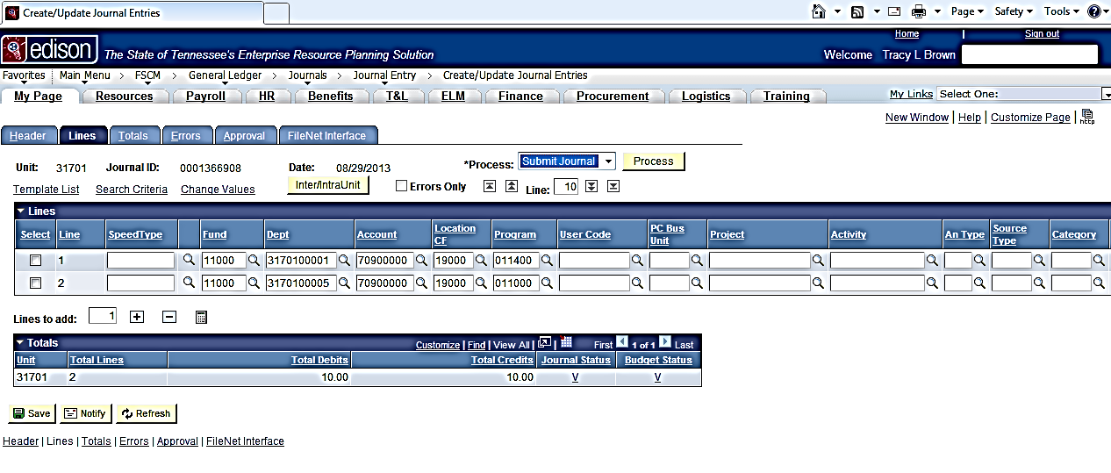
- The message box below is what a user will see if a valid source AG journal has been successfully submitted. The journal will now move through the Agency Only workflow for approval. Division of Accounts will not have to approve the journal. Please remember to attach documentation through Filenet to each journal. The burden will be on each agency to determine the type of documentation to attach and whether or not that documentation is adequate enough to support the journal. Journals may be subject to periodic review for adequacy of documentation. If any journals are found with inadequate documentation, those agencies in question may be subject to the loss of future use of source AG.
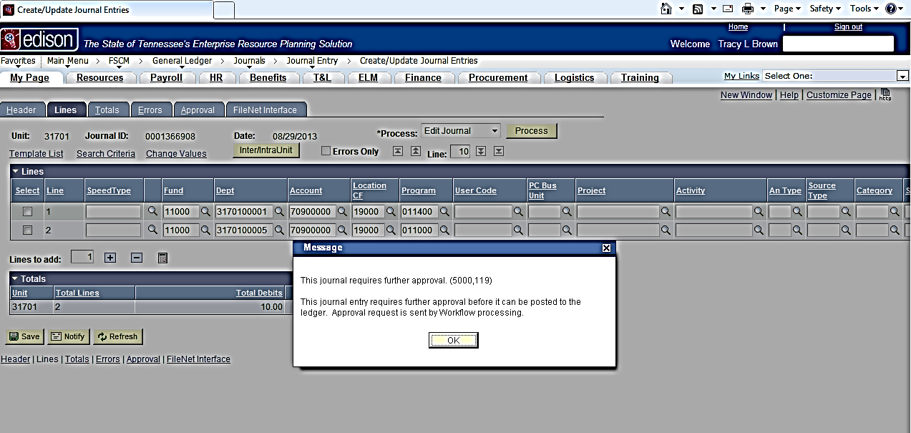
Need to Know:
If a journal is submitted that does not meet the established criteria for a source AG Journal, the following error message will be received: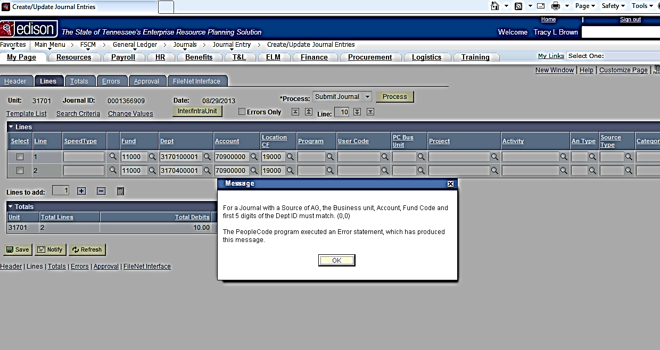
If an error message is received, a new journal using source JV or EX would need to be created and the attempted source AG journal deleted. To delete a journal, select Delete Journal from the Process dropdown box on the Lines tab and click the Process button.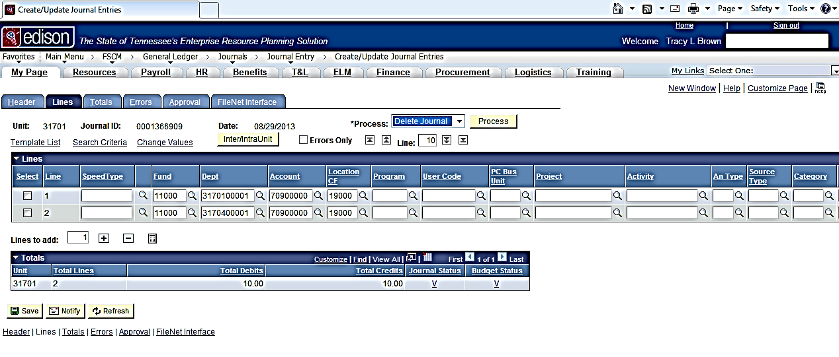
When asked if you are sure that you want to delete this journal, choose Yes.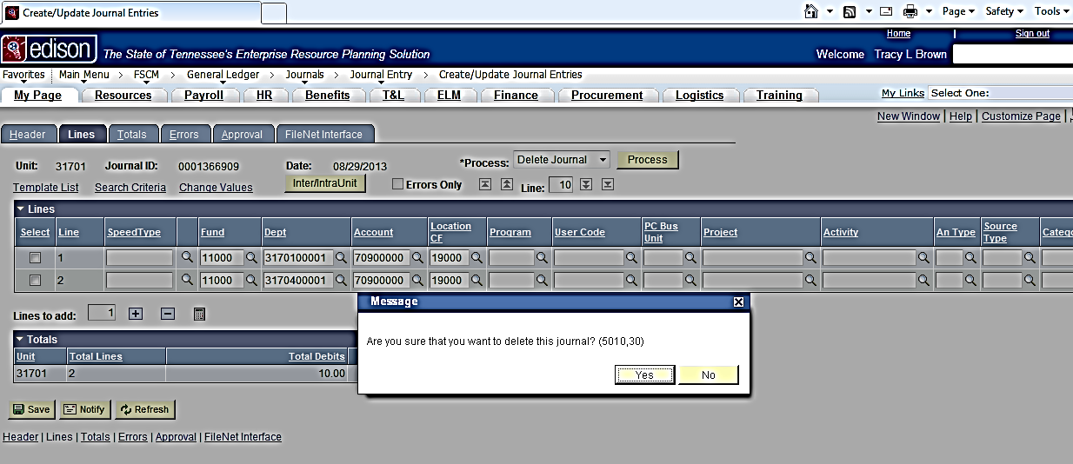
When the journal is successfully deleted, the message below will appear.
