Pre-Edit Error and Recycle Status Vouchers (vouchers not appearing in workflow)

If you are looking for a particular voucher to review/approve and it does not appear in your workflow, it may be in pre-edit error or recycle status. Pre-edit errors include items such as an invalid purchase order number, an inactive vendor number, and a duplicate invoice number. Recycle status includes items such as combo edit errors, and an accounting date not in an open period.

To view vouchers in pre-edit error status, navigate to FSCM Reporting Tools > FSCM Query Viewer. Select the TN_AP09_PRE_EDIT_ERRORS query. Select the HTML run option.

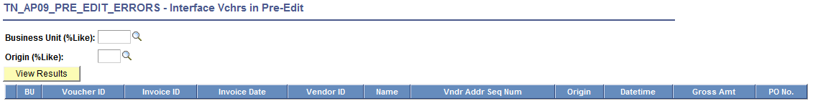

Enter your Business Unit. Enter % in the Origin field to return the full list of vouchers. As an example,

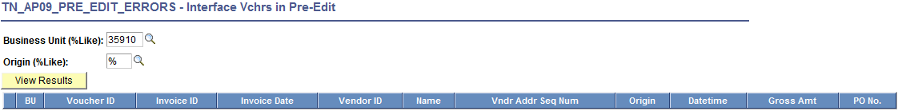

Click the View Results button.

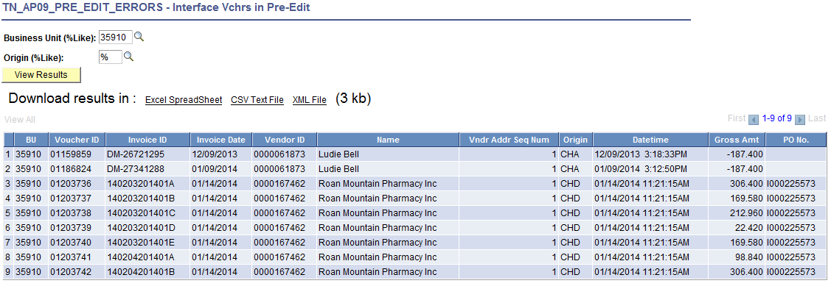

The data can now be downloaded to an Excel spreadsheet.

The errors will need to be corrected on-line as per instructions included in the Edison Agency Interface Guide.

To view vouchers in recycle status, navigate to FSCM Reporting Tools > FSCM Query Viewer. Select the TN_AP09_VCHR_STATUS_RECYCLE query. Select the HTML run option.

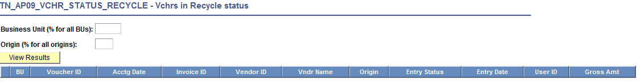

Enter your Business Unit. Enter % in the Origin field to return the full list of vouchers. As an example,

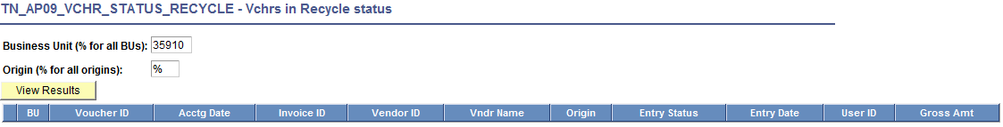

Click the View Results button.

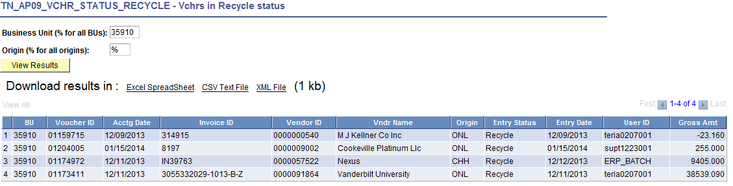

The data can now be downloaded to an Excel spreadsheet.

The errors will need to be corrected on-line as per instructions included in the Edison Agency Interface Guide.

