New Program Toolkit

Purpose
With a growing, statewide focus on ensuring we invest in what works to best serve Tennesseans, this set of resources is designed to support agency program teams during the planning stages of new or pilot programs.

Navigating the Toolkit
Try It
Find this heading for a template where you can apply those steps to the program in mind. Template boxes will expand as you type; you can also add comments or rows as necessary.
Most sections in this toolkit outline important steps to consider during the planning or beginning stages of a program.

This document can be read from beginning to end, but it may be most helpful to consider the current state of the program and follow the suggested order below. Navigate the various document tools using the hyperlinks below and find the Back to Top link at the end of each section to return here.

Planning Stages of a Program  Program idea has been discussed but has not been established; has not yet begun and perhaps has not yet been funded. | Beginning Stages of a Program  Program has been funded, and possibly has already begun; there may be more planning needed or adjustments to make.
- Complete a Needs Assessment  - Identify Existing Research  - Develop a Logic Model  - Identify Program Measures  - Consider External Factors  - Build Evidence  - Collect and Report Data  - Take Next Steps | - Develop a Logic Model  - Identify Program Measures  - Collect and Report Data  - Consider External Factors  - Identify Existing Research  - Build Evidence  - Take Next Steps

More Resources
As you work through some of the items here you may have questions. Visit the Appendix of this toolkit for terms and definitions, samples, and other resources. It may also be helpful to browse the Office of Evidence & Impact’s website for additional background. Contact OEI at OEI.Questions@tn.gov with any remaining questions.
Use red links to jump to other places in this document; blue links will open a resource external to this document.

Complete a Needs Assessment
Before starting a program, it’s a good idea to get a strong understanding of the issue at hand. What is the problem, issue, or need to be addressed? How do you know that some action needs to be taken—what data or research do you have, or can you gather, that demonstrates the need? Who would benefit from the program? Completing a needs assessment can help to inform how you might either build or select a program model that best addresses the demonstrated needs.

Try It: Complete a Needs Assessment
What is the problem, issue, or need to be addressed?
How do you know?
- List any compelling data or research that demonstrates the need.
- Include any citations or links here for easy reference later.
Who will benefit from addressing the need?
- What are the key characteristics of the target population?
- How many people comprise this population/how many have this need?
- Are there any recent, notable trends related to the issue with this population?
What does the current landscape/context look like?
- Are there other organizations or services attempting to meet this need? If so, what does that look like? How will your contribution help?
- What does this look like in other states? How does TN compare/differ?
- What laws/policies might support or constrain the addressing of this issue? Funding? Community appetite? Other contextual factors?
What would be the desired outcomes, either short- or long-term, of a program that might address this need?
Back to Top

Identify Existing Research
Perhaps a challenge or need has been identified, and a brainstorming session is next.
à Is there an existing program model that is evidence-based?
Maybe a pilot has already begun.
à Is your program model evidence-based? If not, could it be?

Either way, it can be helpful to explore a new or young program’s existing evidence base in order to:
- Learn from others working toward the same goals
- Understand the program’s potential short- and long-term benefits
- Build a strong case for funding the program
- Identify opportunities for further program evaluation

Rigorous Evaluations
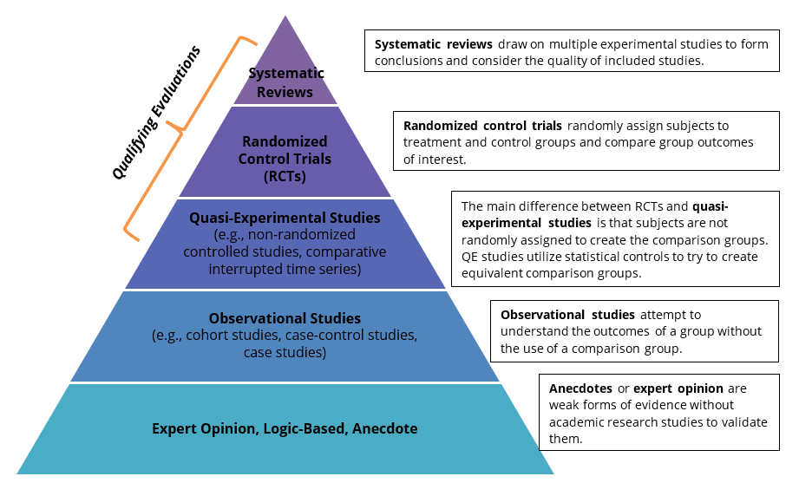
Rigorous evaluations have utilized a comparison group, like those in the top three stages of the evidence pyramid (fig. 1). Research clearinghouses are credible collections of evidence and are a great place to start when looking for evaluations. It is important to consult several sources, where possible, when looking for program evidence to find the most relevant studies.
Figure 1: Evidence Pyramid

You may also know about a Tennessee-specific evaluation of your program (or a similar one) that has not been vetted by a clearinghouse. In this case, an OEI review panel can analyze the study to confirm its level of rigor.

Not every program will have evidence. In some cases, it may not be possible or appropriate for some programs to undergo rigorous evaluation. Or maybe research just has not been done yet. Either way, it is important to conduct a search to see whether rigorous evaluation exists.

Using an Evidence Clearinghouse

Getting Started with Results First
The Results First Clearinghouse Database (“Results First”) is a great place to start, as it combines evidence from several clearinghouses into one location for easy search and comparison.

Searching with Keywords
Begin by entering a key term associated with the program in the search bar, like the name of the program, or a key word or phrase in the program’s name. Sometimes it’s easier to begin with a broad term and narrow from there. If you’re not finding something right away, try:
- A variety of synonyms or related terms
- Other common or scientific terms for the program, an intervention within the program, or a condition/scenario the program seeks to address
- Similar programs run by other organizations or states in your network that might have different names

Narrowing the Results
Most clearinghouses and databases will have filters to immediately narrow the search scope. In Results First, searches can be narrowed by selecting categories, settings, ratings, and clearinghouses where the research is housed. Check any combination of boxes to narrow the search, focusing it more closely to the program in mind.
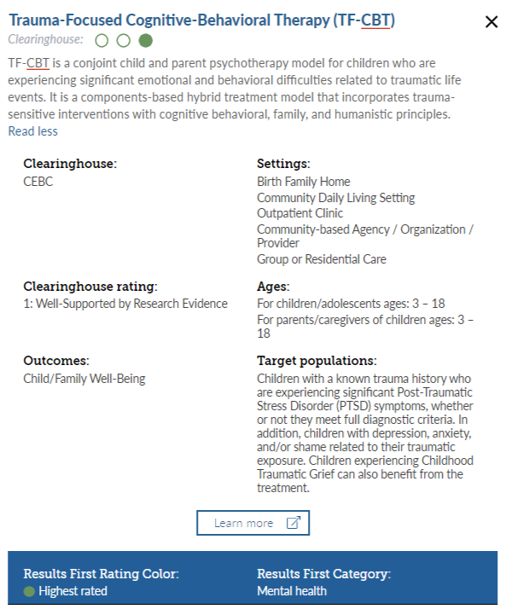
Figure 2: Results First Entry for TF-CBT
1
2
3
4
5

Matching the Research with the Current/Imagined Program
Dig deeper into each available research item to see how closely it aligns with the program in mind, or to identify conditions that will be similar in Tennessee. It is important to find the closest match possible.

Here, you are looking for similarities in the following aspects of the program:
- Who the program is designed for (age, special characteristics of a population)
- What the program is designed to address (outcome)
- Setting in which the program is delivered
- Other program specifics (program duration, additional interventions, other study details)

In Results First, research is organized into tiles by topic, like the one in fig. 2. In this example, TF-CBT appears in three clearinghouses; toggle between each entry with the colored circles at the top of the entry (fig. 2, #1).

Each research article has a summary of the program (fig. 2, #2) and lists the clearinghouse where the related research is housed, and the article’s clearinghouse rating, outcomes, settings, ages, and target populations (fig. 2, #3) for which the program is designed. To review the clearinghouse entry itself, click learn more (fig. 2, #4), which opens the original clearinghouse entry for more information. This would be necessary to find any additional information not included in the summary, including any additional areas of interest and how the outcomes were measured, the specific studies included in the rating, etc.

Interpreting Ratings
In the TF-CBT example, Results First has rated this program highest rated (fig. 2, #5). Highest rated and second-highest rated are Results First’s indications that evidence meets the rigor requirement and has a positive impact. Other Results First ratings indicate the evidence may not strongly support the program. Note that many other clearinghouses and evidence sources rate on similar scales, but they may have different terminology. Look for a ratings key to help you interpret those ratings.

Using WSIPP
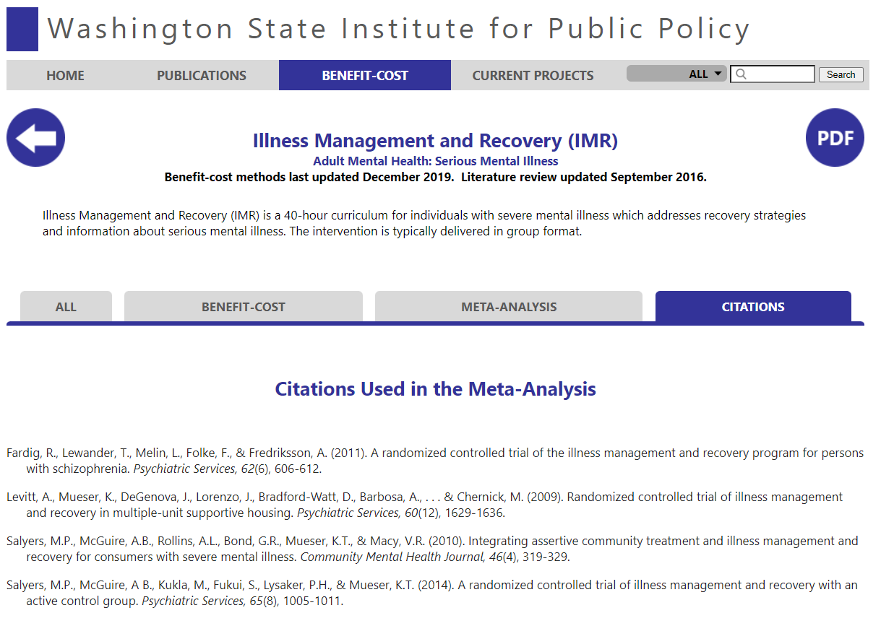
The Washington State Institute of Public Policy (WSIPP) compiles research in various social and human service areas and contains added benefit-cost analyses and meta-analyses that may qualify as rigorous evidence in support of programs.
Figure 3: WSIPP Entry for IMR, Citations
1

Let’s look at an example in WSIPP for Illness Management and Recovery (IMR) as an example (fig. 3).
- In the Citations tab, look for how many studies were evaluated.

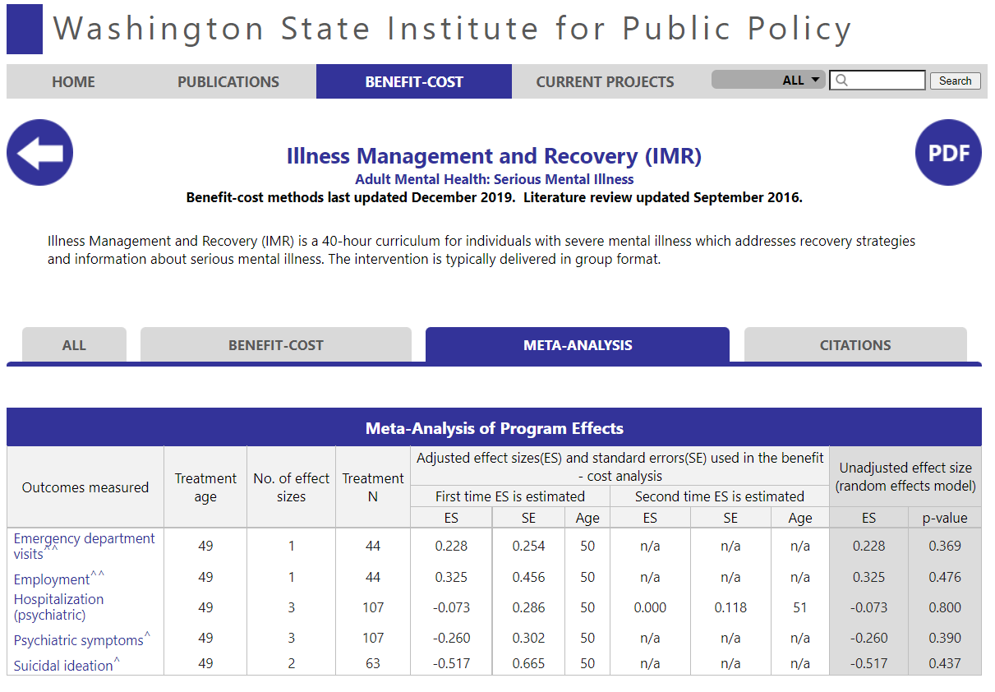
- To get a sense of whether the program outcomes are positive or negative, use the Meta-Analysis tab (fig. 4). Look for the “unadjusted effect size” on each outcome measured. The effect size shows the degree to which the program/intervention affects the measured outcome. If the effect size is positive (0 to 1), the outcome increases; a negative effect size (0 to -1) shows a decreasing outcome.
Figure 4: WISIPP Entry for IMR, Meta-analysis
2

Look closely at the outcomes that are being measured and ask: Is the effect size showing the desirable direction of impact? For IMR, there is a positive effect/increase in employment (0.325), and a negative impact/reduction in psychiatric symptoms (-0.260). Because IMR seeks to increase employment and reduce psychiatric symptoms, these effect sizes are moving in the desired direction, which indicates that this program has a positive impact. If NONE of the effect sizes indicate desired impact, the impact rating is negative. If all effect sizes are at 0.0, the impact rating is neutral.

For further support with interpreting WSIPP results, feel free to contact OEI at OEI.Questions@tn.gov.

Cross-Checking with Other Sources
The appendix has an extensive list of national clearinghouses that can be used beyond Results First and WSIPP. Additionally, because many states offer similar services, consulting other states’ inventories like Minnesota’s can be useful. Use keywords to search, and narrow by rating, area of interest, population, outcome, and setting; click an entry to access the associated research. When using another state’s inventory, remember to check for alignment to the program implemented in Tennessee.
Back to Top

Try It: Use a Research Clearinghouse to Identify Evidence
- Use the table below to record your findings from your clearinghouse review. The table is set up for you to note and compare several clearinghouse entries; add rows as needed.
Clearinghouse | Entry Name & Link | Evidence Rating | Important Notes
Name the clearinghouse or database that reviewed the program or intervention. | Enter the name of the program from a clearinghouse you feel is a good match to your program, and the URL for the page. | How is this piece of evidence rated in the clearinghouse? | If a program has not been selected or started: What might be the limitations of this program’s context or population compared to your possible implementation?
 |  |  | If a program has been selected or started: Does the program model or population differ in some way from the cited evidence?

- Next, consider these questions based on the current state of the program in question. Don’t forget your needs assessment for reference.
A program has not been selected or started yet. |  | A program has been selected and/or has started.
- Which study most closely addresses the identified needs, goals, and/or desired outcomes you’ve identified?  - Which study most closely matches your anticipated target population, setting, and other conditions?  - What would it take to replicate that program in your context? How closely would your program align to the one studied? |  | - Which study aligns most closely with the program? Consider target population, setting, goals and outcomes, program duration (length of time per day, month, year), cost, etc.  - What differences exist? Why? How could the program more closely align with the program in the study?
Perhaps you found no studies in which the program aligns with the goals, desired outcomes, population, or setting of the program in question. It’s possible that a study like this does not yet exist. In this case, use this space to brainstorm:
What connections do we have that could partner with us to study this program? (e.g., research group, in-house data & research team, university partner) | How might we access funding that may be put toward evaluation? (e.g., a percentage of the program budget, connections to grant makers, foundations) |  | Is there an evidence-based program that is similar? What changes would it take to align our program with the evidence-based program? Are those changes reasonable or possible, now or in the future?
Back to Top

Develop a Logic Model

Logic Models
A logic model is a program planning tool designed to support an intended change; it is a visual representation of how a program works toward a set of outcomes. Logic models are typically written during the planning phase of a program and are often required by funders in grant applications and annual reports.

A basic program logic model helps to ensure the success of a program, and can inform decisions during program design, implementation, and evaluation. It provides an outline of how and why the program will produce intended results, and what is needed for program operation. It can be used to support financial and programmatic reporting throughout, and at the end of, a program’s full life cycle. It can also be a useful tool to reference periodically to analyze a program’s success and fine-tune as needed. Sometimes, during the life of a program, intended inputs, activities, outputs, and outcomes change, requiring an adjustment to the logic model itself.
If a program is already underway, writing a logic model can be a powerful exercise to help focus efforts and provide clarity about the program’s purpose, strategies, and results. When written after a program has begun, a logic model should document actual operation.

Key Elements
Figure 5: Logic Model with Program Context
Inputs
Activities
Outputs
Short
Mid
Long
Process
Outcomes
Program Context
Logic models can take various forms with varying levels of depth, but they always include five key elements: program context, inputs, activities, outputs, and outcomes (fig. 5).

Program context pieces outline the purpose of the program and the environment in which it operates. A clearly outlined context can help ensure program alignment throughout every step of the logic model; it can also help manage shifts in program leadership and aid in presenting an overview of the program to those less familiar with the work. What is the program seeking to accomplish? For whom? Why?
- The program’s goals and/or objectives
- Any needs and gaps the program seeks to eliminate (or, during logic model revision, needs/gaps the program is experiencing)
- The target population for the program
- Any partners and/or providers that support the program financially, operationally, or otherwise (these also likely appear in the inputs element)
- Any other external factors or pressures that might influence program implementation
- The program’s mission and vision

Inputs are the resources and investments (human, financial, organizational, community) allocated to the program. What is needed to accomplish the set activities?

Activities are the processes, techniques, tools, events, technology, and actions that will be used to facilitate outcomes. These can also be products, services, or infrastructure. What activities will address the problem or accomplish the goal?

Outputs* are the concrete, measurable/countable results of the activities. What evidence of service delivery will the activities produce?

Outcomes* are changes in participant/recipient behavior or benefit; they are the impact of the inputs, activities, and outputs. What changes will be observed in the recipient/population over time?

*See more about developing outputs and outcomes in the Identify Program Measures section.

If/Then Statement
An if/then statement summarizes the logical progression of a program from its inputs to its long-term outcomes. It can be written between each step within the logic model, essentially in place of the arrows. For example:
Figure 6: If/Then between Each Logic Model Step
Inputs
Activities
Outputs
Short
Mid
Long
If we allocate [inputs/resources], then we can complete [activities].
If [activities] are completed,
then we will see measurable [outputs].
If we see measurable [outputs],
then we will see [short-term outcomes].
If we see [short-term outcomes],
then we will see [mid-term outcomes].
If we see [mid-term outcomes],
then we will see [long-term outcomes].

To make these if/then statements more concise for an overall program vision, break the model into the two process and outcomes elements (fig. 7).
Figure 7: Summary If/Then Statement
Inputs
Activities
Outputs
Short
Mid
Long
Process
Outcomes
If we [complete X activities],
then [short-, mid-term outcomes] will result in [long-term outcomes].

The W.K. Kellogg Foundation calls if/then statements “assumptions.” Following the same basic logic, here is their set of assumptions:
- Certain resources are needed to operate your program.
- If you have access to them, then you can use them to accomplish your planned activities.
- If you accomplish your planned activities, then, you will, it is hoped, deliver the amount of product and/or service that you intended.
- If you accomplish your planned activities to the extent intended, then your participants will benefit in specific ways.
- If these benefits to participants are achieved, then certain changes in organizations, communities, or systems might occur under specified conditions. (W.K. Kellogg Foundation, 2004).

When drafting an if/then statement, pay close attention to these key points:
- An if/then statement should explain enough about the activities of a program so a reader who is unfamiliar with the program could understand what it does, and what it hopes to achieve. For example, go beyond just “services” to give examples of what those services are. It’s okay if the sentence ends up being a little long.
- An if/then statement should be “people focused” in terms of outcomes. It should explain the impact (the “then” part, in particular) that the program has on the people it serves.
- If you are drafting an if/then statement for an evidence-based budgeting form, remember that the sentence should focus on the program itself, not on the justification for the increase request.

Here is a strong example of an if/then statement for a college counseling program for high schoolers called GEAR UP TN:
If we provide comprehensive college access and success focused services (i.e., tutoring, mentoring, counseling, advising, outreach to parents, and assistance applying for college and financial aid), then there will be an increase in college enrollment among participants who graduate from a GEAR UP Tennessee (GUTN) high school, resulting in higher college persistence and degree attainment among graduates of those high schools.

Try It: Write an If/Then Statement
Use the space below to draft a logic model statement. Organize it in a way that makes most sense, while keeping the bold elements of the sentence starter.
Logic Model
If we [complete X activities], then [short/mid-term outcome(s)] will result in [long-term outcome(s)].
Back to Top

Identify Program Measures

Importance of Performance Management
Performance management is the process of aligning employees, resources, and methods in service of strategic goals and objectives. For programs, performance management is critical for monitoring implementation and gathering data that identifies strengths and areas of opportunity in program operation. Having a consistent, documented process across all programs helps a department improve at both the program level and department-wide and enables a department to support their stories of success with data.

Outputs vs. Outcomes
For your performance management process, the selection and number of outputs and outcomes should be informed by any reporting requirements for a program and the information necessary to make strong short-term and long-term decisions about the program. They should overlap with or reflect the agency’s strategic planning work (e.g., the planning done in partnership with Customer Focused Government).

Outputs are the concrete, measurable/countable results of the activities. They answer the questions: What does the program provide? How do we know the program is happening? They account for a program’s production at a specific point in time and might measure efficiency. They are things that can be tallied, such as the number of classes taught, participants served, miles of cable laid, or dollars granted to a community.

Outcomes are the impact of the program’s inputs, activities, and outputs. They attempt to answer the question: How is the citizen/population/community better off because of the program/service? They might capture change in behaviors, conditions, or knowledge that suggest a program’s impact on its target population.

Outcomes can be identified in terms of what short-, mid-, and long-term changes will occur because of the identified outputs. Using this framework, typically outcomes move from how an individual benefits from the program (short-term) to how the program produces organizational or system-level changes (long-term). When identifying outcomes, be sure they are measurable, and that capacity exists to collect data at the frequency needed.

Outputs | Outcomes
- Answer the questions:  - What does the program provide?  - To what extent is the program happening?  - Measure countable products of the program and often start with “Number of”  - May also include efficiency or quality measures | - Answer the questions:  - What is the program’s impact?  - To what extent is the program working?  - Measure change in participant/recipient behavior or wellbeing  - Are measures of what the program influences, but does not necessarily control  - Can be short, medium, or long term

For outcomes, thoughtful planning for how to measure and collect the data related to the change in participants is critical. In cases where vendors or grantees are responsible for program delivery, outcome measurement and data submission requirements should be built into contracts. (Jump to the Collect and Report Data section to see what data collection and reporting can look like.)

Examples
This table outlines examples of outputs and outcomes.
Example Outputs | Example Outcomes
- Number of participants  - Number of health screenings  - Number of outreach sessions  - Number of grants awarded  - Average time to complete eligibility screening  - Percentage of participants rating services “useful” or “very useful” | - Percentage of program participants employed six months after training  - Percentage of students at grade level in reading by 3rd grade in Tennessee  - Job growth rate within Tennessee  - Poverty rate in Tennessee  - Number of traffic accidents per year in Tennessee  - Dollars per $1 spent (ROI)

Let’s look at a specific example: Tennessee Promise is a state program that provides last-dollar scholarships to recent high school graduates to pursue an associate degree or certificate program at a public community college, a TCAT, or a public or private university with an eligible associate degree program.

Here are a few outputs and outcomes that the agency plans to collect for Tennessee Promise.
Output Measures |  | Outcome Measures
☐ | Number of students enrolled at an eligible institution | ☐ | Student success rate (graduated or still enrolled)
☐ | Average number of credit hours earned by students in the first semester | ☐ | State FAFSA filing rate
☐ | Number of students who transfer to a Tennessee public university to continue their education | ☐ | FAFSA filing rate for Tennessee Promise applicants
☐ | Number of students eligible for Tennessee Promise as of the community service deadline | ☐ | Tennessee Promise take-up rate at a public college (college-going rate on TNP of all Promise-eligible students)
☐ | Number of eligible Tennessee Promise students enrolled in Tennessee Promise | ☐

Measuring Outcomes
Determining the best way to collect data is just as important as identifying the right outcomes. You’ll want to use a measurement tool consistently to collect information at several points in time. For example, you may want to collect data prior to the start of program participation, and then again at the end of participation (and sometimes it is appropriate to take measurements in-between those two points, as well).

There are several methods for collecting data: administrative data collections, surveys, interviews, assessments, documentation, observations. The options and tools available to you will depend on who your program participants are and how your program is designed. Two common examples of measurement tools are surveys and assessments.

Surveys
- Good tools for capturing a participant’s opinions and experiences
- Usually quick and easy to administer to adults; kids might need one-on-one support
- Survey design is very important; here are a couple of resources for building an effective survey:
  - Smart Survey Design (Survey Monkey)
  - How to Create an Effective Survey (Qualtrics)

Assessments
- Good for measuring knowledge about a topic or process
- Can measure the effectiveness of a training or class
- Assessments are easier to design that surveys, but their design and administration are still important, and there are different types; here are two resources about assessment design generally and writing effective multiple choice questions.

Measuring Outcomes Step-by-Step
- Select one outcome to measure.
  - What do we need to know to determine the success of the program? What do we expect to see/hear/know when the outcome has been achieved?
- Identify what needs to be measured, when, and from whom.
  - What kind of change are we trying to measure: change in behavior? In attitude? In understanding or knowledge?
  - What information is needed to measure the change? From whom will we collect information?
  - How many measurements do we need to demonstrate the outcome (before, during, after, multiple points throughout)?
- Determine the evaluation method (e.g., survey, assessment) that might best capture evidence to demonstrate the outcome.
- Develop the survey, assessment, or other data collection method.
  - What technology might we already have (or need to minimally adjust) that we can use to collect this information?
- Conduct the survey, assessment, or other evaluation method, collecting the selected data.
- Organize and analyze the results.
  - What change were we trying to demonstrate? What themes are arising?
  - How can we use these results to improve the program?
Back to Top

Try It: Brainstorm and Select Program Measures
- In the table below, draft or identify existing output and outcome measures for the program. Output and outcome measures can, but do not need to, have a 1:1 correlation. Add more rows if needed.
Output Measures |  |  | Outcome Measures
Outputs are the concrete, countable results of activities; often products or services measured in tangible terms. What evidence do/will you collect that demonstrates the service has been delivered? |  |  | Outcomes describe the impact of activities; typically, they show benefits or changes in behavior for the participant/recipient, and do not focus on operational changes, such as growth in participation or services. They can be individual benefits or system-level changes. What changes in behavior, benefit, or systems are you seeing?
☐ |  |  | ☐
☐ |  |  | ☐
☐ |  |  | ☐
☐ |  |  | ☐
☐ |  |  | ☐
☐ |  |  | ☐
☐ |  |  | ☐
☐ |  |  | ☐
☐ |  |  | ☐
☐ |  |  | ☐

- For programs that have not yet begun: Highlight the output and outcome measures that you think will best demonstrate the progress and success of the program. Use these in your logic model, and plan to collect these data when the program begins; see the Collect and Report Data section.
For programs that have begun: Review each output and outcome.
  - If data is currently being collected/analyzed for that measure, check the box.
  - Of the checked boxes only, highlight the top measures that tell the most complete story about how the program is performing: 3-5 outputs and 1-3 outcomes.
Back to Top

Try It: Complete a Full Logic Model
When drafting a logic model from scratch, space to map out program context can be helpful. Note that this template is set up for outcomes to span more than one goal. Use this template as a starting point, completing empty boxes and adjusting as necessary (add or delete rows, merge/unmerge cells, recreate in another format, add in moderators, mediators, or local support factors, etc.). Refer to previous activities for your notes on needs assessment, research base, if/then statement, and outputs, and outcomes. Return to make any updates after completing the external factors activity.

Program Name
Program Context
Vision
Mission
Target Population
Partners
Needs & Gaps
External Factors
If/Then Statement | If we [complete X activities], |  |  | then [short, mid-term] will result in [long term outcomes].
Goals/Objectives | Inputs  To accomplish our set of activities, we need: | Activities  To address our problem or asset we will complete these activities: | Outputs  We expect that, once accomplished, these activities will produce this evidence of service delivery: | Overall Outcomes
 |  |  |  | Short Term  We expect that if accomplished these activities will lead to the following changes in (6 months/1-3 years): | Mid Term  We expect that if accomplished these activities will lead to the following changes in (1-2 years/4-6 years): | Long Term  We expect that if accomplished these activities will lead to the following changes in (2-5 years/7-10 years):
Back to Top

Consider External Factors
The elements of a logic model help program managers plan out expected outcomes, steps to achieve those outcomes, and how to measure progress and effectiveness. But how and why will it work? What external factors can/will influence parts of the process or expected outcomes? Will those influences be positive, negative, or neutral? What assumptions is this model built upon?

Whether you already have a plan to evaluate your program, or you’re still considering that path, you can consider factors outside of your program that may influence whether your program has the desired impact:
- Local support factors are contextual factors that are necessary to implement the activities in the logic model. What external structures, policies, or other supports are needed to establish or sustain these activities?
- Mediators are factors that shape the movement from activities through outcomes. What may influence the extent to which program activities produce the expected outcomes?
- Moderators are factors, typically outside the control of the implementers, that affect the ability of the program to achieve its goals. What may accelerate or prevent the program’s ability to achieve the established goals?

Newcomer and Hart (2022) call this more robust logic model, with the addition of assumptions and external factors, a theory of change.
Figure 9: Mediators, Moderators, and Local Support Factors, Related to the Logic Model
Inputs
Activities
Outputs
Short
Mid
Long
Process
Outcomes
Program Context
Moderators
Mediators
Local support factors

Additional questions to consider:
- What assumptions do we have about what support exists for this program, or how implementation should happen?
- What is outside the control of program implementers that may affect the ability of the program to produce the desired outcomes?
- What assumptions do we have about the participants’ behavior in response to this program?

Identifying local support factors, moderators, and mediators can help program managers either leverage them for easier implementation or anticipate and mitigate potential barriers they may present. It is helpful to think about the logic model and the external factors overall as relatively “evergreen”—subject to adjustment over time based on collected data, shifted priorities or policies, and other lessons learned.
Back to Top

Try It: Consider External Factors
- Refer to your existing logic model, and identify the points where local support factors, moderators, and mediators might make an impact.
Inputs
Activities
Outputs
Short
Mid
Long
Process
Outcomes
Moderators
Mediators
Local support factors

- Consider the following questions, using the white boxes to record your notes.
Local Support Factors | Moderators | Mediators
What external structures, policies, or other supports are needed to establish or sustain these activities?  What exists already that we can leverage? What may make these activities more difficult? | What may influence the extent to which program activities produce the expected outcomes?  What may become supports or barriers between the activity and the expected outputs?  What may become supports or barriers between the outputs and outcomes? | What may accelerate or prevent the program’s ability to achieve the established goals?
What assumptions do we have about what support exists for this program, or how implementation should happen?
What is outside the control of program implementers that may affect the ability of the program to produce the desired outcomes?
What assumptions do we have about participant behavior in response to this program?

- Now that you have identified some possible support factors, moderators, and mediators, return to your logic model and/or list of output & outcome measures. Use these guiding questions to make any necessary revisions in those places:
  - What assumptions or additional background should be noted about the program’s context?
  - How might these external factors inform what, how, and when inputs and activities are completed?
  - How might outputs be impacted by these factors? Should output measures be adjusted as a result? If so, how?
  - How might outcomes be impacted by these external factors? Should outcome measures or data collection be adjusted to compensate? If so, how?
  - Will any other shifts be needed, at any point along the logic model, to account for these external factors?
Back to Top

Build Evidence

Evaluation Planning
With the foundation of a strong logic model, being intentional about evaluation from the beginning can help you understand the impact of your program and plan any programmatic adjustments (see fig. 8). An evaluation plan can outline the key questions to be answered about the program’s effectiveness, the information needed to answer those questions, and how to make that information useful. Tennessee’s Evaluation Guidelines summarize the types of evaluations that exist, how they can be applied within the Tennessee Evidence Framework, and how they can be used to inform decisions. By crafting an evaluation plan alongside the needs assessment, research base, logic model, and external factors activities, you can take ownership of the evidence-building efforts from the start.
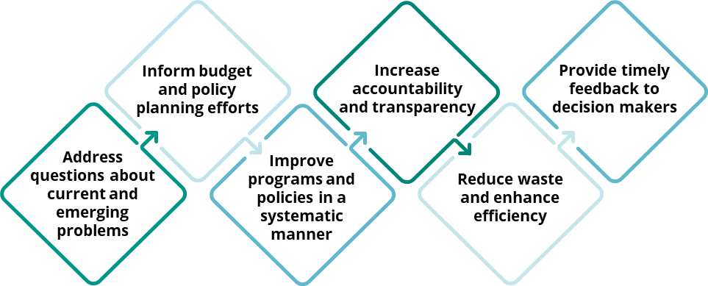
Figure 8: Benefits of Evaluation for State Government

Evaluation Methods & Partnerships
Several types of evaluations exist. When building evidence, it is important to identify the appropriate evaluation method for your program. For example, a program may not be a good candidate for an impact evaluation in its current form due to the length of time to achieve results or the lack of an appropriate comparison group. However, that program could be best suited for an outcomes evaluation.

A partnership with the Office of Evidence & Impact (OEI) and/or an external research entity can help you determine the best type of evaluation for your program. Partnerships can help you increase your capacity for using evidence and assessing the effectiveness of your program. OEI can support by consulting on evaluation design, identifying a research partner at an academic institution, and, under certain conditions, funding evaluations to build robust evidence. Email OEI.Research@tn.gov for more information about evaluation.
Back to Top

Try It: Draft an Evaluation Plan
Use the template below to record some thoughts about a potential evaluation plan. Use this as a starting point when consulting with OEI or a potential evaluation partner.
Determine the Goal
What question should be evaluated? What would be the most helpful to understand about the results of the program?
What decisions might the answers to this question inform?
Apply Appropriate Methods
Is it possible to track who receives the program, or program participants? If so, how are they tracked?
Is it possible to track whether an individual experienced the entire program or part of the program?
Are there any outcomes or results associated with the logic model that are not currently collected or tracked?
Is there an appropriate comparison group? (I.e., is there a group we could study that is not receiving the program?)
Make the Results Useful
How might you plan to communicate these results?
How might these results inform improvements?
Other Helpful Information
Are there any researchers you know of who have experience with studying this type of program? Do you know of any existing research partnerships related to your field or department?
Back to Top

Collect and Report Data
Note: This section directly mirrors what is required for reporting in the program inventory and evidence-based budgeting processes. Outside of these requirements, be sure you can collect and store data most efficiently for your context. Additionally, you are not limited to a certain number of metrics—collect and analyze as much data as necessary and/or reasonable.

When reporting data, outputs and outcomes should include a timeframe. For the purposes of the program inventory or evidence-based budgeting, data will be requested for 1) the most recent, complete year, and for outcomes, 2) a comparison year. A “year” can be state or federal fiscal year, school/academic year, or calendar year, depending on how the data is collected and analyzed.

Let’s revisit Tennessee Promise. The agency has implemented the program for several years now, and they are ready to report on program outputs and outcomes. Here’s what that might look like, with data reported:
Output* | Year | Result
1. Number of students eligible for TN Promise as of the community service deadline | AY 2021-22 | 27,517
2. Number of eligible TN Promise students enrolled in Tennessee Promise | AY 2021-22 | 15,738
Outcome* | Year | Result
1. FAFSA filing rate of Tennessee Promise Applicants | AY 2021-22 | 86.0%
 | AY 2015-16 | 79.3%
2. Tennessee Promise take-up rate at a public college (college-going rate on TN Promise of all Promise-eligible students) | AY 2021-22 | 22.2%
 | AY 2015-16 | 26.8%
Raw numbers go here, making it easy to see discrete data points. For EBB and Program Inventory, there is no need to calculate trends.
The most recent year’s data are listed in the first row, then a prior year for side-by-side comparison. For this outcome, data lags a few years; the most recent data available is for 2021-22.

*Please note these data are for demonstration purposes only and will not be updated in this document every year.

On the next page are two additional examples of strong outcomes, along with sample reported data. We have also noted the characteristics that make these strong outcomes.

Outcome Example 1: Large health program for individualized support of a population with special needs
Outcome  Outcomes describe the impact of activities; typically, they show benefits or changes in behavior for the participant/recipient, and do not focus on operational changes, such as growth in participation or services. They can be individual benefits or system-level changes. What changes in behavior, benefit, or systems are you seeing? Provide 1-3 outcomes, with the most recent data AND one year of prior data, that tell the strongest story about the program. | Year(s): Most Recent and Comparison  Please specify fiscal year (FY), calendar year (CY), academic year (AY), etc. | Result: Most Recent and Comparison
1. Number of working age adults with I/DD who are employed in an integrated setting earning at or above minimum wage | CY 2022 | 969
 | CY 2017 | 265

Why is this a strong outcome?
- The focus is on impact to participants (adults receiving services).
- Two years of data are provided, including the most recent, complete year of data; a reader can easily compare the two data points when side-by-side.

Outcome Example 2: Agricultural cost-share program with return-on-investment calculation (ROI)
Outcome  Outcomes describe the impact of activities; typically, they show benefits or changes in behavior for the participant/recipient, and do not focus on operational changes, such as growth in participation or services. They can be individual benefits or system-level changes. What changes in behavior, benefit, or systems are you seeing? Provide 1-3 outcomes, with the most recent data AND one year of prior data, that tell the strongest story about the program. | Year(s): Most Recent and Comparison  Please specify fiscal year (FY), calendar year (CY), academic year (AY), etc. | Result: Most Recent and Comparison
1. Return on investment (calculated by the University of Tennessee Agri-industry Modeling & Analysis Group) | ROI last calculated in 2019, analyzing data from CY 2014-2018 | Each program dollar generates $3.89 for local economies

Why is this a strong outcome?
- This program may not capture data regarding the specific impacts to farmers, but there is a broader impact to economies that the agency is working with a partner to capture.
- The source of the ROI calculation is named here. If the calculation is internal, OEI may request additional information regarding your formula.
- The listing includes the year the ROI was last updated and what years are included in the calculation. If there are two calculations, please provide both for comparison. In this case, there is only one calculation spanning several years.

Try It: Collect Output & Outcome Data
Refer to your program measure brainstorm, and copy & paste the 2-5 outputs and 1-3 outcomes you selected for measurement. Use the table below to record the most recent results/data, and the year or timeframe associated with that data. Data can be entered in whatever format makes most sense. Of course, you may not have data yet—that’s okay. Come back here when you do to track it.

Output | Year: Most Recent & Comparison | Result: Most Recent & Comparison
1.
2.
3.
4.
5.
Outcome | Year: Most Recent & Comparison | Result: Most Recent & Comparison
1.
2.
3.
Back to Top

Take Next Steps
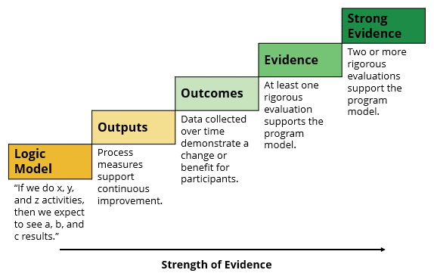
Congratulations! You have now done the hard work of planning or revising your program with lots of thought about different levels of evidence and research. You have:
Figure 10: Tennessee Evidence Framework
- Assessed the need, setting the foundation for strategic program planning to meet that need
- Learned the extent to which rigorous evidence may exist to support your program, or where there may be opportunities for future research
- Developed a full logic model, laying out the program from the program’s inputs to its results, and an if/then statement to briefly and clearly describe that theory of action
- Established an evaluation plan to build evidence of program effectiveness and/or considered external factors that might influence results and how to augment or mitigate them
- Identified both process and impact measures to help you monitor the program and gauge its impact and effectiveness
- Established a basic plan to collect and report data

With all of this, you have just worked through each of the steps in the Tennessee Evidence Framework (fig. 9), setting up a strong foundation to build evidence that supports your program. Understanding the evidence behind your program can help you gauge program performance, which can support data- and research-informed adjustments, increase transparency with the public, and justify new funding requests.

Analyze Data and Adjust as Needed
Through the collection of output and outcome data, program teams can analyze performance and identify meaningful trends and conclusions. Data analysis can help program teams to make data-informed decisions or adjustments and can support the narrative around the program’s impacts and budget requests.

Leveraging data to build evidence is a key step in making use of outcome data. Tennessee state employees have access to a secure environment to share and analyze data: the Tennessee Data Analytics for Transparency and Accountability Hub, or TN DATA. With TN DATA, process or participant data that your agency collects can be used to support your evaluation plan and estimate whether the program has led to changes in outcomes. TN DATA also enables data sharing across the state enterprise so that a program’s effectiveness can be understood within the broader context of program delivery. For example, does an education intervention lead to better workforce outcomes? Does an early childhood program lead to better reading performance in schools?

TN DATA provides an accessible, secure environment for data analytics that can help you move your program from the Outcome step to the Evidence step, laying the foundation to pursue a more rigorous evaluation. Refer to the Tennessee Evaluation Guidelines for details on what is required for this type of evaluation. OEI can facilitate, and in some cases fund, an academic partnership with leading researchers in the field to produce a robust program evaluation. With further questions about TN DATA, please reach out OEI.Research@tn.gov.

Tennessee Program Inventory
The program inventory is an interactive public dashboard that contains a comprehensive list of state-funded programs in the base budget, including the extent to which they are supported by rigorous evidence. Executive cabinet agencies contribute to the inventory and can update their content each year.

With the implementation of your new program, you may be asked to submit your program’s information to the inventory. The information you’ve compiled in the activities in this document is directly aligned with what is required for inventory submissions. When it’s time, you’ll have all the necessary information in one place.

Learning Agenda
It’s important to recognize that your program exists in a larger ecosystem of programs and initiatives within a state agency. Without question, agency leaders have competing priorities and limited resources. OEI recognizes this challenge at the state level and has worked with each cabinet-level agency to create a statewide learning agenda. The learning agenda focuses on building and using research and evidence to prioritize key questions, spur coordinated evaluation and research, and ensure that results inform programmatic decisions.

The efforts and coordination across state government to develop a statewide learning agenda can serve as a model for agencies wanting to focus their evidence-building efforts. Crafting an agency-specific learning agenda is an innovative way to prioritize resources, support continuous improvement efforts, and build evidence effectively. OEI can support agency learning agenda development through a training program that can be self-guided or done in partnership with OEI. For more information, please contact OEI.Research@tn.gov.

Evidence-Based Budgeting
To ensure that the state is investing in programs and initiatives supported by evidence and research, Tennessee uses a strategy called evidence-based budgeting. Every September, state agency budget teams submit cost increase requests to the Division of Budget, and those submissions require detailed responses to questions related to the evidence framework. More information about what the budget submission entails is on the budget website.

We recommend that discussing any anticipated fiscal needs with your agency’s budget team. If you have completed all the activities in this document, you will be well-equipped to support your fiscal officer in submitting a cost increase request form for your program if that is the route you decide to take. Here are a few ways this document aligns with evidence-based budgeting:
- The information you compiled in your needs assessment can provide the bulk of the justification for your request (in the FY25 form, that’s questions 2a and 2b).
- The evidence questions in the request form (in the FY25 form, that’s questions 8-10) directly align with each step of the framework. Those questions will ask for an if/then statement, output and outcome measures and two years of data (if it’s available), and any existing rigorous evidence.
Back to Top

Appendix

Evidence/Evaluation Glossary: Terms & Concepts

Benefit-Cost
A calculation of the most tangible financial gains or benefits that can be expected from a project versus the cost of implementing the suggested program or solution. The Washington State Institute of Public Policy (WSIPP) does benefit-cost analysis on high-quality studies across the US and can be an important resource.

Causal Relationship
The relationship established that shows that an independent variable, and nothing else, causes a change in a dependent variable. It also establishes how much of a change is shown in the dependent variable.

Mill’s 3 critical conditions for establishing cause:
- Cause must precede its anticipated effect in time
- If the levels of cause differ in some systematic way, there must be corresponding variation in the effect (correlation)
- Must be able to discount all other plausible explanations for the link observed between the cause and effect (nonspurious); randomized experiments are preferred because they satisfy this requirement

Effect Size
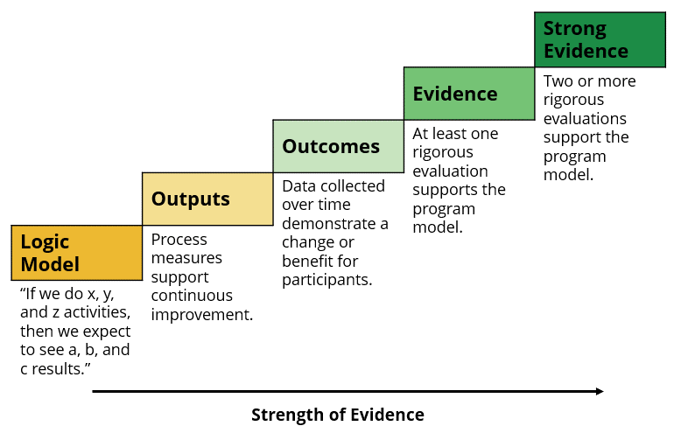
A standard metric that summarizes the degree to which a program or policy affects a measured outcome. If the effect size is positive (0 to 1), the outcome increases. If the effect size is negative (0 to -1), the outcome decreases. An effect size closer to zero indicates a more neutral impact, or that the impact could not be separated from other variables.
Figure 11: Tennessee Evidence Framework

Evidence Framework
The context through which state executive agencies can demonstrate the evidence of both proposed and existing programs during the program inventory or budget processes. The framework includes the five evidence steps.

Intervention
An individual component of a program that may or may not be research-based. Where an “umbrella” program exists, both the program and all associated interventions should each be included in a program inventory.

Meta-analysis
A meta-analysis is a statistical method to combine the results from separate studies on a program, policy, or topic in order to estimate its effect on an outcome.

Program
A systematic activity that engages participants in order to achieve desired outcomes. Terms often used in its place can include service, intervention, or practice. If a systematic activity has participants and has its own name, it is likely a program. For the purposes of the program inventory, a program may contain one or more interventions.

Rigorous Evaluations
Evaluations that use high-quality experimental or quasi-experimental designs. For the purposes of the Tennessee evidence framework, this includes quasi-experimental studies (QEDs, where subjects are not randomly assigned, but use statistical controls to create equivalent comparison groups), randomized control trials (RCTs, where subjects are randomly assigned to treatment with control groups), and systematic reviews (studies that draw conclusions based on multiple experimental studies).

Sample
The population researched in a particular study. Usually, attempts are made to select a "sample population" that is considered representative of groups of people to whom results will be generalized or transferred. In studies that use inferential statistics to analyze results or studies that are designed to be generalizable, sample size is critical, generally the larger the number in the sample, the higher the likelihood of a representative distribution of the population.

Theory of Change
A logic model with the addition of external influencing factors; it “describes and illustrates how and why a specific policy or program is expected to produce desired outcomes and maps out the various assumptions and mediating factors that may facilitate or impede the policy or program from achieving espoused goals.”
Back to Top

Clearinghouse Resources
During a program inventory, and when completing the evidence-based budgeting forms, agencies will be asked about evidence-based practice registers they may have visited in the past or that they may use actively. These are the clearinghouses in which OEI will be primarily interested, although agencies may also provide information about additional resources they have consulted.

Agencies are encouraged to start with clearinghouse databases, as they combine evidence from several clearinghouses into one location for easy search and comparison. For more information about using evidence in program inventories and budgeting, please contact OEI.Questions@tn.gov for additional guidance.

Clearinghouse Databases
- Results First Clearinghouse Database | https://evidence2impact.psu.edu/what-we-do/research-translation-platform/results-first-resources/clearing-house-database/ | Database includes:
  - Blueprints for Healthy Youth Development
  - California Evidence-Based Clearinghouse for Child Welfare (CEBC)
  - The Laura and John Arnold Foundation’s Social Programs that Work
  - The U.S. Department of Education’s What Works Clearinghouse (WWC)
  - The U.S. Department of Health and Human Services’ Evidence-Based Cancer Control Programs (EBCCP)
  - The U.S. Department of Health and Human Services’ Teen Pregnancy Prevention Evidence Review
  - The U.S. Department of Justice’s Crime Solutions
  - The U.S. Substance Abuse and Mental Health Services Administration’s National Registry of Evidence-based Programs and Practices (NREPP)
  - The University of Wisconsin Population Health Institute and Robert Wood Johnson Foundation’s County Health Rankings and Roadmaps What Works for Health
  - Penn State Clearinghouse for Military Family Readiness

Benefit-Cost Registers
- Washington State Institute for Public Policy | https://www.wsipp.wa.gov/BenefitCost

State Inventories
- Minnesota | https://mn.gov/mmb/results-first/inventory/

Clearinghouses by Policy Area

Education
- Child Care & Early Education Research Connections | https://www.researchconnections.org/
- Collaborative for Academic, Social and Emotional Learning (CASEL) Program Guides | https://www.casel.org/guide/
- Evidence for ESSA, Johns Hopkins University https://www.evidenceforessa.org/

Health
- Centre for Reviews and Dissemination (York University) | https://www.york.ac.uk/crd/
- Clearinghouse for Maternal and Child Health Programs, Georgetown University | https://www.mchlibrary.org/
- Cochrane Database of Systematic Reviews | http://www.cochrane.org/
- Compendium of Evidence Based Interventions and Best Practices for HIV Prevention | https://www.cdc.gov/hiv/research/interventionresearch/compendium/index.html
- Curated Library about Opioid Use for Decision-makers, Oregon Health & Science University | https://www.opioidlibrary.org/resource_category/policymakers/
- Effective Child Therapy: Evidence-based Mental Health Treatment for Children and Adolescents | https://effectivechildtherapy.org/
- Effective Interventions HIV Prevention that Works | https://effectiveinterventions.cdc.gov/
- Evidence-Based Cancer Control Programs, U.S. National Cancer Institute | https://ebccp.cancercontrol.cancer.gov/index.do
- Evidence-based Practices (EBP) Resource Center (SAMHSA) | https://www.samhsa.gov/ebp-resource-center
- Evidence-Based Reports, U.S. Agency for Healthcare Research and Quality | https://www.ahrq.gov/research/findings/evidence-based-reports/search.html
- Healthy People Evidence-Based Resources, U.S. Office of Disease Prevention and Health Promotion | https://www.healthypeople.gov/2020/tools-resources/Evidence-Based-Resources
- Society of Clinical Psychology | https://www.div12.org/treatments/
- Suicide Prevention Resource Center (SPRC) | https://www.sprc.org/
- The Community Guide, U.S. Centers for Disease Control | https://www.thecommunityguide.org/
- What Works for Health, University of Wisconsin Population Health Institute | https://www.countyhealthrankings.org/take-action-to-improve-health/what-works-for-health

Justice
- Model Programs Guide, U.S. Office of Juvenile Justice and Delinquency Prevention | https://ojjdp.ojp.gov/model-programs-guide/home
- OJJDP Model Programs Guide | https://www.ojjdp.gov/mpg
- What Works in Reentry Clearinghouse | https://whatworks.csgjusticecenter.org/

Labor
- Clearinghouse for Labor Evaluation and Research, U.S. Department of Labor | https://clear.dol.gov/
- Pathways to Work Evidence Clearinghouse | https://pathwaystowork.acf.hhs.gov/find-interventions

Social Policy
- Child Trends/What Works | http://www.childtrends.org/what-works/
- Clearinghouse for Military Family Readiness | https://militaryfamilies.psu.edu/
- Connecticut Clearinghouse | https://www.ctclearinghouse.org/
- Home Visiting Evidence of Effectiveness, U.S. Administration for Children & Families https://homvee.acf.hhs.gov/
- National Clearinghouse on Homeless Youth & Families, U.S. Administration for Children & Families https://rhyclearinghouse.acf.hhs.gov/
- PracticeWise | https://www.practicewise.com/
- Prenatal-to-3 Policy Impact Center, Vanderbilt University‘s Peabody College of Education and Human Development | https://pn3policy.org/
- Resource Center for Adolescent Pregnancy Prevention (ReCAPP) | http://recapp.etr.org/recapp/
- Social Programs That Work | http://evidencebasedprograms.org/
- Suicide Prevention Resource Center, U.S. Substance Abuse and Mental Health Services Administration | https://www.sprc.org/resources-programs
- The Campbell Collaboration | https://www.campbellcollaboration.org/
- Title IV-E Prevention Services Clearinghouse, U.S. Administration for Children & Families | https://preventionservices.acf.hhs.gov/
- Youth.gov | https://youth.gov/
Back to Top

Additional Logic Model Resources
W.K. Kellogg Foundation, Logic Model Development Guide (2004)
- Comprehensive guide to developing a logic model, including samples, checklists, and templates
- To access the document, click Download PDF on the right side of the page

University of Wisconsin-Extension, Program Development and Evaluation
- Website with resources and training materials for program planning, design, evaluation
- Includes Developing a Logic Model: Teaching and Training Guide (2008) with workshop agendas, activities, templates, and samples

CDC Office of Policy, Performance, and Evaluation, Home Page
- Includes a step-by-step checklist for developing a logic model: Program Evaluation Framework Checklist for Step 2
- Also available from the CDC’s Division for Heart Disease and Stroke Prevention is PDF Evaluation Guide: Developing and Using a Logic Model, with guidance on developing a logic model, templates, and samples
Back to Top

Logic Model Samples

Sample: Mental Health & Substance Abuse Services | Project Rural Recovery (FY22)

Vision | Make the access to whole-person care easy for the patients of rural Tennessee
Mission | Improve the well-being outcomes for underserved populations with or at-risk of chronic health, substance use, and serious mental health conditions totaling
Target Population | Adults and children with co-existing or at risk of physical and serious mental health, substance use disorder conditions in rural, medically underserved areas of Tennessee are the populations of focus. Ten rural counties will be targeted: Cocke, Jefferson, Grainger, Claiborne, Hancock, Wayne, Lewis, Perry, Lawrence, and Marshall. Veterans and their families will be prioritized for services
Partners | Buffalo Valley, Inc. (BV) and Helen Ross McNabb Center, Inc. (HRMC), Project Director, Evaluator
Goals | Activities | Output Measures | Overall Outcomes
 |  |  | Short Term | Long Term
Goal #1: To create a model of integration between primary care and mental health/substance use disorder providers to serve as a template for reproduction across the State of Tennessee. | A. Development of 2 regional multidisciplinary care teams to improve the health and wellbeing in adults, children, and families in ten Tennessee counties  B. Identify and engage 3 community partners per county to refer to mobile health unit in year 1  C. Create a system to share information using the electronic medical records of the clinical partners  D. Cross-train team members and community practitioners on integrated care models and behavioral support as evidenced by evaluation scores  E. Develop a case service fee rate for mobile, integrated care for the managed care organizations and safety net in order to sustain funding | # teams established  Composition of teams  # of local partnerships  # trained providers  Pre- and post-test training scores  # of sustained teams  # of agreements for payment | Increased awareness of integrated care  Increased access to affordable integrated behavioral health services  Increased utilization of integrated behavioral health services  Increased community supports to sustain behavioral health service needs  Reduced tobacco use  Reduction in ER visits  Improved biometric measures  Improved stability in housing  Improved employment status  Reduction in number of arrests  Improvement in daily functioning  Improvement in social connectedness | Participating community members are engaged in meeting their behavioral health service needs  Participating community members realize improvements in their health status  Integrated behavioral health care is sustained in the target communities  Lessons learned provide insights about delivering integrated behavioral health care in other communities
Goal #2: To engage and treat the rural populations who are currently underserved in order to improve their health status | A. Purchase two mobile health units with two treatment rooms each and essential medical equipment in Year 1  B. Outreach to 500 stakeholders (30%) and patients (70%) through marketing in media and in person in Year 1  C. Assess and diagnose no less than 10 patients per day, 2400 encounters per year in years 2-5, prorated for Year 1  D. Provide integrated mental health/substance use disorder, and physical interventions such as medication management and chronic disease management to 80% of assessed patients  E. Provide preventative health screenings (TB, HIV, Hepatitis) 100% of consenting patients  F. Refer and link 50% of patients to needed services such as utility, housing assistance, smoking cessation, and substance use disorder treatment.  G. Decrease the number of individuals seeking care at emergency departments in the 10 counties as evidenced by patient report  H. Provide nutrition and/or exercise interventions for at least 200 applicable patients during the project  I. 65% of adult patients served will show an improvement in blood pressure, body mass index, waist circumference, breath CO, plasma glucose and/or HgbA1c, lipid profile over the course of treatment  J. 75% of children and adolescents will show an improvement in their body mass index and blood pressure throughout the course of treatment | # equipped units and composition of units  # and types of outreach activities  # screened and types of screenings  # served and types of services  # satisfied with services  # of referrals  # patients that use tobacco and reduced tobacco use  # patients with ER visits  # patients making nutrition and exercise changes  NOMS biometric measures (blood pressure, body mass index, waist circumference, breath CO, plasma glucose and/or HgbA1c, lipid profile)  NOMS measures for emotional and behavioral functioning  # of completed NOMS (baseline and 6-month intervals)  # of patients with a reduced suicide rating score and reduced occurrences of suicide ideation

Sample: Economic and Community Development | Business Development/FastTrack (FY22)

Sample: Economic and Community Development | Rural Economic Opportunity Fund Grants (FY22)

Back to Top

https://www.instrumentl.com/blog/needs-assessment-for-a-nonprofit-organization https://www.springly.org/en-us/blog/how-to-perform-a-needs-assessment-for-your-nonprofit/ (while these resources are centered on starting a non-profit, some of the concepts here may be helpful)
Newcomer & Hart. Evidence-Building and Evaluation in Government. Sage Publications, 2022, p. 72.
Flow chart adapted from CDC Evaluation Guide: Developing and Using a Logic Model, 2.
W.K. Kellogg Foundation, Logic Model Development Guide (2004), 2.
Ibid, 8.
Ibid.
Ibid, 7.
Table adapted in part from W.K. Kellogg Foundation, Logic Model Development Guide (2004), 54, and University of Wisconsin-Extension, Developing a Logic Model: Teaching and Training Guide (2008), 55.
This section adapted from Newcomer & Hart. Evidence-Building and Evaluation in Government. Sage Publications, 2022, p. 63-79.
Newcomer & Hart. Evidence-Building and Evaluation in Government. Sage Publications, 2022, p. 70.
https://libguides.usc.edu/writingguide/researchglossary
Richard J. Murnane and John B. Willett, Methods Matter: Improving Causal Inference in Educational and Social Science Research (New York: Oxford University Press, 2011), 29.
https://www.wsipp.wa.gov/BenefitCost
Murnane and Willett, Methods Matter, 91.
https://www.wsipp.wa.gov/BenefitCost
https://libguides.usc.edu/writingguide/researchglossary
Newcomer & Hart. Evidence-Building and Evaluation in Government. Sage Publications, 2022, p. 63.

