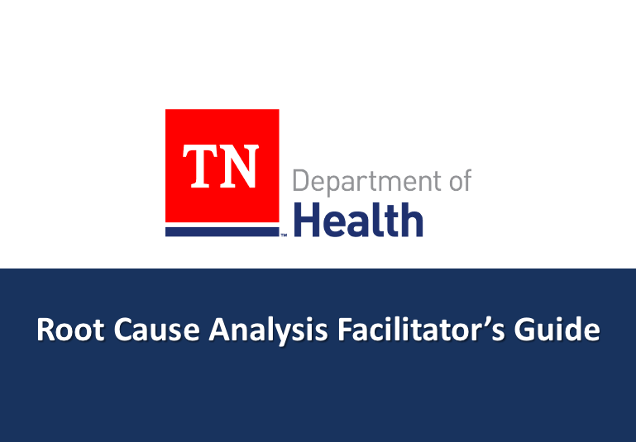

Purpose
The purpose of the Root Cause Analysis Toolkit is to provide a framework for addressing public health from a prevention perspective by centering equity throughout the process. The goal of this toolkit is to support your team’s existing projects and initiatives by incorporating upstream and systems thinking in to that process. This toolkit is designed to support TDH’s mission “To protect, promote, and improve the health and prosperity of people in Tennessee”.

This toolkit is made accessible for virtual, hybrid, and in-person teams. The activity instructions apply regardless of the chosen format. Please choose the activity format that is most suitable for your situation.

Google Jamboard
https://jamboard.google.com/d/16xN_eqQaqBqeW2vzBzurFLFq_qlq7CW6iqf9_EV1YpQ/viewer?f=0 (Access activity here)
This format is recommended for virtual or hybrid teams. Before conducting this activity, make a copy of the Jamboard template for your team to use. Click the three dots in the top right corner of the screen and select make a copy. Rename your team’s Jamboard. After completing this exercise, download as PDF to keep for your records. Use the left and right arrows at the top of your screen to navigate through the frames.

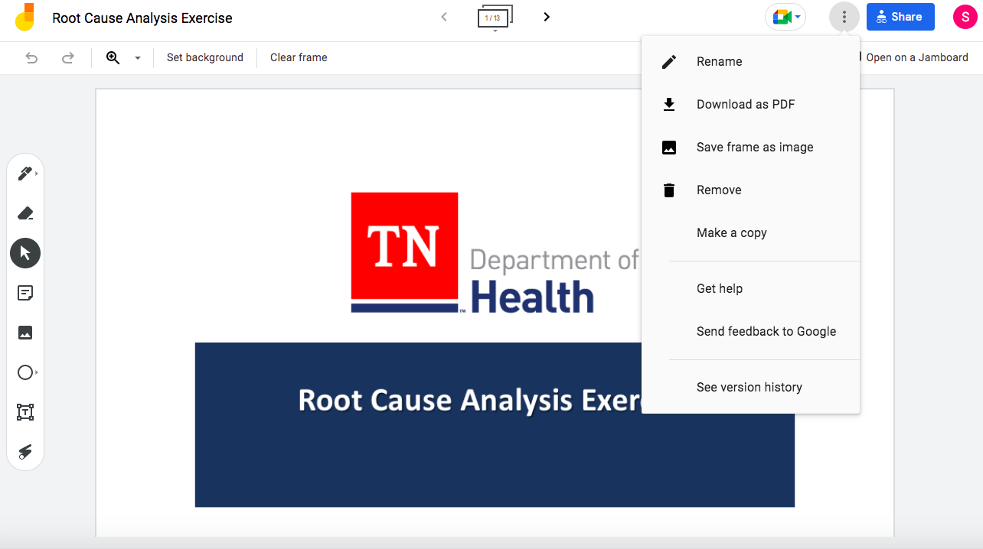
Create Text Box
Create Sticky Note
Erase
Draw

Depending on the size of your team, you may have multiple breakout groups. To create additional breakout rooms, duplicate the activity slides by clicking the frames icon at the top of the screen. In the top right hand corner of the frame that you’d like to duplicate, click the three dots. Select duplicate. Edit the textbox in the bottom right corner to rename the duplicated frames (ex. Breakout Group 2, Team Michael, etc.) so that participants can easily navigate the Jamboard. Click and hold to drag and drop your duplicated frames into the appropriate order.

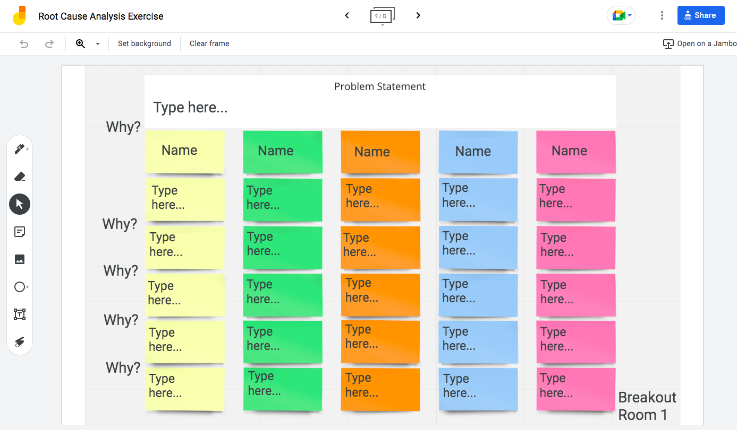
Rename

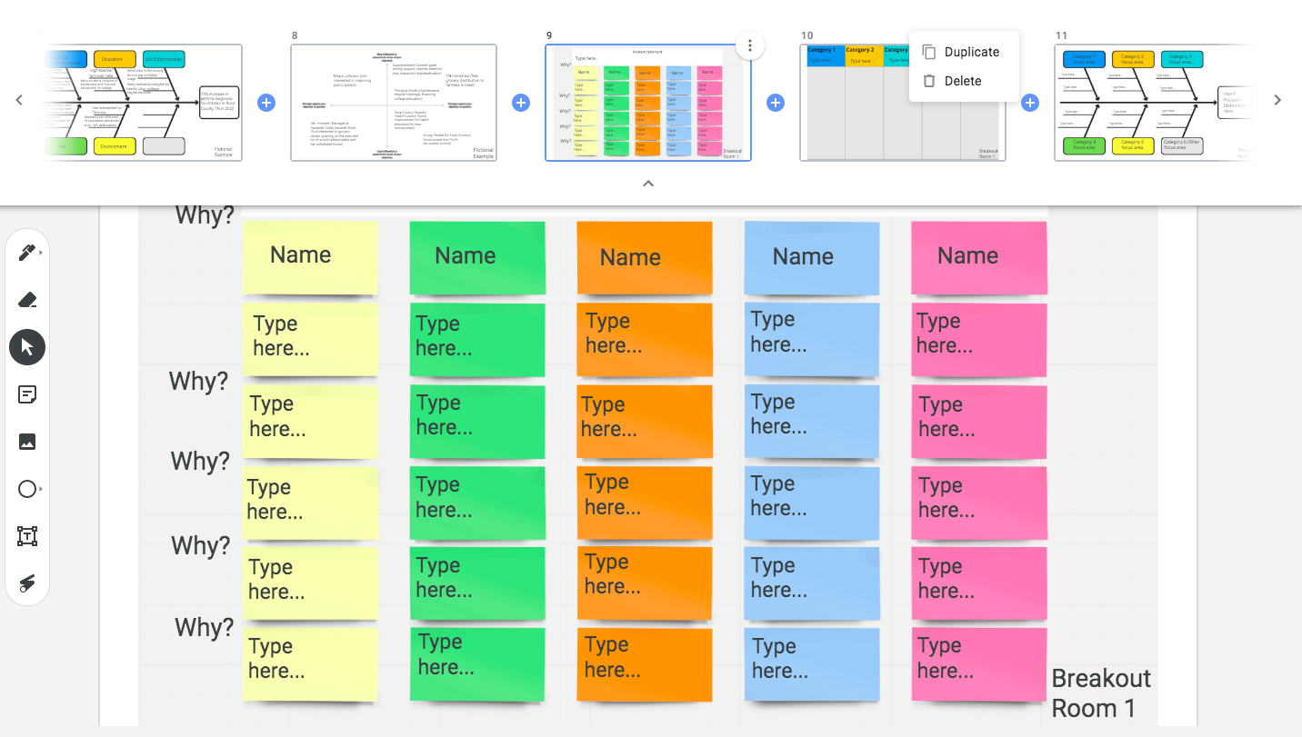
Rename

After tailoring your copy of the Jamboard to your team’s specific needs, navigate back to the title frame. Copy the URL. This is the link that you will share with your team.

Word Document
This format is recommended for virtual or hybrid teams. If you would like to make this document simultaneously editable, add to a platform like One Drive or a Google Drive folder. Ensure that all participants have access to the document via the shared file. This document may also be printed and used in person. Follow all activity instructions per usual. Find a copy of this word document in the toolkit folder.

Whiteboard/Easel Pads
This format is recommended for in-person teams. Using the Google Jamboard and Word Document as a model, create the frameworks for each section of the exercise. Participants may write on the sticky notes, or directly on to the whiteboard/easel pad to express their ideas. You may decide this as the facilitator. Follow activity instructions as follows. See example below.
Materials needed:
- White board or easel pads
- Writing utensils (dry erase, regular markers, pens, pencils)
- Sticky notes

Exercise Instructions
The 5 Why’s
- Each participant should find their breakout group’s workboard. Depending on the size of your team, the number of breakout groups may vary. Each person should put title their column. This way you can keep track of responses.
- As a group, decide on a problem statement (health issue) that you would like to address. This may have been determined prior to the activity, or this may be decided now.
- Step 3: Set a timer for 5 minutes. Ask "why", or what has caused the issue stated immediately above the note you are working on. Add sticky notes as you see necessary.
- After the timer goes off, set another timer for 5 minutes. Talk with your group about each person's line of thinking, and address any questions. Stop here, or go to the Fishbone Diagram.

Fishbone Diagram
At this point, it is okay if your group has not yet been able to identify the root cause(s) of your problem statement. This section is meant to give a more wholistic view of the problem by understanding the different systems that influence the chosen problem statement. The second part of this activity will assist your team in identifying common themes to begin thinking systemically about your problem statement.

- Set a timer for 5 minutes. As a group, review responses in Part 1. Develop 3-5 broad categories (ex. policy, education, transportation, healthcare). Label each column.
- Set a timer for 3 minutes. Organize the causes from Part 1 into a category. Feel free to condense, edit, or further flesh out causes that arose from the 5 Why’s activity.
- Set a timer for 5 minutes. Discuss any common themes, root causes, ideas and questions that your group has developed after categorizing causes.
- Fishbone Diagram. For each category, identify a focus area. Title each section with a focus area. On the supporting branches, identify contributing causes.

Power Analysis
Now that your group has identified the potential root cause(s) of your problem statement, you may decide to examine current partnerships and relationships related to the issue. This optional next step is meant to help your team identify existing partnerships and brainstorm new ones that would support you in addressing the health concern.

- Set a timer for 7 minutes. As a group, brainstorm existing and potential partnerships that could assist you in addressing the chosen health outcome.
- Choose the appropriate quadrant for each partnership. (High Influence/Strong Support, High Influence/Low Support, etc.)

NOTE
- The allotted times in the instructions are a recommendation. As the facilitator, feel free to alter the pace of the exercise according to your team’s needs.
Additional Resources
If you are interested in exploring the concepts mentioned in this toolkit more deeply, consider checking out the following resources.

Upstream Thinking
https://www.youtube.com/watch?v=xYeAmafTGCA (~2 minute video)
https://nccdh.ca/images/uploads/Moving_Upstream_Final_En.pdf (~6 minute read)
https://www.ncbi.nlm.nih.gov/pmc/articles/PMC3431152/ (~20 minute read)
Systems Thinking
https://www.youtube.com/watch?v=FW6MXqzeg7M (~4 minute video)
https://www.youtube.com/watch?v=FW6MXqzeg7M (~7 minute read)
https://www.cdc.gov/policy/polaris/tis/index.html (~2 minute read + additional videos available)
Health Equity
https://www.cdc.gov/chronicdisease/healthequity/index.htm (CDC webpage)

