Instructions for Accessing TBI VPN using Two Factor Authentication – TBI Employees Only

There are 2 main steps involved in configuring your AnyConnect VPN to utilize two-factor authentication, which is a mandate by CJIS for all VPN connections.
- Login to the two-factor (also called X2) web server and register your cell phone. Your cell phone will receive a 6-digit PIN code to complete your VPN connection.
- Modify your existing AnyConnect connection to use the two-factor server.

STEP 1
For this step, a connection to TBI’s network is required, either from your TBI work computer or while connected to TBI via your existing AnyConnect VPN.
- In a web browser, go to https://x2.tbiapps.tn.gov
- Be sure that the Domain selected is NET.ADS.STATE.TN.US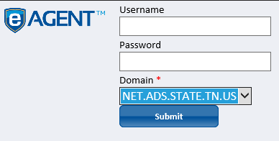
- Enter your RACF ID (DH#) and current password.
- Click on Add SMS Device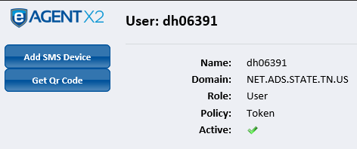
- Enter the phone number to which you want the PIN codes to be sent and a description of the device (optional) 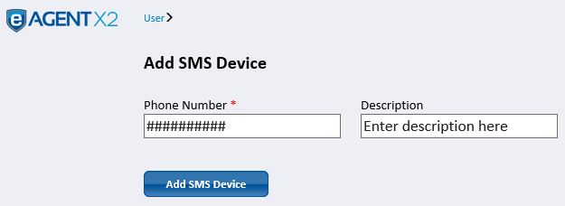
Click Add SMS Device
- You will now see that the device is listed 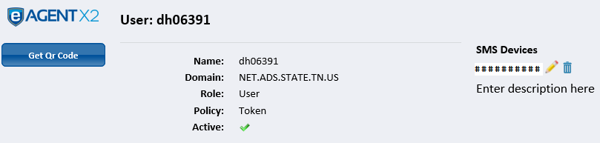
- You should receive a text message on the device that states: This device is now registered with eAgentX2
NOTE: To change the phone number that is registered, click the pencil icon to modify it.
- If you performed this step using AnyConnect to access the TBI network, you must disconnect before proceeding.

STEP 2
After successfully registering your SMS device on the X2 server, you will now need to configure your AnyConnect VPN client to use the two-factor server. For this step, you cannot be connected to the TBI network, so perform this step from outside the TBI HQ facility without being connected to AnyConnect, or while connected to the state’s wireless network from inside the TBI HQ facility.
- Open AnyConnect and enter tbivpn.tbi.tn.gov in the box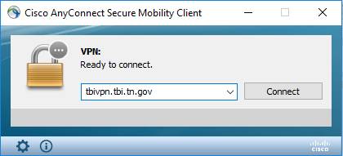
- Click Connect and select TBI-TwoFactor in the drop down box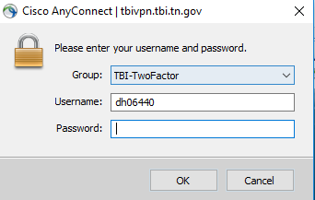
- Enter your RACF ID (DH#) and password and click OK. You will receive a box for the PIN code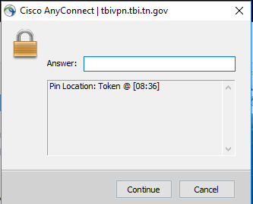
- The PIN code will be sent as an SMS (text) message to the device you registered in Step 1 above. Enter this PIN and click Continue.
- You should now be connected to TBI’s network just as before.
If you experience problems, or have questions, contact the TBI Help Desk at 615-744-4357 or email TBI.ServiceDesk@tn.gov.

