Remote instructions for users to access TBI IT resources.
The following instructions are for users who are working from home and do not have a TBI assigned device.
If you do not have a TBI assigned laptop and no way to get emails. Follow these steps below from your home computer.
Open up any browser and go to https://Office.com
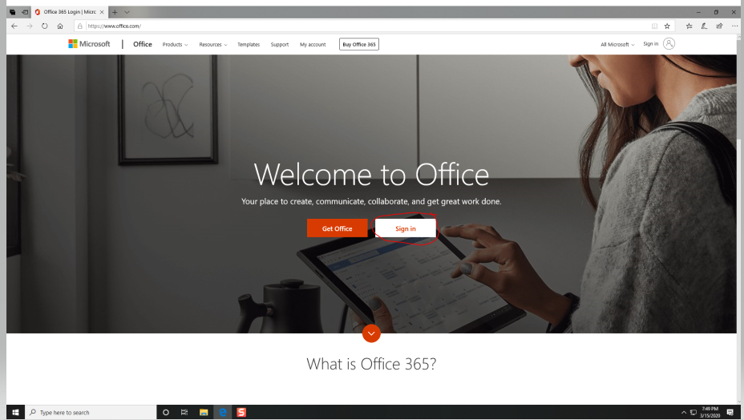
Click the sign in button.
You will see the following screen: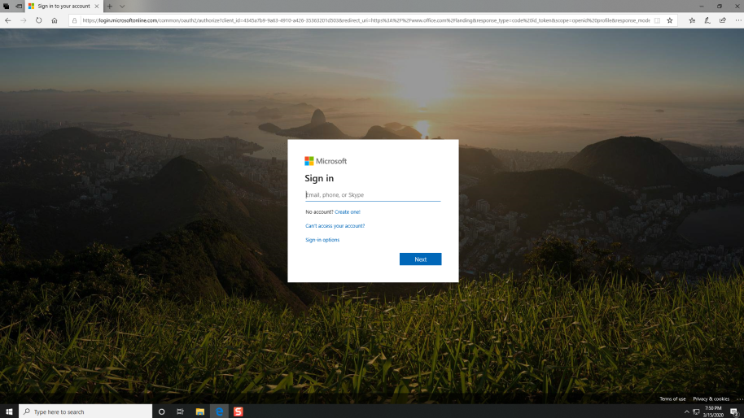

Your sign in will be your DH# @tn.gov.

Example:
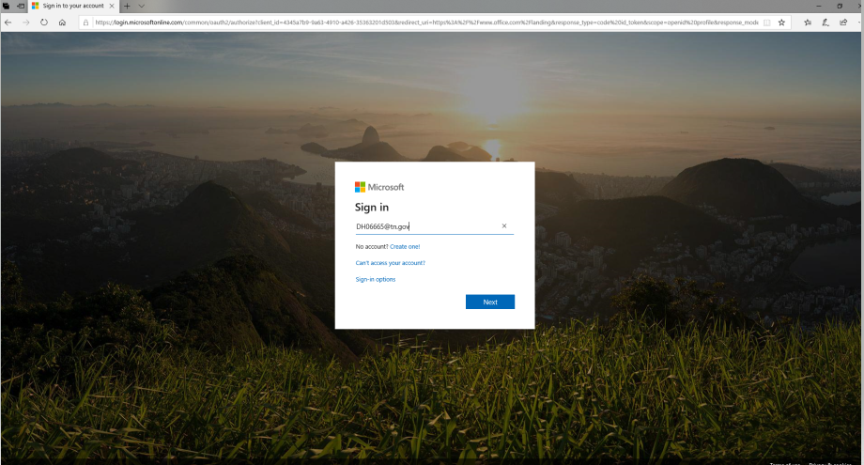

You will be prompted to pick your credentials:
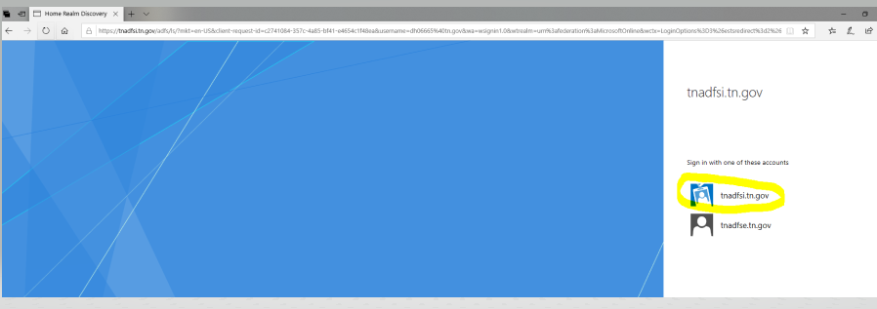
Click the Blue Badge tnadfis.tn.gov.
You will be prompted for your Organization log in.
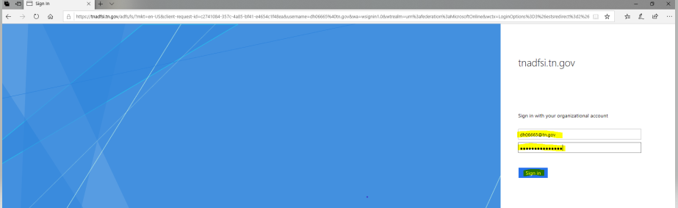

Enter your DH# @tn.gov as shown above. Then enter your password that you use when you login to the network.
You will see the following screen to sign in.

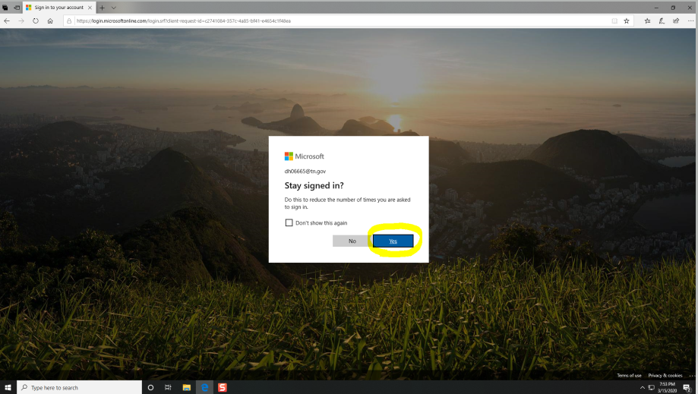

Click yes.

The Office 365 Web page will be displayed with all the Office Suite products.
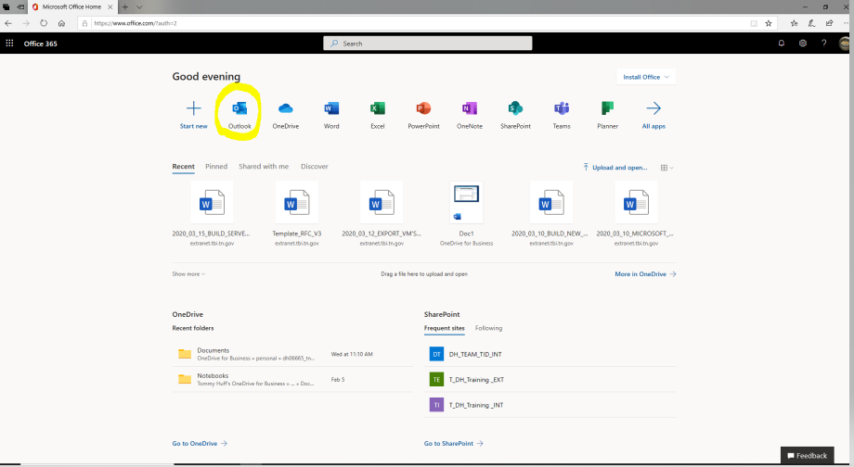
Click Outlook to open your email.
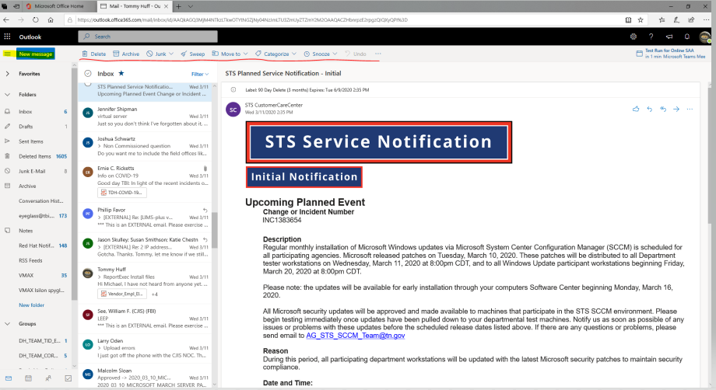
As you see from the screenshot above your mail will be displayed as normal. The yellow Mark in the upper left-hand corner indicates where you can create new mail. The underlined tools in red are how you can manage your emails.

If you need any assistance Please contact the Service Desk at 615-744-HELP.

