Office Lens
Office Lens trims, enhances, and makes pictures of whiteboards and docs readable. You can use Office Lens to convert images to PDF, Word and PowerPoint files, and you can even save images to OneNote or OneDrive. Office Lens is like having a scanner in your pocket. Like magic, it will digitize notes from whiteboards or blackboards. Always find important documents or business cards. Sketch your ideas and snap a picture for later. Don't lose receipts or stray sticky notes again!
Scenarios: - Capture and crop a picture of a whiteboard or blackboard and share your meeting notes with co-workers. - Make digital copies of your printed documents, business cards, or posters and trim them precisely. - Printed and handwritten text will be automatically recognized (using OCR), so you can search for words in images and then copy and edit them.
Video Demo: https://www.youtube.com/watch?v=jzZ3WVhgi5w

To install Microsoft Lens on your State iPhone / iPad Please follow the instructions below.
Locate the App Store on your phone and tap the icon.
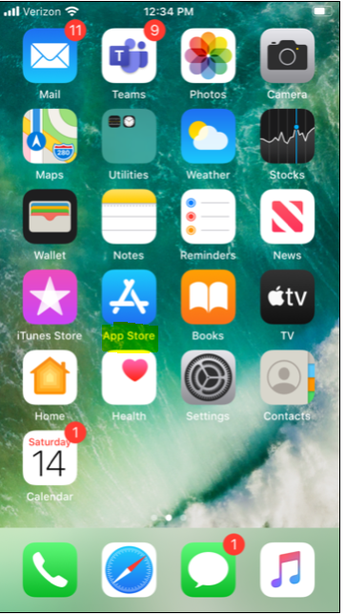
Once the App Store opens. In the lower right hand corner click on Search.
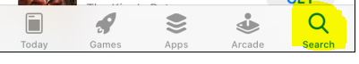

When the Search Window Opens. In the Top field type Microsoft Lens.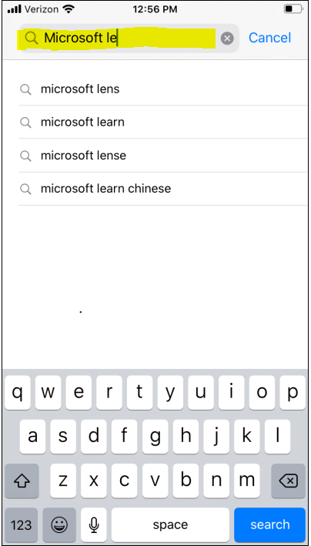
On the next screen you will see Microsoft Lens.
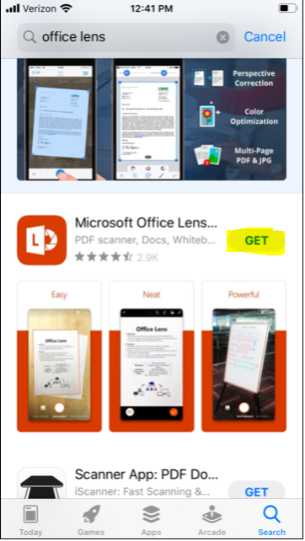
Tap Get.
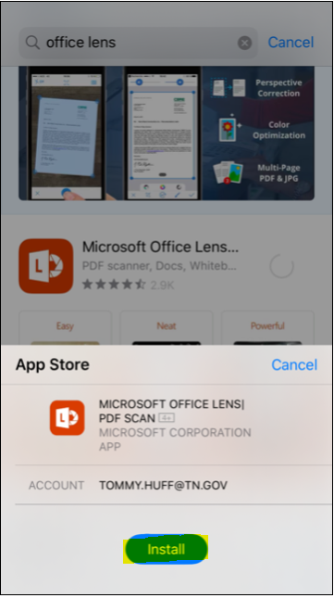
Tap install and the application will load.
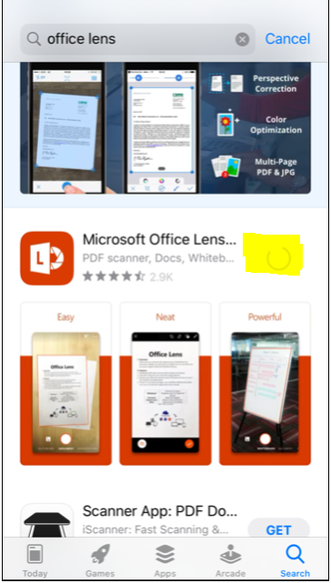

Once the App is installed you will see the following screen.
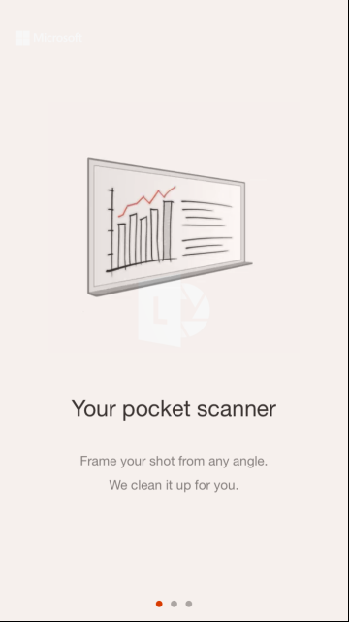
Swipe to the left two times.
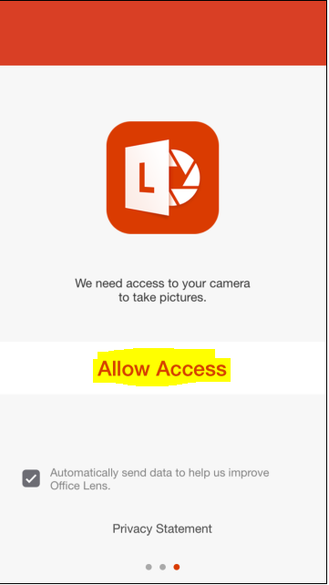
Tap allow access.
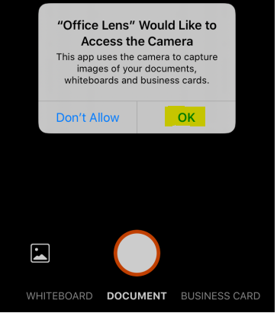
Tap OK to allow Access to the Camera.

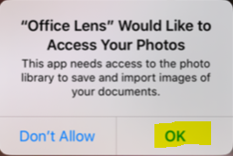
Tap OK.

The camera will be ready to take a picture. In the upper right-hand corner of the screen tap the … button.

The settings screen will be displayed.
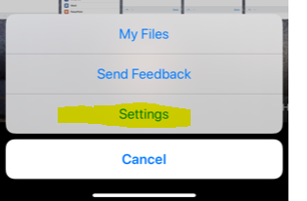
Tap settings.

The following sign in screen will appear.
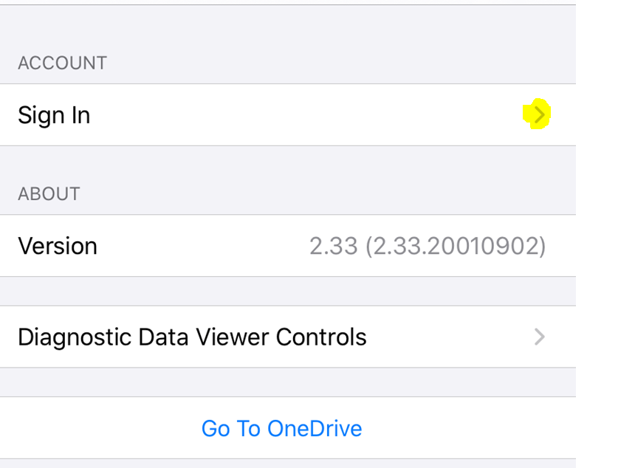

Tap the arrow to the left of the sign in button.

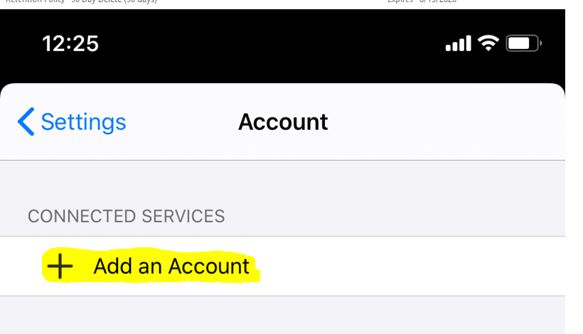
Tap the Add an Account.

You will be presented with a Microsoft Sign in page:
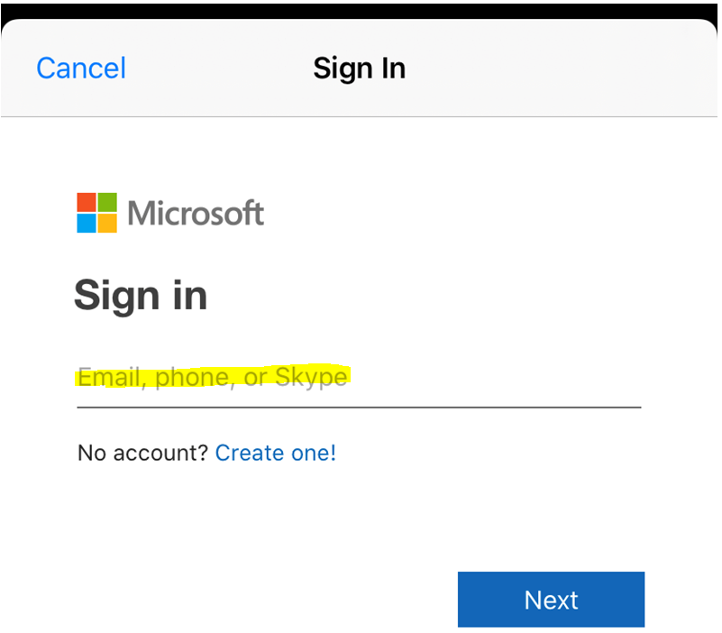
Enter your DH# @tn.gov and Tap Next.
Example:
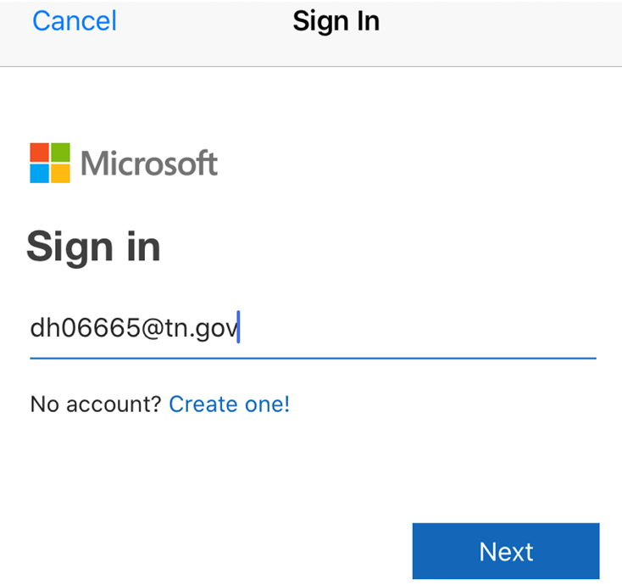

You will be prompted to choose an account.
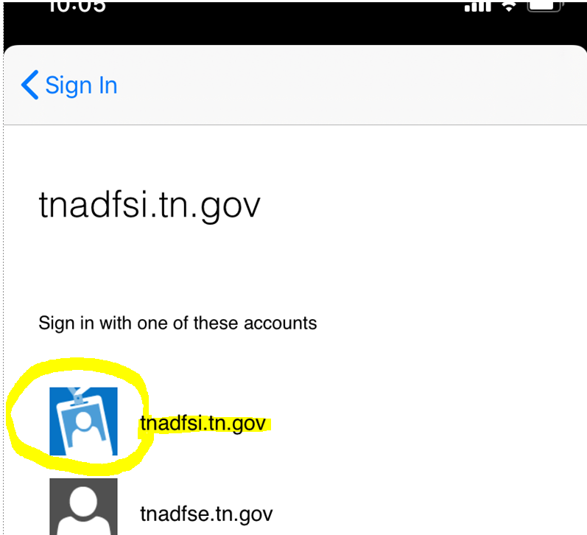

Please tap the Blue Badge tnadfsi.tn.gov.
You will be prompted to enter your Net account and password. You will use DH # @tn.gov. Your password will be the same that you use to log into your work computer.
Example:
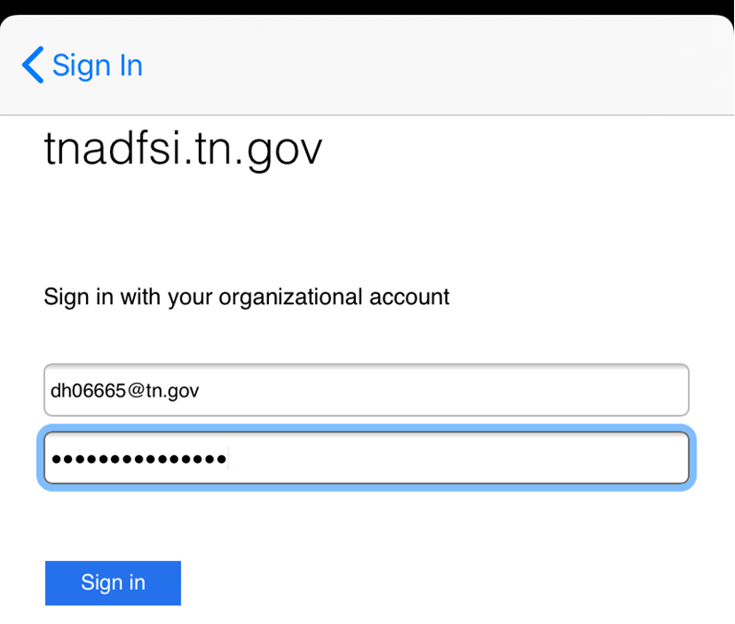
Click Sign in.

Once sign is complete
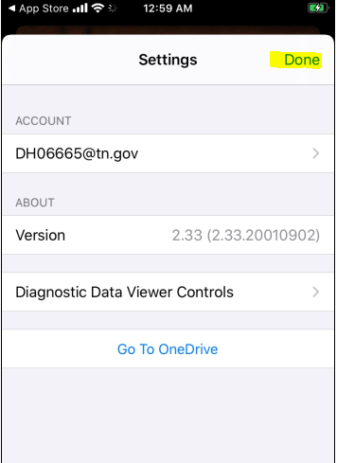
tap done in the upper right-hand corner.

You will now be ready to Take pictures.

Here are some tutorial links: on using
https://support.office.com/en-us/article/microsoft-office-lens-for-ios-fbdca5f4-1b1b-4391-a931-dc1c2582397b
https://www.cnet.com/how-to/getting-started-with-microsoft-office-lens/

