State Route 31
Virtual Public Information Meeting Invitation
From Mooresburg to Adams Lane

Project History
The Tennessee Department of Transportation (TDOT) is currently proposing a project for improvements to State Route 31 from Mooresburg to Adams Lane in Hawkins County. The purpose of this meeting is to discuss and share changes made to the proposed improvements. A public design meeting for this section of Hawkins SR 31 was held in 2012. Since then, the department has re-evaluated all projects to ensure that they meet the purpose and need. For the proposed State Route 31 projects, public comments from the 2012 meeting were also taken into consideration during the re-evaluation process.

Project Description

The proposed improvements include widening the portion of the existing State Route 31 from a two-lane highway to a three-lane highway (two travel lanes; one in each direction, and a center left turn lane) from State Route 1 (US 11W) to near Jarnigan Road. In addition to the widening section, improvements will be made to the intersection of State Route 31 and Helton Road. These improvements include the addition of a left-turn lane from State Route 131 onto Helton Lane. Finally. The State Route 31 bridge over Poor Valley Creek at LM 4.17 will be replaced as part of the proposed improvements. The proposed typical sections can be found below.

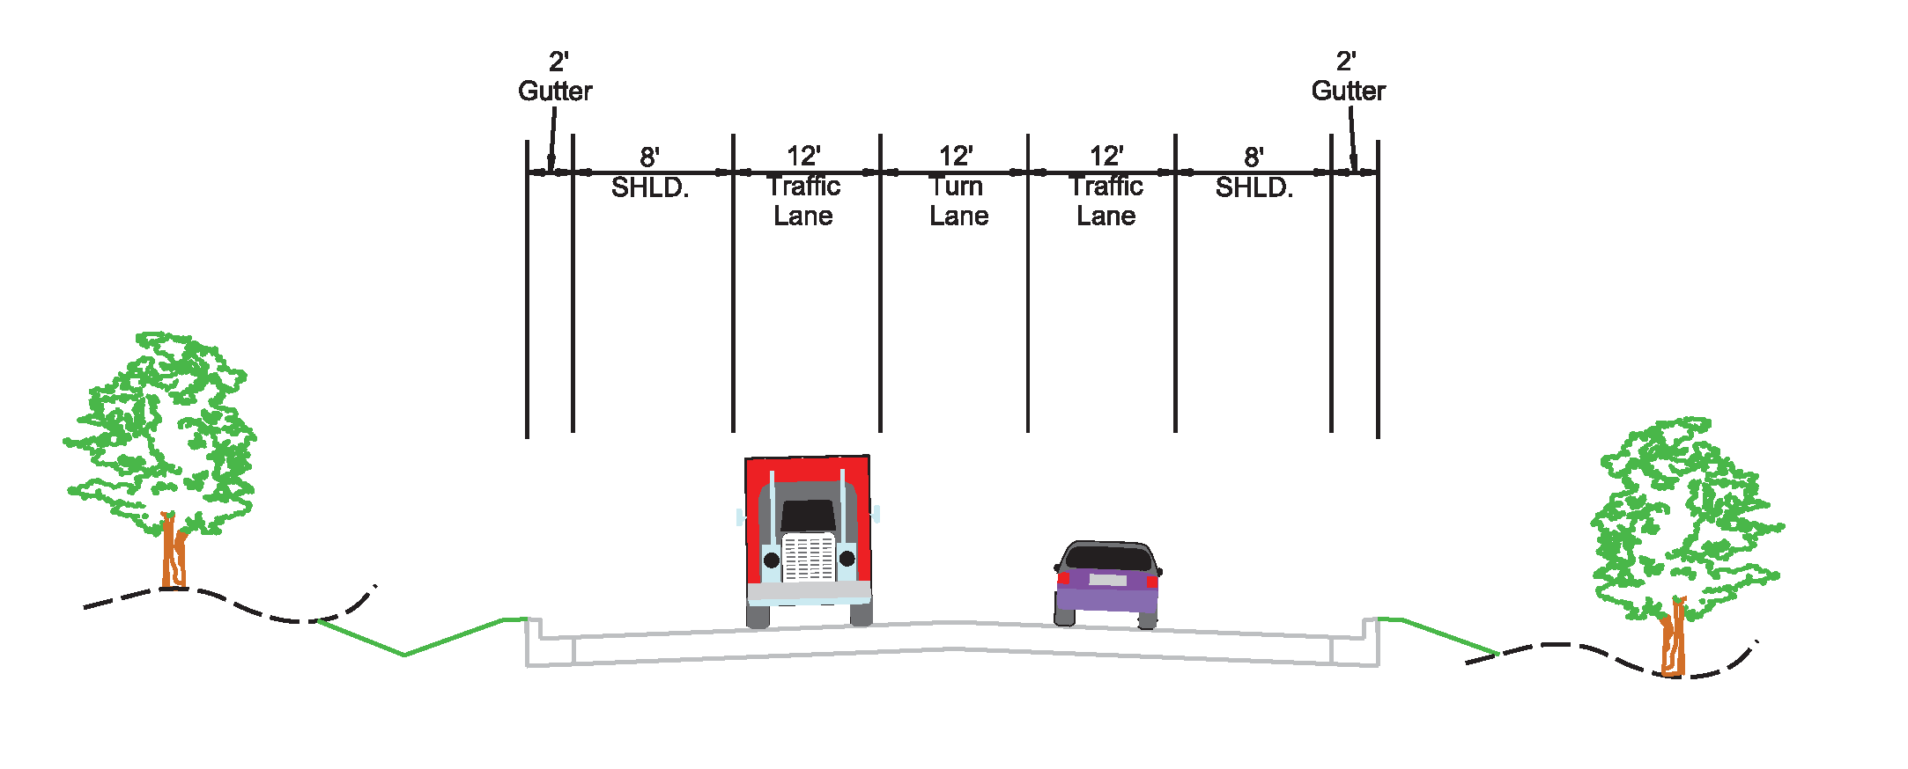

State Route 31 widening from State Route 1 (US 11W) to near Jarnigan Road

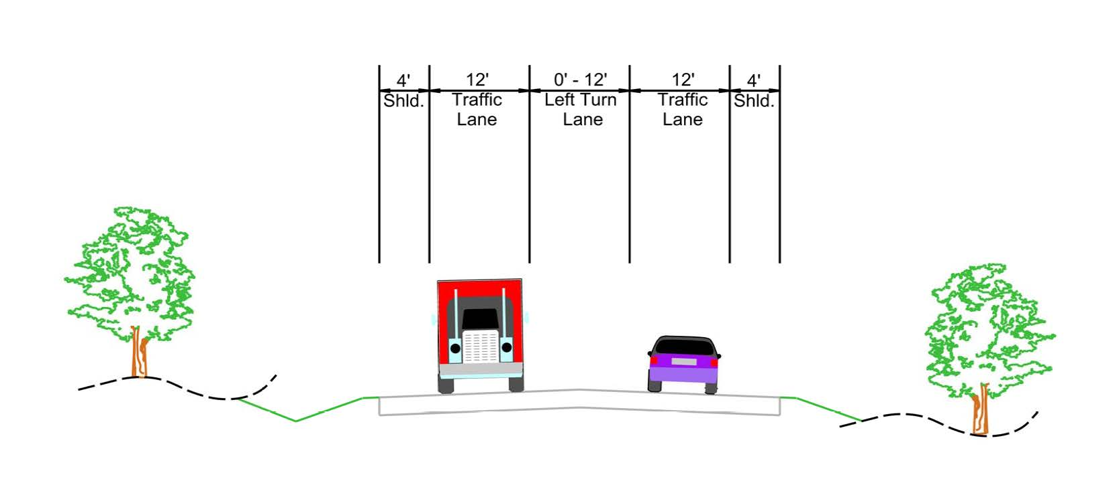

Intersection Improvements at State Route 31 and Helton Lane

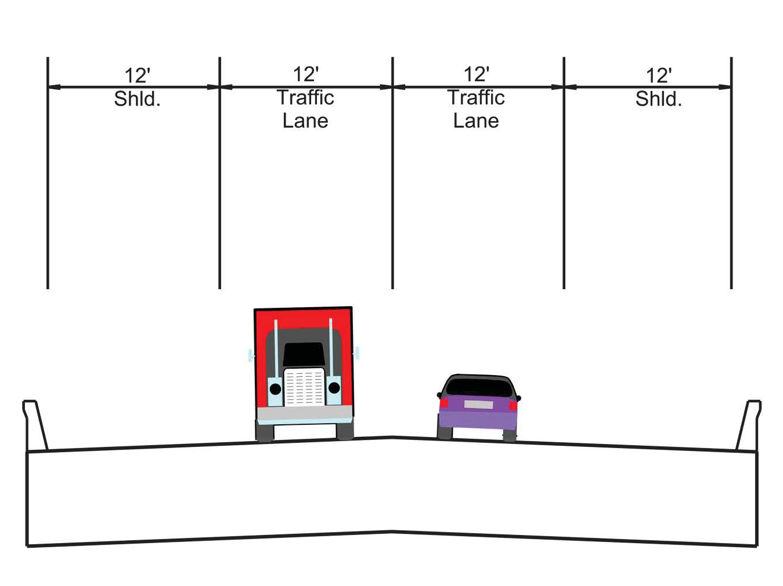

State Route 31 bridge replacement at Poor Valley Creek, LM 4.17

