Consistency Determination

Allotment Amounts:
June 1, 2021 – May 31, 2022

Comparing to Budgets from:
TAMP Version 2019.1.2

What is Consistency Determination?
TDOT strongly believes in operating as an open and transparent governmental body. TDOT’s Transportation Asset Management Plan (TAMP) exemplifies TDOT’s commitment to plan, design, build, maintain, and manage one of the best transportation systems in the nation. This effort is rooted in our Mission, Vision, and Values. The annual consistency determination is TDOT’s proof that it is managing the state’s NHS pavement and bridge assets in accordance with a strategic plan to be as efficient and effective as possible with federal and state dollars and achieve Tennessee’s performance goals and objectives.
Mission:
Provide a safe and reliable transportation system that supports economic growth and quality of life.
Vision:
A commitment to excellence in managing and improving the state’s transportation system, promoting the success of our employees, and strengthening the trust of our customers.
Values:
- Stewardship
- Integrity
- Safety
- Consistency
- Development
- Innovation
- Collaboration
- Family

What are the MAP-21 and Final Rule requirements?
Consistency requirements are identified in 23 CFR Part 515.13 (b) (2) as follows: Annual determination of consistency under 23 U.S.C. 119(e)(5). Not later than August 31, 2019, and not later than July 31 in each year thereafter, FHWA will notify the State DOT whether the State DOT has developed and implemented an asset management plan consistent with 23 U.S.C. 119. The notice will be in writing and, in the case of a negative determination, will specify the deficiencies the State DOT needs to address. In making the annual consistency determination, the FHWA will consider the most recent asset management plan submitted by the State DOT, as well as any documentation submitted by the State DOT to demonstrate implementation of the plan. The FHWA determination is only as to the consistency of the State DOT asset management plan and State DOT implementation of that plan with applicable requirements and is not an approval or disapproval of strategies or other decisions contained in the plan. With respect to any assets the State DOT may elect to include in its plan in addition to NHS pavement and bridge assets, the FHWA consistency determination will consider only whether the State DOT has complied with § 515.9(l) with respect to such discretionary assets.
(1) Plan development. The FHWA will review the State DOT’s asset management plan to ensure that it was developed with certified processes, includes the required content, and is consistent with other applicable requirements in this part.
(2) Plan implementation. The State DOT must demonstrate implementation of an asset management plan that meets the requirements of 23 U.S.C. 119 and this part. Each State DOT may determine the most suitable approach for demonstrating implementation of its asset management plan, so long as the information is current, documented, and verifiable. The submission must show the State DOT is using the investment strategies in its plan to make progress toward achievement of its targets for asset condition and performance of the NHS and to support progress toward the national goals identified in 23 U.S.C. 150(b). The State DOT must submit its implementation documentation not less than 30 days prior to the deadline for the FHWA consistency determination.
(i) FHWA considers the best evidence of plan implementation to be that, for the 12 months preceding the consistency determination, the State DOT funding allocations are reasonably consistent with the investment strategies in the State DOT’s asset management plan. This demonstration takes into account the alignment between the actual and planned levels of investment for various work types (i.e., initial construction, maintenance, preservation, rehabilitation and reconstruction).
(ii) FHWA may find a State DOT has implemented its asset management plan even if the State has deviated from the investment strategies included in the asset management plan, if the State DOT shows the deviation was necessary due to extenuating circumstances beyond the State DOT’s reasonable control.

Is the TDOT TAMP Compliant with Current Federal Requirements?
In November 2022, the Federal government passed the Bipartisan Infrastructure Law (BIL), which modified 23 USC 119 to require the life cycle cost and risk management analyses used to develop the TAMP to consider extreme weather and resilience (23 USC 119(e)(4)(D)). TDOT’s current TAMP (version 2019.1.2) has not been certified by FHWA as compliant with this new requirement. In accordance with the requirements of 23 CFR 515.13(a) and guidance issued by FHWA in May of 2022, TDOT will seek an extension from FHWA to submit an updated TAMP that is compliant with all requirements, including the additional requirements established through passage of the BIL, no later than December 31, 2022. A TAMP that does not address the new requirements will be submitted to FHWA by the due date of July 19, 2022, but that TAMP will not be considered for certification if FHWA grants TDOT the extension.

What is TDOT’s Process for Documenting Consistency?
TDOT will submit to FHWA a summary of how the agency’s annual investment strategy of planned allocations, as documented in TDOT’s TAMP Version 2019.1.2, is in alignment and reasonably consistent with actual investment amounts during the 12-month period from June 1, 2021 to May 31, 2022, as agreed to by TDOT and the FHWA Tennessee Division during the meeting on February 26, 2020. This 12-month period allows TDOT sufficient time to extract the actual investment amounts and prepare the consistency determination report before the deadline. Should the amounts significantly deviate, TDOT will provide documentation to justify the deviation. The 12-month TAMP Budget amounts and the Actual Investment amounts for each of the five work types, as defined by FHWA (Maintenance, Preservation, Rehabilitation, Construction, and Reconstruction), are compared in Table D-1. Explanations for differences are also provided. Crosswalks between TDOT’s treatment types and the FHWA work types are presented in Table D-2. The planned TAMP investments for pavements and bridges are presented in Tables D-3 and D-4, respectively.
TDOT’s budget process does not currently split out amounts for Construction and Reconstruction separately. Therefore, Table D-1 shows the budget amount for Construction and Reconstruction combined into a single value for TAMP Budget under the Reconstruction & Construction row. Project allotment amounts in TDOT’s Program, Project, and Resource Management (PPRM) application have been separated into categories for New Construction and Reconstruction, so the actual investment amounts for construction and reconstruction can be properly separated and shown individually in Table D-1; however, for consistency determination, these amounts have been combined before comparing to the combined budget amount.
TDOT was able to enhance the data query from PPRM so that details on bridge expenditures included in pavement projects can be identified more easily. This allowed the pavement and bridge obligation adjustments to be calculated within the tabulation spreadsheet, reducing the manual adjustments that were required in previous years. TDOT has identified Project Delivery Network (PDN) as a replacement solution for PPRM and is moving forward with the implementation tentatively scheduled to launch in April 2023. This will further enhance TDOT’s ability to track expenditures for future consistency determination reports.
Table D-1
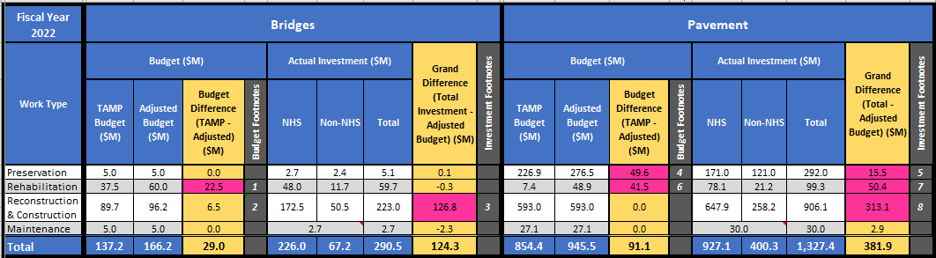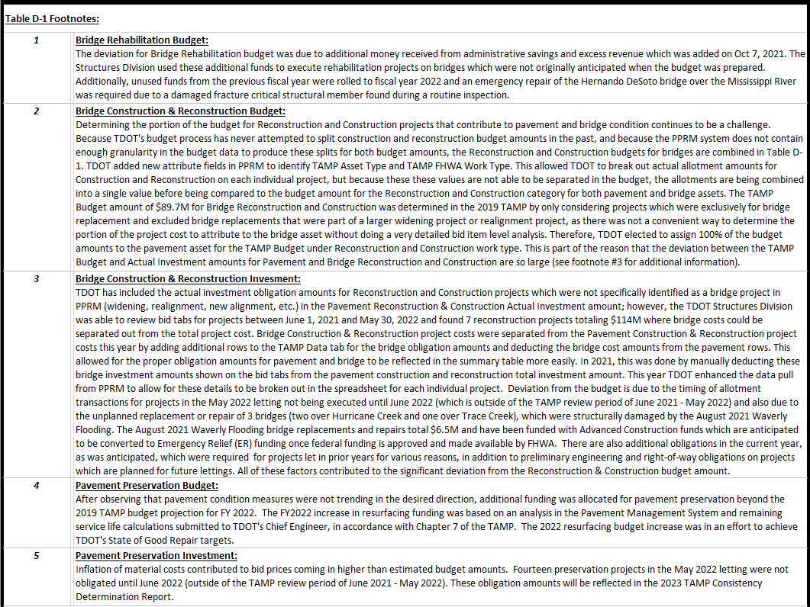

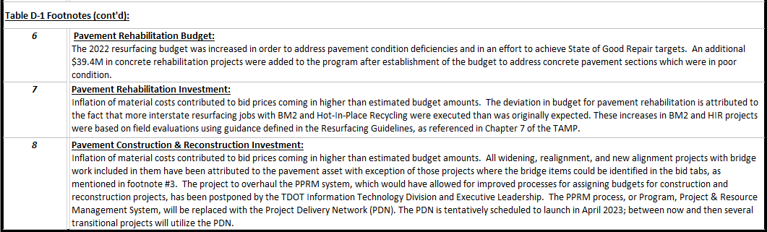

This Consistency Determination document will be updated and posted on TDOT’s website annually. It will also be referenced in the appendix of each version of TDOT’s TAMP using the appropriate URL web address. Accompanying the 2022 Consistency Determination document is a link to the spreadsheet that was used to compile the actual investment data from PPRM (shown below). Below are links to the documents on TDOT’s website.

TAMP Consistency Determination Document:
- https://www.tn.gov/content/dam/tn/tdot/maintenance/asset-management-office-/tamp/2022_TAMP-Consistency Determination_v.1.1.docx

TAMP Consistency Determination Spreadsheet:
- https://www.tn.gov/content/dam/tn/tdot/maintenance/asset-management-office-/tamp/TAMPData_2022_Consistency_Determination_v1.1.xlsx

Table D-2: Crosswalk Between TDOT Treatment Types and FHWA Work Types
MAP-21 Work Types | TDOT Pavement Treatments | TDOT Bridge Treatments
Preventative Maintenance | Maintenance Activities, including:  - Shallow patching Skin patching  - Partial-depth patching  - Repair concrete corner breaks Concrete joint repair  - Other thin patching | Preventive Activities, including:  - Filling potholes in deck  - Minor Structure repair  - Major structure repair  - Cleaning Structure
Preservation | Preservation Activities, including:  - Thin asphalt overlay (1.5” or less)  - Microsurfacing  - Chip seals  - Cape seals  - Crack sealing  - Concrete joint sealing  - Mill and fill asphalt  - overlays (1.5” or less | Preservation Activities, including:  - Repainting structural steel  - Sweeping  - Deck repairs  - Deck waterproofing  - Deck epoxy overlay  - Polymer modified  - concrete deck overlay  - Cleaning and resealing expansion joints  - Scour prevention (1)
Rehabilitation | Rehabilitation Activities, including:  - Full-depth patching  - Repair/replacing concrete slabs  - Hot-in-Place recycling with  - 1.25” overlay | Rehabilitation Activities, including:  - Replacement of expansion joints  - Concrete spall repairs  - Structural steel repairs  - Scour repairs (1)  - Bearing replacement
Reconstruction | Reconstruction Activities, including:  - Rubblization and overlay of concrete pavement  - Full-depth replacement of asphalt pavement | Reconstruction Activities, including:  - Bridge Replacement
Construction | Construction Activities, including:  - Highway Widening  - Highway Realignments  - New Highway Construction | Construction Activities, including:  - Bridge Widening  - New Bridge Construction

Table D-3: TDOT 10-Year Estimated Budget for Pavements by Work Type (Dollars in Millions)
(Values in italics were revised from 2019 TAMP)
Year | Construction & Reconstruction  (2) | Repair/ Rehab  (3) | Preservation  (3) | Maintenance | Total
2019 | $584.2 | $7.3 | $223.5 | $23.8 | $838.8
2020 | $587.1 | $7.3 | $224.6 | $26.8 | $845.8
2021 | $590.0 | $7.4 | $225.7 | $26.9 | $850.0
2022 | $593.0 | $7.4 | $226.9 | $27.1 | $854.4
2023 | $596.0 | $7.4 | $228.0 | $27.2 | $858.6
2024 | $598.9 | $7.5 | $229.1 | $27.3 | $862.8
2025 | $601.9 | $7.5 | $230.3 | $27.5 | $867.2
2026 | $604.9 | $7.6 | $231.4 | $27.8 | $871.7
2027 | $608.0 | $7.6 | $232.6 | $27.9 | $876.1
2028 | $611.0 | $7.6 | $233.8 | $28.0 | $880.4
Total | $5,975.0 | $74.6 | $2,285.9 | $270.3 | $8,605.8

Table D-4: TDOT 10-Year Estimated Bridge Management Budget by Work Type (Dollars in Millions)
Year | Construction & Reconstruction  (4) | Repair/ Rehab | Preservation | Maintenance | Total
2019 | $67.6 | $42.3 | $9.4 | $4.5 | $123.8
2020 | $67.7 | $40.5 | $5.0 | $5.0 | $118.2
2021 | $89.7 | $37.0 | $5.0 | $5.0 | $136.7
2022 | $89.7 | $37.5 | $5.0 | $5.0 | $137.2
2023 | $89.7 | $38.0 | $5.0 | $5.0 | $137.7
2024 | $89.7 | $39.0 | $5.0 | $5.0 | $138.7
2025 | $89.7 | $40.0 | $5.5 | $5.5 | $140.7
2026 | $90.2 | $41.0 | $5.5 | $5.5 | $142.2
2027 | $90.7 | $42.0 | $5.5 | $5.5 | $143.7
2028 | $91.2 | $43.0 | $5.5 | $5.5 | $145.2
Total | $855.9 | $400.3 | $56.4 | $51.5 | $1,364.1

Table D-2 Footnotes:
- Per instruction from Structures Director, Ted Kniazewycz, Scour Prevention for bridges has been moved from Bridge Rehabilitation to Bridge Preservation and Scour Repairs has been added to Bridge Rehabilitation in Table D-2: Crosswalk Between TDOT Treatment Types and FHWA Work Types.

Table D-3 Footnotes:
- During execution of the review for consistency in 2020, it was discovered that TDOT had included items in the 2019 TAMP document related to the budget amount for Pavement Construction and Reconstruction which should have been excluded from this budget amount. This included a duplication of the resurfacing budgets for pavement preservation and rehabilitation, a duplication of the bridge preservation and rehabilitation budget amounts, budgets for the TDOT Help Truck Operations, and budgets for the Rockfall Mitigation Program – all totaling $318.1 million. Also, budgets for ITS Expansion projects totaling $40.7 million should have been excluded from the Pavement Reconstruction and Construction budget. Therefore, the FY19 TAMP budget amount for Pavement Reconstruction and Construction should have been $584.2 million ($943.0M - $318.1M - $40.7M = $584.2M) instead of $943.0 million. The FY 2020 budget amount for Pavement Reconstruction and Construction would have then been increased by 0.5% for inflation, which would make the FY 2020 budget amount $587.1 million ($584.2M * 1.005 = $587.1M) instead of $947.7 million. This discrepancy was discussed by TDOT and FHWA’s TN Division Office on June 24, 2020 and it was decided that this error should be documented in the 2020 Consistency Determination justifications. A revised version of Table D-3 showing the corrected budget amounts for pavements is shown above for reference, and this will be incorporated into TDOT’s 2022 TAMP submittal for recertification by FHWA.
- During execution of the review for consistency in 2020, it was discovered that TDOT had unintentionally switched the budget amounts for Pavement Preservation and Pavement Rehabilitation in the 2019 TAMP. During a June 24, 2020 meeting with FHWA TN Division representatives, it was agreed that this would not be a significant change requiring a resubmittal of the TAMP for recertification, and that TDOT should simply note this error in the 2020 & 2021 Consistency Determination. TDOT will correct this error in the next TAMP document submittal.

Table D-4 Footnotes:
- All new bridge construction was included with major grade and drain projects, which have been attributed to the pavement asset since TDOT does not have sufficient detail to break down those budgets by asset type.

