**DL Log (Home)**

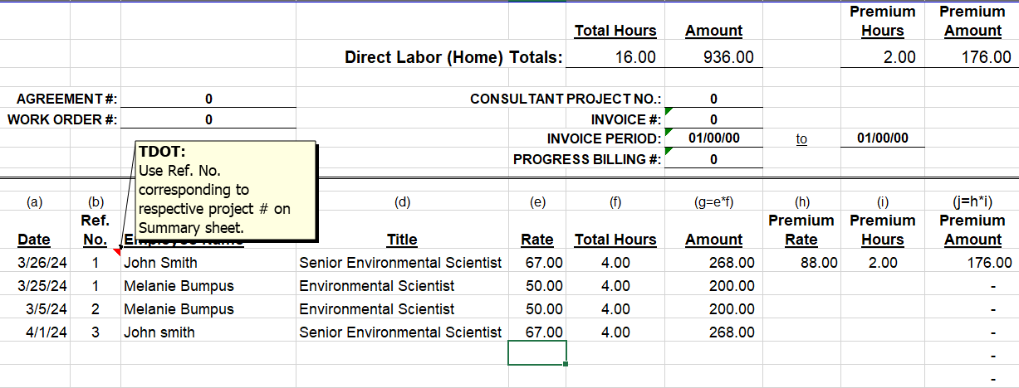

**DL Summary (Home)**

Information in all columns must be completed to properly populate on the summary sheet

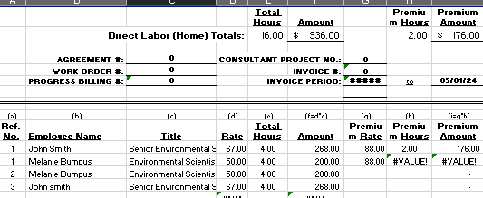

**This will populate from the summary sheet**

**This will populate from the direct costs and other costs tabs**

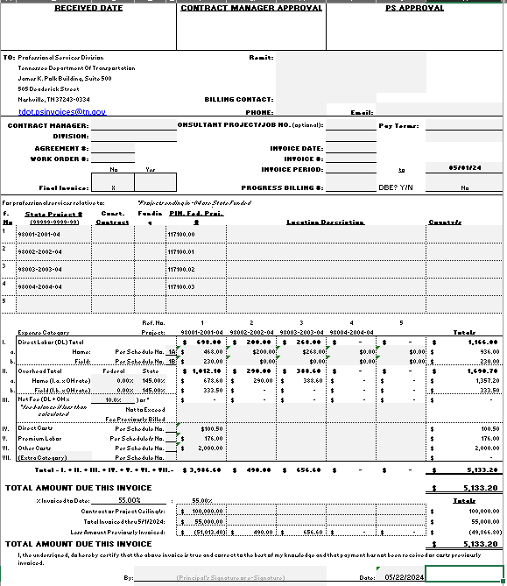

**Summary Sheet**

**You will need to fill in these areas**