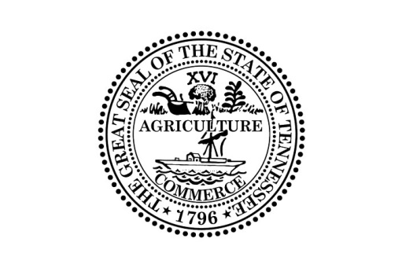

Public Meeting Notice

The Tennessee Financial Literacy Commission (“TNFLC”) Executive Committee will be meeting at 11:00 A.M. (Central Time) on December 11, 2018 in the Treasurer’s Conference Room located at the Tennessee State Capitol, First Floor; 600 Charlotte Avenue; Nashville, Tennessee 37243. TNFLC will consider the following contracts:

- Agreement with EverFi, Inc. for educational software;
- Agreement with Vanguard for the My Classroom Economy program;
- Agreement with June Puett for the provision of educational programs; and
- Agreement with Rachel Barrett & Company for fundraising services.

This meeting will be conducted permitting participation by electronic or other means of communication pursuant to Tenn. Code Ann. § 8-44-108. Please contact Bill Parker, Director of the Tennessee Financial Literacy Commission at (615) 532-5892 for more information.

Individuals with disabilities who wish to participate in these proceedings and require an accommodation should contact Bill Parker, Director of the Tennessee Financial Literacy Commission no fewer than two (2) days prior to the scheduled meeting date to allow time for the Treasury Department to arrange for an accommodation. You may contact the Tennessee Financial Literacy Commission at Andrew Jackson Building, 15th Floor; 502 Deaderick Street; Nashville, Tennessee 37243; (615) 532-5892, or Bill Parker by email at Bill.Parker@tn.gov.

