Black Bean and Tomato Salsa

Prep Time: 10 minutes Servings: 4

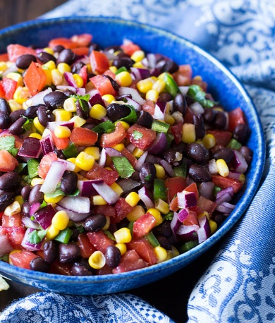

Ingredients:
- 1 cup seeded, diced plum tomatoes (3-4 tomatoes)
- 1 cup canned black beans, rinsed
- 2 tablespoons chopped scallions
- 1 tablespoon chopped fresh cilantro (or parsley)
- 1 tablespoon lime juice
- 1 ½ teaspoons extra-virgin olive oil
- ½ to 1 teaspoon minced canned chipotle in adobo sauce (see ingredient note)
- 1/8 teaspoon salt

Directions:
1. Combine all ingredients in a medium bowl; stir to blend. Refrigerate until ready to serve.

Notes:
This salsa is also a good accompaniment for burgers or scrambled egg burritos.
Chipotle peppers are smoked jalapenos with a fiery taste that are canned in adobo sauce. Look for them in the Hispanic section of large supermarkets and in specialty stores.

Nutrition:
Per serving: 78 calories; 2 g fat; 11 g carbohydrates; 3 g protein; 3 g fiber; 283 mg sodium; 118 mg potassium
Recipe source: www.eatingwell.com

